How to Prepare Revenue Remittances
A Guide for Courts and Traffic Violation Bureaus that do not use the Judicial Information System (JIS).

REVENUE REMITTANCE QUICK START 3
Resources 3
Quick Start: Step by Step 4
CLERK’S REVENUE TRANSMITTAL FORM 8
Introduction 8
Criminal Fines 9
Transmittal Form Totals 10
INFRACTIONS 11
Traffic Infractions 11
Payment Schedules 11
Remittance Calculations 13
Transferring Totals to Clerk’s Revenue Transmittal Form 16
Summary – Traffic Infractions 16
School Zone Speeding 17
Payment Schedules 17
Remittance Calculations 19
Transferring Totals to Clerk’s Revenue Transmittal Form 22
Summary – School Zone Speeding Infractions 22
Non-Traffic (Civil) Infractions 23
Payment Schedules 23
Remittance Calculations 24
Transferring Totals to Clerk’s Revenue Transmittal Form 27
Summary – Non-Traffic Infractions 27
Clerk’s Revenue Transmittal Form Totals 27
Partial Payments 30
Example 30
APPENDIX 41
Revenue Accounts 41
Legislative Assessment ($20) 42
Construction Zone Violations 43

This page is meant to be blank.

REVENUE REMITTANCE QUICK START

For detailed instructions and illustrated examples, see the sections that follow this “Quick Start” section.

Resources
Find the forms and schedules referenced below at http://www.courts.wa.gov/newsinfo/index.cfm?fa=newsinfo.infractionPenalties .

Clerk’s Revenue Transmittal Form
To report your remittances to the city/county Treasurer, use the Non-JIS Courts Clerk’s Revenue Transmittal Form from the above Web page.

Non-JIS Courts Infraction Payment Schedules
Use this Excel file to begin identifying values that you will transfer to the Clerk’s Revenue Transmittal Form.

Non-JIS Courts Remittance Calculations
Use this Excel file to complete calculations for the Clerk’s Revenue Transmittal Form.

Quick Start: Step by Step

Infractions Paid in Full
- Receipt an infraction payment.
- Open the Non-JIS Courts Infraction Payment Schedules file.
- Click the tab that matches the type of infraction:
- Traffic Infraction (Green Tab, “Traffic”)
- School Zone Speeding violation (Orange Tab, “School Zone Speeding”)
- Civil (Non-Traffic) Infraction (Yellow Tab, “Non-Traffic”)

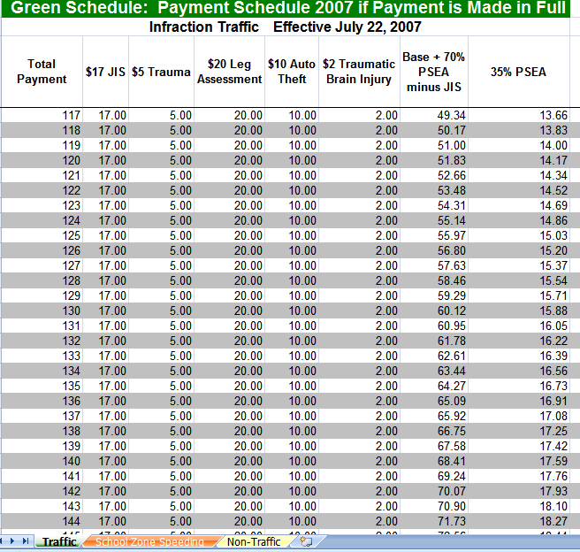
Use the Green, Orange, or Yellow tab.

- On the green, orange, or yellow schedule find the line that matches the amount paid.
- Make a note of the values listed on that line.
- Open the Non-JIS Courts Remittance Calculations file.
- Click the appropriate tab:
- Traffic Infraction
- School Zone
- Non-Traffic Infr(action)

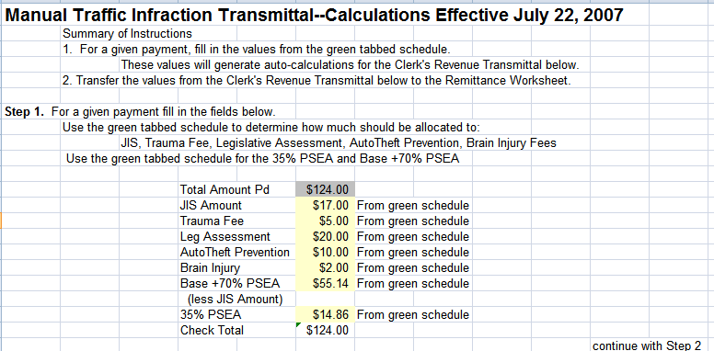
Type values into fields shaded yellow.

- In the yellow area of that worksheet, type the values you noted previously.
- The worksheet automatically calculates the remittance amounts for this payment.
- Scroll down to Step 2 of the Remittance Calculation worksheet.

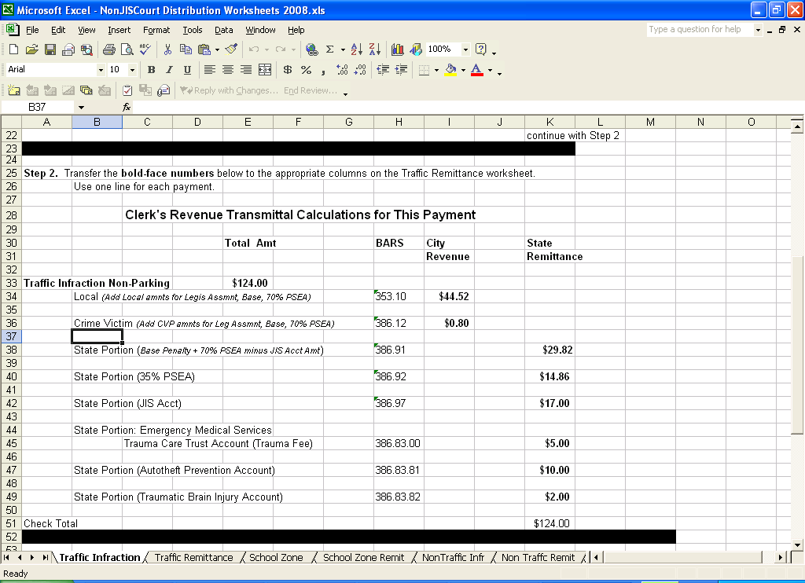
Boldface values

- Print the whole page, or make a note of the values in boldface print.
- In the Remittance Calculations file, click the Remittance tab associated with the type of infraction
- Traffic Remittance
- School Zone Remit
- Non-Traffic Remit

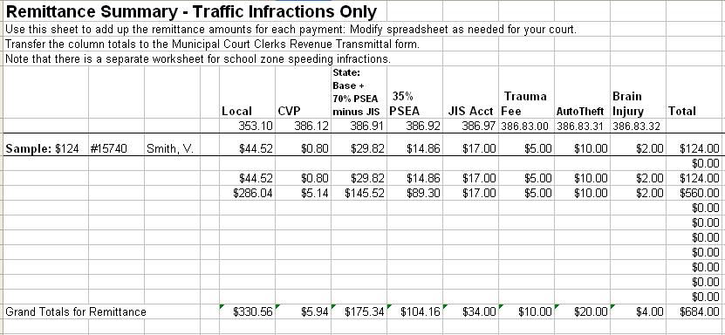

- In the designated columns, type the boldface values you noted previously.
- When you are ready to remit, use the totals at the bottom of these remittance worksheets.
- On the Clerk’s Revenue Transmittal Form, enter the totals from the remittance worksheets in the appropriate fields.
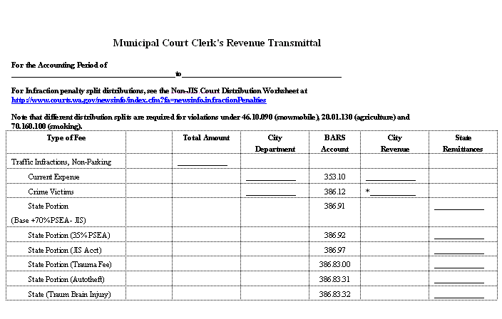
- Note the totals (by BARS code) at the end of the form.

Other Types of Payments
- Partial Infraction Payments
- See detailed instructions later in this Guide.
- Misdemeanors
- Use the percentages listed on the Clerk’s Revenue Transmittal Form.
- All other payments
- Use the percentages listed on the Clerk’s Revenue Transmittal Form.

CLERK’S REVENUE TRANSMITTAL FORM

Introduction
Use the Clerk’s Revenue Transmittal Form to send payments to your county or city treasurer. The detail on this form will assist the treasurer to deposit the funds into the right accounts. Some of these accounts are local funds; some are state funds.

Excel spreadsheet calculations are required for filling out revenue for infractions. See below.

Other revenue can be calculated as you fill out the Transmittal Form itself.

You can find a copy of this form at http://www.courts.wa.gov/newsinfo/index.cfm?fa=newsinfo.infractionPenalties
Click the link for Non-JIS Courts Clerk’s Revenue Transmittal Form.

Criminal Fines
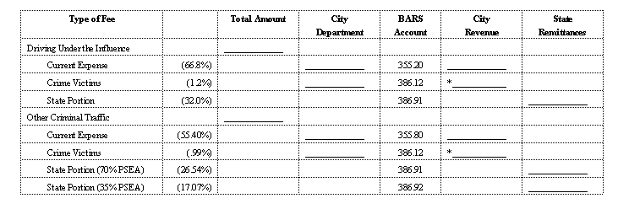
Criminal fines other then Driving Under the Influence (DUI) are split among
- The local general fund (“Current Expense”, BARS code 355.20)
- The local Crime Victims Fund (BARS code 386.12)
- The 70% PSEA State Portion (BARS code 386.91)
- The 35% PSEA State Portion (BARS code 386.92)

In the example below, the court received $1000 in criminal fines during the month.

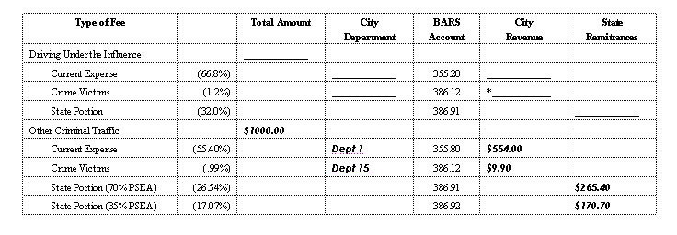
Record total amount here.
In these boxes type the city/county department name or number for this account
55.40 % x $1000 = $554.00
0.99% x $1000 = $9.90
26.54% x $1000 = $265.40
17.07% x $1000 = $170.70

Transmittal Form Totals
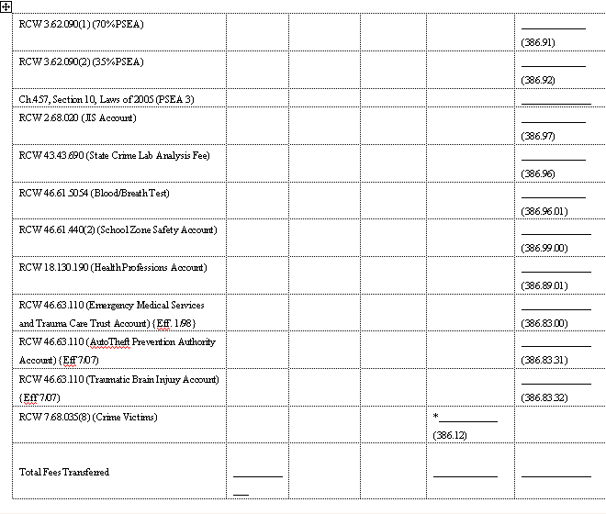

At the end of the transmittal form are total rows for each BARS code. The city/county treasurer will transfer the state remittance totals to the appropriate row of the State Treasurer’s Cash Receipts Journal Form A8.

INFRACTIONS

The infraction sections of the Clerk’s Revenue Transmittal Form require more complex calculations.

Use spreadsheet files for calculating distribution of payments for traffic infractions, school zone speeding violations, and non-traffic (civil) infractions.

Traffic Infractions

Payment Schedules

Non-JIS Court Infraction Payment Schedules are available at http://www.courts.wa.gov/newsinfo/index.cfm?fa=newsinfo.infractionPenalties.

On the next page is an illustration of one page from the green payment schedule for traffic infractions paid in full.

If the defendant pays $124, this is how to distribute the funds.
Further calculations are necessary before you can transfer these amounts to the Clerk’s Revenue Transmittal form.
Note the effective date. These schedules change whenever there is a penalty increase. Be sure you have the most recent set of schedules.

This is the schedule for traffic infractions.

Remittance Calculations
A Remittance Calculation Excel file performs the calculations necessary to provide you with totals for the Clerk’s Revenue Transmittal Form. See the illustrations that follow.

The Non-JIS Courts Remittance Calculations file is available at http://www.courts.wa.gov/newsinfo/index.cfm?fa=newsinfo.infractionPenalties.

Before using this Calculations spreadsheet:
Consult the green payment schedule and note the values in the row that matches the total payment you receipted.
Note the effective date. These spreadsheets change whenever there is a penalty increase. Be sure you have the most recent file.

This is a two step process. Step 2 is discussed next page.
Type the total amount paid.
Type the values from the green traffic infraction payment schedule.

In this example, the total payment was $124. The values in the yellow fields are from the $124 line on the green payment schedule.

See next page for Step 2.

After you enter the values for Step 1, the spreadsheet automatically calculates remittance amounts for this payment.
These boldface values match columns on the next worksheet
Scroll down the page to Step 2.

The results of the automatic calculations display in boldface type.
The boldface numbers and their labels also match fields on the Remittance Transmittal Form.
- Note that there are two worksheets for school zone speeding and two worksheets for non-traffic infractions.
- One worksheet calculates the distribution of a single payment. The Remittance worksheet totals all the payment distributions for that infraction type.
Manually copy the boldface values to the Traffic Remittance Summary worksheet available behind the Traffic Remittance tab.

- Print this page of Traffic Infraction calculations.
- Choose the Traffic Remittance tab.

On the Remittance Summary for traffic infractions, enter the boldface values from the automatic calculations on the previous worksheet.
The column headings match the labels from the previous worksheet. They also match the Clerk’s Revenue Transmittal form.
In the example below, there have been two payments:
- $124
- $560

This line is just a sample. It is not included in the totals.
Copy these values from the boldface values on the previous worksheet.
You can enter case number or name here.
When you are ready to remit, copy the totals to the Clerk’s Revenue Transmittal Form.

- Court staff will continue to enter calculation results as traffic infraction payments are made.
- When the court is ready to remit, court staff will copy the totals from this Remittance Summary page to the traffic infraction section of the Clerk’s Revenue Transmittal Form.

Transferring Totals to Clerk’s Revenue Transmittal Form

When you are ready to remit, transfer the traffic infraction totals from the Remittance Calculations file to the Clerk’s Revenue Transmittal Form.

In the example below, the court has transferred the totals from the Traffic Remittance Summary (see previous page) to the traffic infraction section of the Clerk’s Revenue Transmittal Form.

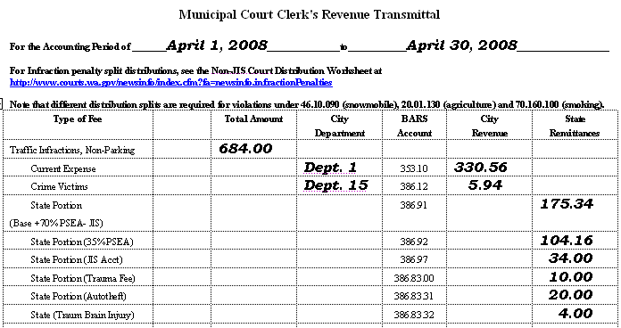

Summary – Traffic Infractions
- Find the payment amount on the green payment schedule.
  - Note the values in each column.
- Open the Non-JIS Courts Remittance Calculations file and click the Traffic Infraction tab.
- Enter the values from the green payment schedule into the yellow cells on this worksheet.
- Scroll down to Step 2.
  - Note the values in boldface type.
- Click the Traffic Remittance tab.
- Type the boldface values into the Traffic Infraction Remittance Summary.
- When you are ready to remit, enter the totals from the Traffic Remittance Summary into the non-parking traffic Infraction section of the Clerk’s Revenue Transmittal Form.

School Zone Speeding

Payment Schedules

The Non-JIS Court Infraction Payment Schedules include an orange schedule for school zone speeding violation payments.

- These schedules are available at http://www.courts.wa.gov/newsinfo/index.cfm?fa=newsinfo.infractionPenalties

Choose the orange tab at the bottom of the Excel file.

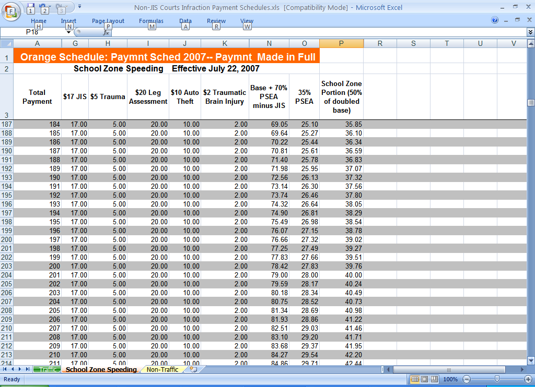

Below is an illustration of one page from this school zone payment schedule.

If the defendant pays $189, this is how to distribute the funds.
Further calculations are necessary before you can transfer these amounts to the Clerk’s Revenue Transmittal form.
Note the effective date. These schedules change whenever there is a penalty increase. Be sure you have the most recent set of schedules.

Remittance Calculations
- In the Remittance Calculations file, there are separate school zone worksheets for calculating values for the Clerk’s Revenue Transmittal Form. See the illustrations that follow. (The Non-JIS Courts Remittance Calculations File is available at http://www.courts.wa.gov/newsinfo/index.cfm?fa=newsinfo.infractionPenalties )

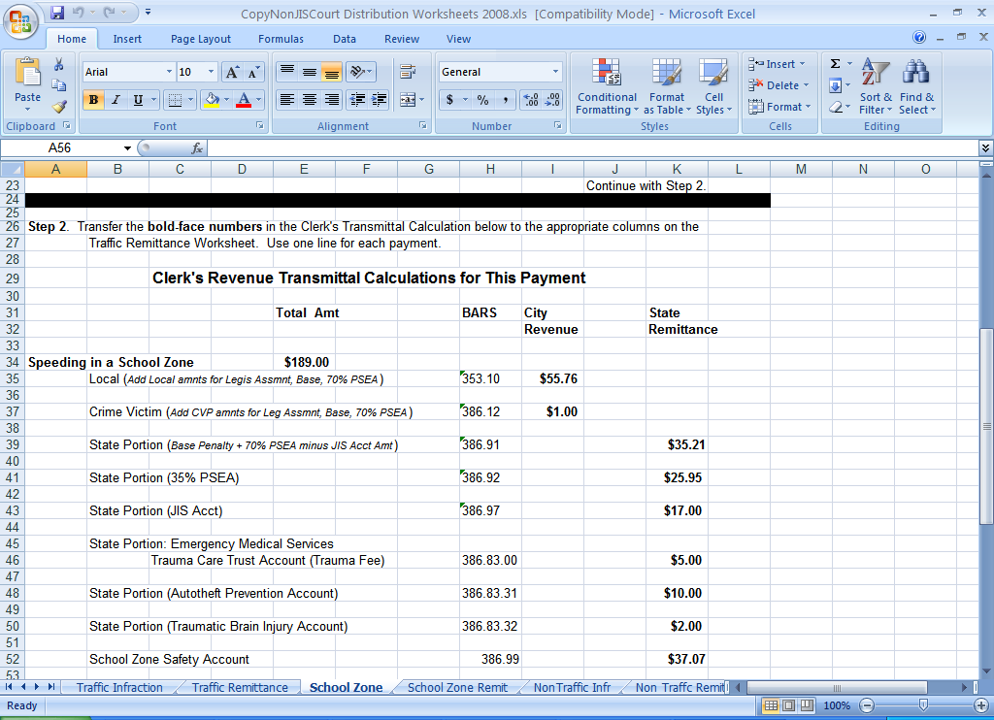

Before using this School Zone worksheet:
Consult the orange payment schedule and note the values in the row that matches the total payment you receipted.

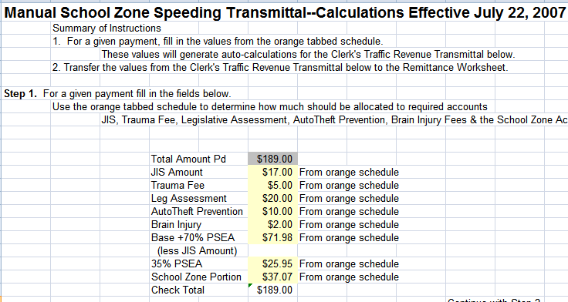
This is a two step process. Step 2 is discussed next page.
Type the total amount paid.
Type the values from the orange school zone payment schedule.

In this example, the total payment was $189. The values in the yellow fields are from the $189 line on the school zone speeding orange payment schedule.

See next page for Step 2.

After you enter the amounts for Step 1, the spreadsheet automatically calculates remittance amounts for this payment.

Scroll down on the page to Step 2.
These boldface values match columns on the next worksheet

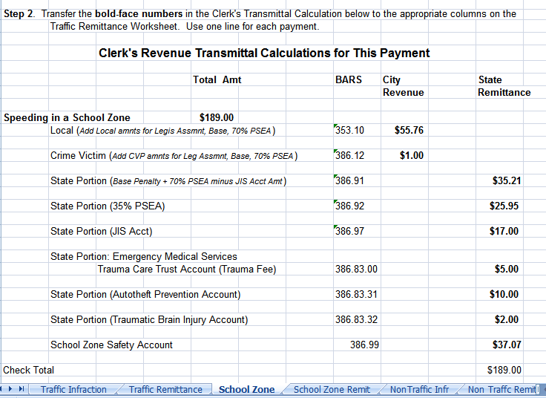
The results of the automatic calculations display in boldface type.
The boldface numbers and their labels also match fields on the Clerk’s Revenue Transmittal Form.

Manually copy the boldface values to the School Zone Remittance Summary worksheet available behind the School Zone Remit tab.

- Print this page of School Zone speeding calculations.
- Choose the School Zone Remit tab.

On the Remittance Summary for school zone speeding infractions, enter the boldface values from the automatic calculations on the previous worksheet.

In the example below, there have been two payments:
- $189
- $210
The column headings match the labels from the previous worksheet. They also match the Clerk’s Revenue Transmittal form.

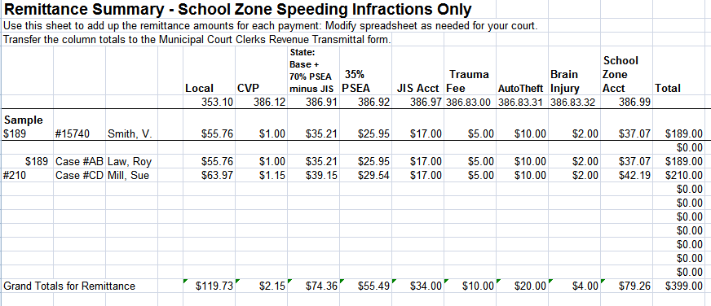
This line is just a sample. It is not included in the totals.
Copy these amounts from the boldface values on the previous worksheet.
You can enter case number or name here.
When you are ready to remit, copy the totals to the Clerk’s Revenue Transmittal Form.

- Court staff will continue to enter calculation results as school zone speeding payments are made.
- When the court is ready to remit, court staff will copy the totals from this School Zone Remittance Summary page to the school zone section of the Clerk’s Revenue Transmittal Form.

Transferring Totals to Clerk’s Revenue Transmittal Form

When you are ready to remit, transfer the school zone totals from the Remittance Calculations file to the Clerk’s Revenue Transmittal Form.

In the example below, the court has transferred the totals from the School Zone Remittance Summary (see previous page) to the School Zone section of the Transmittal Form.

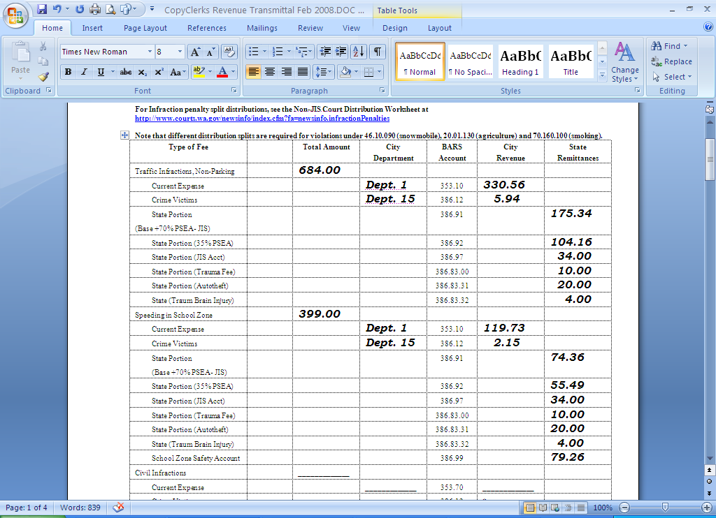

Summary – School Zone Speeding Infractions
- Find the payment amount the orange payment schedule.
  - Note the values in each column.
- Open the Non-JIS Courts Remittance Calculations file and click the School Zone tab.
- Enter the values from the orange payment schedule into the yellow cells on this worksheet.
- Scroll down to Step 2.
  - Note the values in boldface type.
- Click the School Zone Remit tab.
- Type the boldface values into the School Zone Remittance Summary.
- When you are ready to remit, enter the totals from the School Zone Remittance Summary into the School Zone section of the Clerk’s Revenue Transmittal Form.

Non-Traffic (Civil) Infractions

Payment Schedules

The Non-JIS Court Infraction Payment Schedules include a yellow schedule for non-traffic (civil) infractions.
- These schedules are available at http://www.courts.wa.gov/newsinfo/index.cfm?fa=newsinfo.infractionPenalties

For non-traffic infractions paid in full, select the yellow tab.
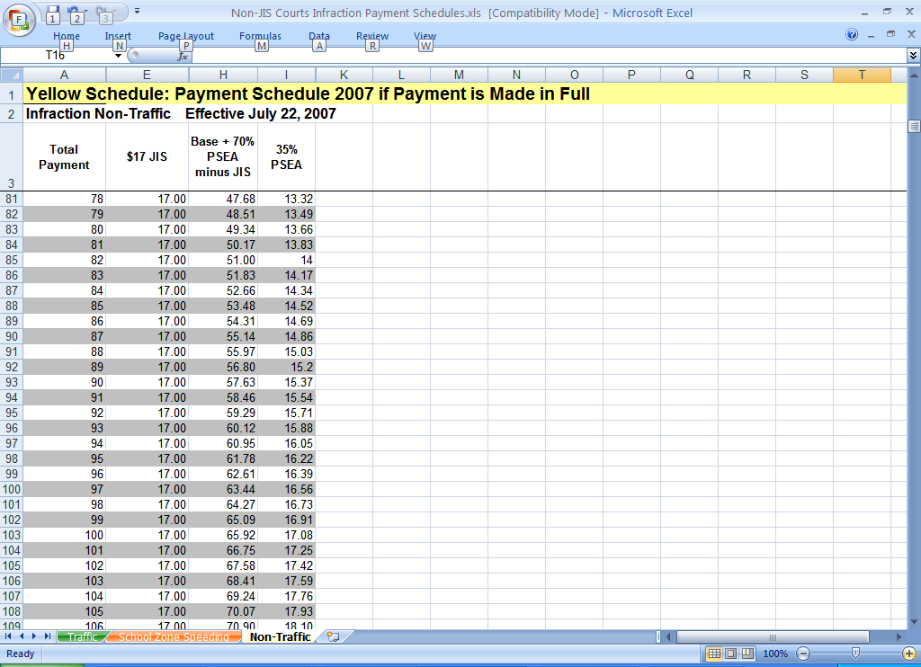
Below is an illustration of one page from this non-traffic payment schedule.
If the defendant pays $87, this is how to distribute the funds.
Note the effective date. These schedules change whenever there is a penalty increase. Be sure you have the most recent set of schedules.

Remittance Calculations
- In the Remittance Calculations file, there are separate non-traffic infraction worksheets for calculating values for the Clerk’s Revenue Transmittal Form. See the illustrations that follow. (The Non-JIS Courts Remittance Calculations File is available at http://www.courts.wa.gov/newsinfo/index.cfm?fa=newsinfo.infractionPenalties )

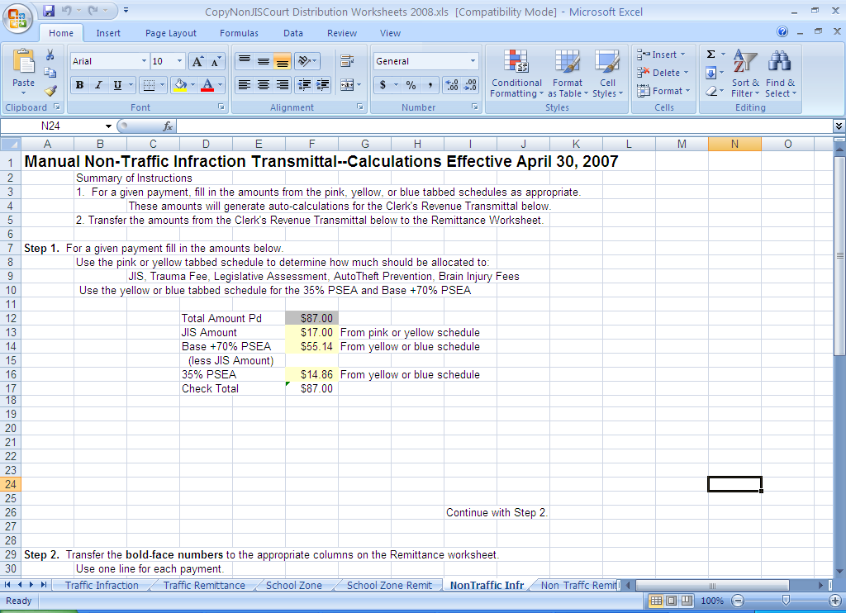

Before using this Calculations spreadsheet:
Consult the yellow payment schedule and note the values in the row that matches the total payment you receipted.

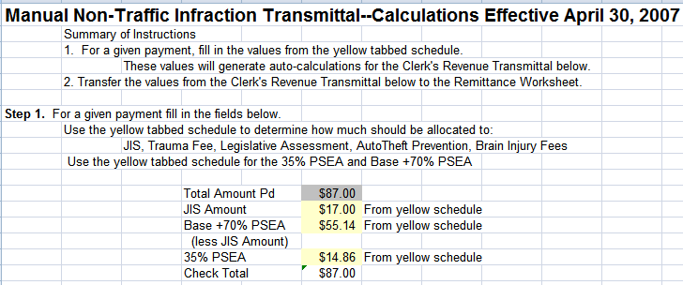
This is a two step process. Step 2 is discussed next page.
Type the total amount paid.
Type the values from the yellow non-traffic infraction payment schedule.

In this example, the total payment was $87. The values in the yellow fields are from the $87 line on the yellow non-traffic payment schedule.

See next page for Step 2.

After you enter the values for Step 1, the spreadsheet automatically calculates remittance amounts for this payment.

These boldface values match columns on the next worksheet
Scroll down the page to Step 2.
The results of the automatic calculations display in boldface type.

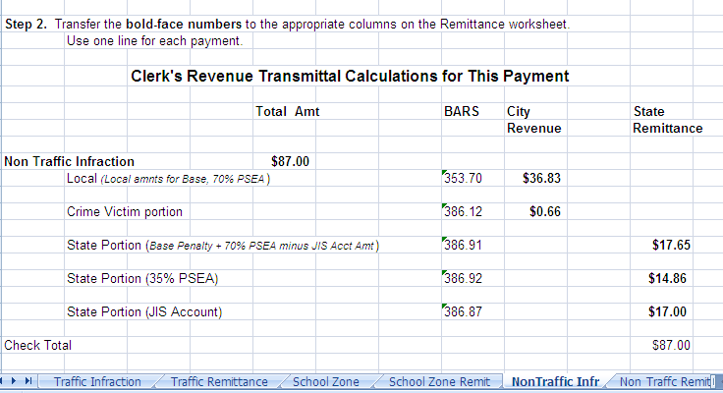
The boldface numbers and their labels also match fields on the Remittance Transmittal Form.

Manually copy the boldface values to the Non-Traffic Remittance Summary worksheet available behind the Non-Traffic Remit tab.

- Print this page of Non-Traffic Infraction calculations.
- Choose the Non Traffic Remit tab.

On the Remittance Summary for non-traffic infractions, enter the boldface values from the automatic calculations on the previous worksheet.
The column headings match the labels from the previous worksheet. They also match the Clerk’s Revenue Transmittal form.
In the example below, there have been two payments:
- $87
- $292

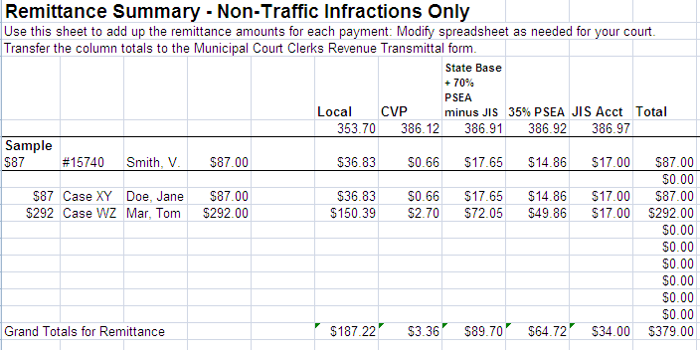
This line is just a sample. It is not included in the totals.
Copy these amounts from the boldface values on the previous worksheet.
You can enter case number or name here.
When you are ready to remit, copy the totals to the Clerk’s Revenue Transmittal Form.

- Court staff will continue to enter calculation results as Non-Traffic infraction payments are made.
- When the court is ready to remit, court staff will copy the totals from this Remittance Summary page to the Civil (non-traffic) infraction section of the Clerk’s Revenue Transmittal Form.

Transferring Totals to Clerk’s Revenue Transmittal Form

When you are ready to remit, transfer the non-traffic infraction totals from the Remittance Calculations file to the Clerk’s Revenue Transmittal Form.

In the example below, the court has transferred the totals from the Non-Traffic Remittance Summary (see previous page) to the Civil (Non-Traffic) Infraction section of the Clerk’s Revenue Transmittal Form.

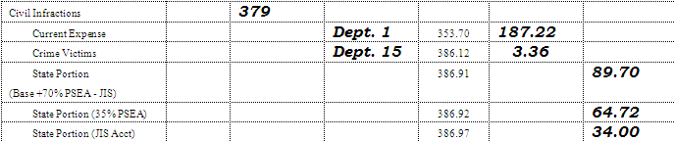

Summary – Non-Traffic Infractions
- Find the payment amount the yellow payment schedule.
  - Note the values in each column.
- Open the Non-JIS Courts Remittance Calculations file and click the Non-Traffic Infr(action) tab.
- Enter the values from the Yellow payment schedule into the yellow cells on this worksheet.
- Scroll down to Step 2.
  - Note the values in boldface type.
- Click the Non-Traffic Remit tab.
- Type the boldface values into the Non-Traffic Infraction Remittance Summary.
- When you are ready to remit, enter the totals from the Non-Traffic Remittance Summary into the Civil (Non-Traffic) Infractions section of the Clerk’s Revenue Transmittal Form.

Clerk’s Revenue Transmittal Form Totals
The last page of the Clerk’s Revenue Transmittal Form has totals for each revenue category and grand totals for local remittance vs. state remittance.

On the following pages are excerpts from a Clerk’s Revenue Transmittal Form, showing individual items and how they roll up to the totals page.
Distribution of payments received this month.

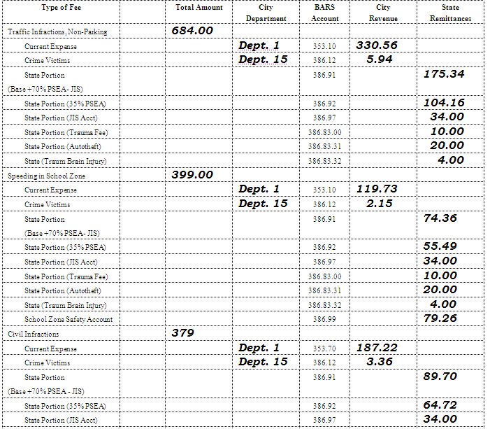
= = = = = = = = = = = = = = = = = = = = = = = = = = = = = = = = = = = =

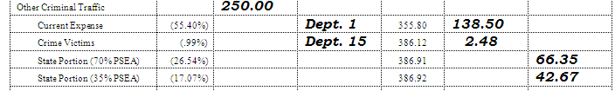

See next page for totals.
Totals from previous page.

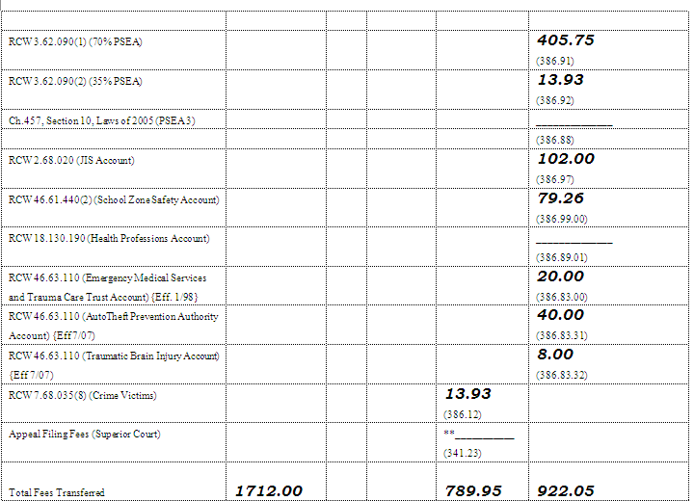

Note: You may have to round up or down by a penny to come out even. This is because many of the spreadsheet calculations involve rounding.

Partial Payments
Sometimes you may accept partial payments. The example below shows you how to use the Paid in Full worksheets for partial payments.

Example
In the following example, the court receives three payments from a traffic defendant.
- The first payment is $40.
- The second payment is $40.
- The third payment is $44.

Since this is a traffic infraction, the court uses the green “Traffic” schedule.

For the first $40 payment, the court uses the amounts on the $40 line:
  - $11.50: JIS Account
The court enters these values on the Traffic Infraction Remittance Calculations spreadsheet (see next page).
  - $5: Trauma Fee
  - $11.50: Legislative Assessment
  - $10: Autotheft Prevention
  - $2: Brain Injury

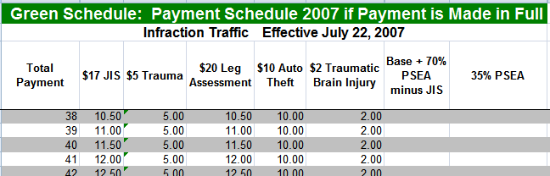

Below, the court has entered the values from the green schedule’s $40 line (previous page) onto the Traffic Infraction Remittance Calculation spreadsheet:

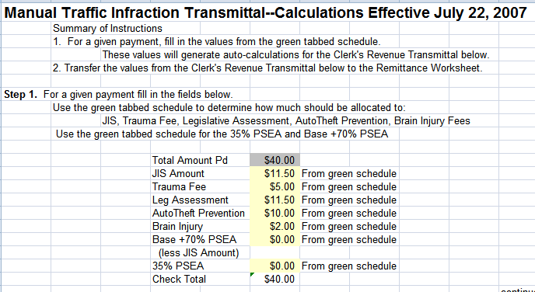
The court has entered values from the $40 line of the green schedule (see previous page).

See next page for the results of the automatic calculations.

The Remittance Calculations spreadsheet automatically calculates values for entry on the Traffic Infraction Remittance Summary worksheet.

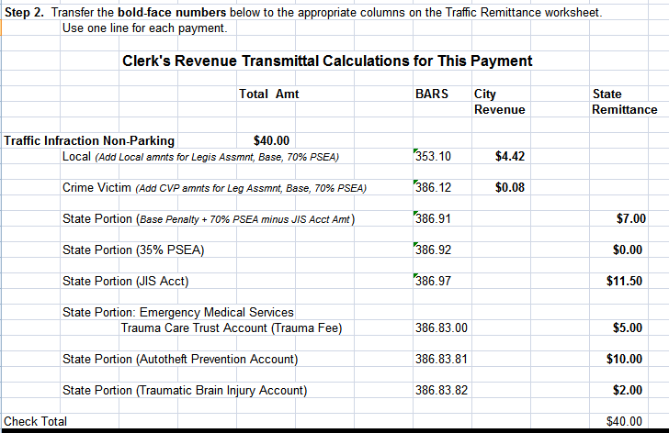
The Traffic Infraction Calculation worksheet automatically calculates values that the court will copy to the Traffic Remittance Summary worksheet.

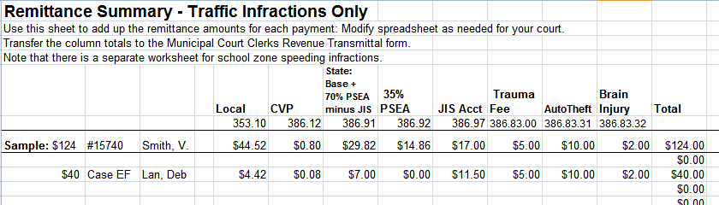

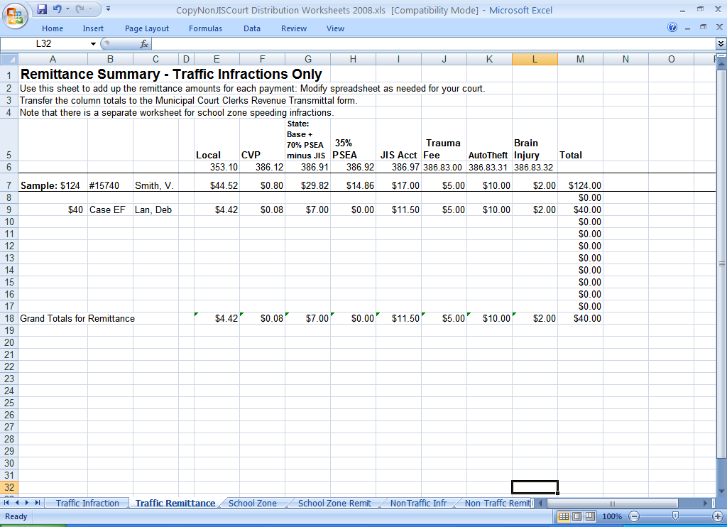

The court has copied the boldface values from the Traffic Infraction Calculations page to the Traffic Remittance Summary page.

The Defendant’s second payment is $40.

The court uses the $80 line of the green payment schedule. This line is the total of both payments. The court subtracts from the $80 line the amounts from the $40 line that were previously paid.

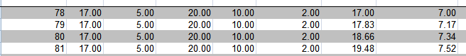

Differences
5.50 | 0.00 | 8.50 | 0.00 | 0.00 | 18.66 | 7.34

Below, the court has entered the differences (previous page) on the Traffic Infraction Remittance Calculations spreadsheet.

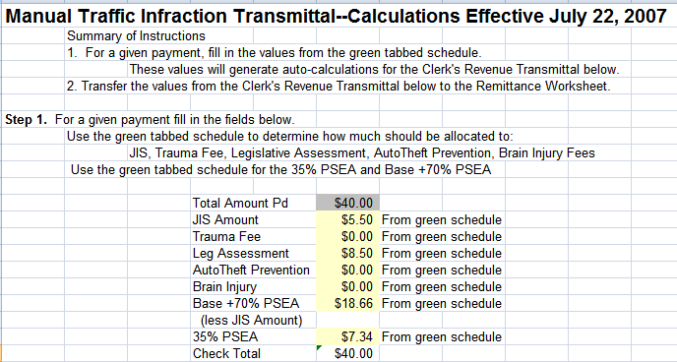
The court has entered the differences between the $40 and $80 lines from the green payment schedule.

See next page for the automatic calculation results.

The Remittance Calculations spreadsheet automatically calculates the values for entry on the Traffic Infraction Remittance Summary.

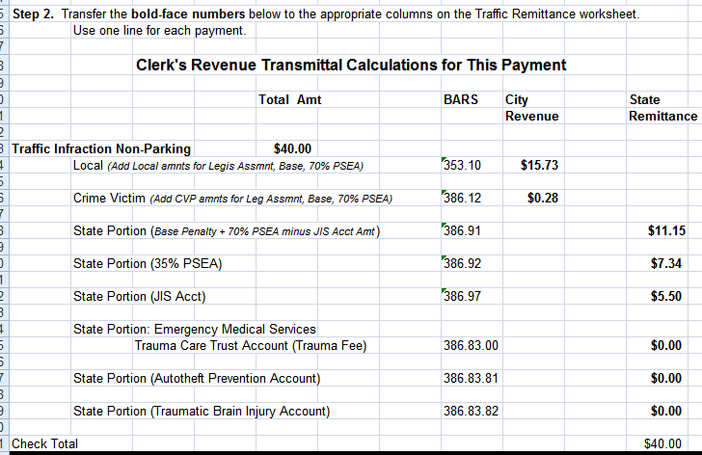
The Traffic Infraction spreadsheet automatically calculates values that the court will copy to the Traffic Remittance Summary.

The court enters the boldface values onto the Traffic Infraction Remittance Summary.

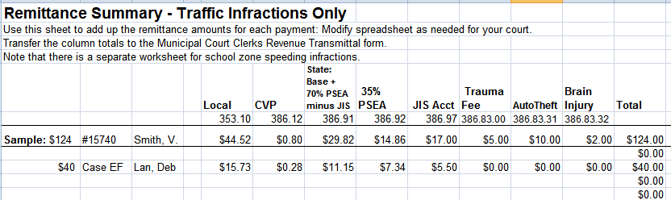

The court has copied the boldface values from the Traffic Infraction Calculations worksheet to the Traffic Remittance Summary worksheet.

See next page for the Defendant’s third payment.

The Defendant’s third and last payment is $44.

The court uses the $124 line of the green schedule. This line is the total of all three payments. The court subtracts from the $124 line the amounts from the $80 line. (The $80 line shows the distribution of all previously paid amounts.)

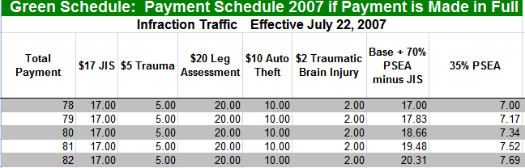

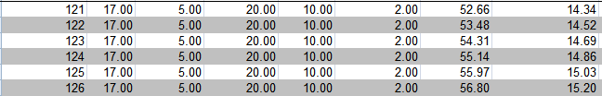

Differences
0.00 | 0.00 | 0.00 | 0.00 | 0.00 | 36.48 | 7.52

The court enters these Differences into the Remittance Calculations page for traffic infractions.

Below, the court has entered the differences (previous page) onto the Traffic Infraction Remittance Calculations spreadsheet.

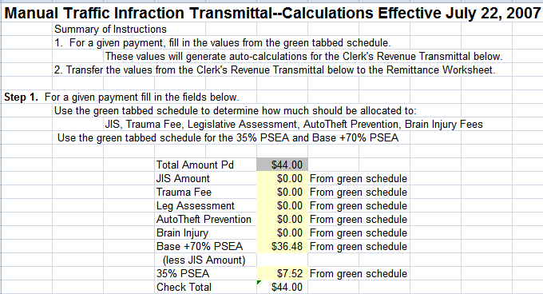
The court has entered the differences between the $80 and $124 lines from the green payment schedule.

See next page for the results of the automatic calculations.

The Remittance Calculations worksheet automatically calculates the values for entry on the Traffic Infraction Remittance Summary.

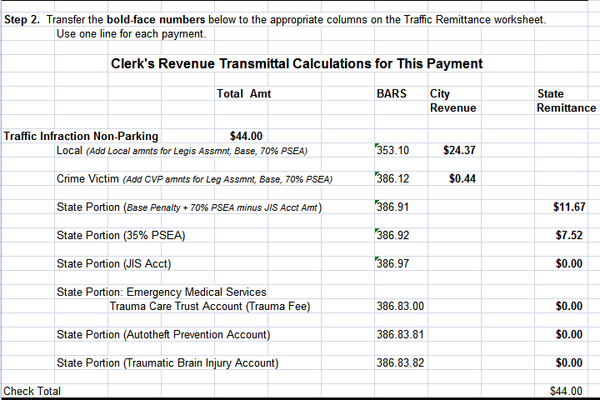
The Remittance Calculations worksheet automatically calculates values that the court will copy to the Traffic Remittance Summary page.

The court enters the boldface values on the Traffic Infraction Remittance Summary.

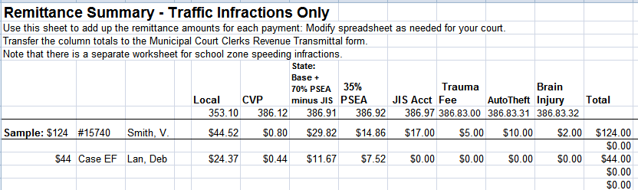

The court has copied the boldface values from the Traffic Infraction calculations page to the Traffic Remittance Summary.

APPENDIX

Revenue Accounts

BARS Code | Description
341.23 | Appeal Filing Fees (Local and Law Library portions)
341.32 | Clerk's Records Services (Local portion)
341.33 | District/Municipal Court Administrative Fees (Local)
341.62 | Copy/Tape Fees (Local portion)
342.33 | General Adult Probation Service Fees (Local)
342.36 | Housing/Monitoring Of Prisoners (Local portion)
342.90 | Criminal Conviction Fees (Local portion)
352.30 | Mandatory Insurance Administrative Costs (Local)
353.10 | Traffic Infractions (Local portion)
353.70 | Non-Traffic (Civil) Infractions (Local portion)
354.00 | Parking Infractions (Local)
354.00.01 | Disabled Parking (Local)
355.20 | DWI Violations (Local portion)
355.80 | Other Criminal Traffic Misdemeanors (Local portion)
356.40 | Boating Safety-Criminal Fines (Local)
356.90 | Other Non-Traffic Misdemeanors (Local portion)
357.30 | Court Cost Recoupments (Local)
357.31 | Jury Demand Costs (Local)
357.32 | Witness Costs (Local)
357.33 | Public Defense Costs (Local)
357.34 | Sheriff Services Costs (Local)
357.35 | Court Interpreter Costs (Local)
357.36 | Collection/Credit Card Costs (Local)
361.11 | Court Investment Revenue (Local)
361.40 | Interest Income (Local portion)
361.40.03 | District/Municipal Court Current Expense (Local portion)
386.12 | City Crime Victim Program (Local)
386.83 | State Emergency Medical Services & Trauma Care Trust Account (RCW 46.63.110)
386.83.31 | State Auto Theft Prevention Authority Account (RCW 46.63.110)
386.83.32 | State Traumatic Brain Injury Account (RCW 46.63.110)
386.88 | Equal Justice Sub-Account (PSEA 3, RCW 43.08.250)
386.89 | State Health Professions Account (RCW 18.13.190)
386.91 | State Public Safety and Education Account (PSEA 1, RCW 3.62.090(1)
386.92 | State PSEA 2 Account (35% Assessment, RCW 3.62.090(2))
386.94 | State Fish & Wildlife Enforcement Reward Account (RCW 77.21.070)
386.95 | Unclaimed Restitution (State portion) (RCW 7.68.290)
386.96 | Crime Lab Analysis (State portion) (RCW 43.43.690)
386.96.03 | State Crime Lab—Blood/Breath Testing (RCW 46.61.5054)
386.97 | State Judicial Information Services (JIS) Account (RCW 2.68.020)
386.98 | State Prostitution Prevention/Intervention Account (RCW 43.63A.740)
386.99 | State School Zone Safety Account (RCW 46.62.440 (2))
386.99.01 | School Zone Safety 7/03 to 4/07

Legislative Assessment ($20)

RCW 46.63.110 (8) establishes an additional $20 penalty on all traffic infractions except for construction zone violations (RCW 46.61.527):

(8)(a) In addition to any other penalties imposed under this section and not subject to the limitation of subsection (1) of this section, a person found to have committed a traffic infraction other than of RCW 46.61.527 shall be assessed an additional penalty of twenty dollars. The court may not reduce, waive, or suspend the additional penalty unless the court finds the offender to be indigent. If a court authorized community restitution program for offenders is available in the jurisdiction, the court shall allow offenders to offset all or a part of the penalty due under this subsection (8) by participation in the court authorized community restitution program.
(b) Eight dollars and fifty cents of the additional penalty under (a) of this subsection shall be remitted to the state treasurer. The remaining revenue from the additional penalty must be remitted under chapters 2.08, 3.46, 3.50, 3.62, 10.82, and 35.20 RCW. Money remitted under this subsection to the state treasurer must be deposited as provided in RCW 43.08.250. The balance of the revenue received by the county or city treasurer under this subsection must be deposited into the county or city current expense fund. Moneys retained by the city or county under this subsection shall constitute reimbursement for any liabilities under RCW 43.135.060.

The JIS Payment Schedules include a column for this $20 penalty. The Remittance Calculations spreadsheet calculates the distributions for this assessment and adds the appropriate amounts to the fields for local accounts and to the field for the State PSEA 1 account. You do not need to do anything beyond filling out the Remittance Calculations spreadsheet for traffic infractions. The calculations will be automatic.

If you are calculating this distribution manually, use the following percentages (effective July 22, 2007):
- 38.41% to the local current expense account.
- 0.69% to the local crime victims’ account.
- 60.9% to the state Public Safety and Education Account (70% PSEA, BARS 386.91).

Construction Zone Violations
The Non-JIS Payment Schedules do not, at this time, include a schedule for construction zone violations. If you receipt payments for construction zone violations, distribute the $20 that would have gone to the Legislative assessment as follows:
- 55.40% ($11.08) to the local current expense account.
- 0.99% ($0.20) to the local crime victims’ account.
- 26.54% ($5.31) to the state Public Safety and Education Account
(70% PSEA, BARS 386.91).
- 17.07% ($3.41) to the state Public Safety and Education Account
(35% PSEA, BARS 386.92).

