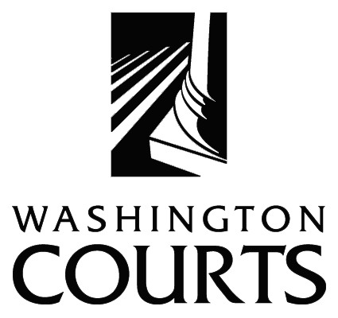

Unintended Consequences: Removing Obstacles to Justice for Immigrants in the Courts

45th Washington Judicial Conference, October 1, 2002.

FOREWORD
The purpose of Unintended Consequences: Removing Obstacles to Justice for Immigrants in the Courts, is to increase judicial officers’ understanding of immigration related issues and promote the fair administration of justice by improving the courts response to non-citizens in Washington State courtrooms. The curriculum provides an overview of:
- How cultural and language issues affect non-citizens in court.
- How criminal pleas and sentencing impact a non-citizen’s immigration and naturalization status.
- How judges can assist battered non-citizens petitioning for residency under amendments to the Violence Against Women Act.

The course is designed to provide a forum for judges to:
- Develop a fundamental understanding of immigration law.
- Identify important issues affecting immigrants.
- Determine what principles of law apply.
- Assess the social, moral, economic, and legal consequences of applying those principles of law.
- Develop a well reasoned approach to deciding the issues that arise involving immigrants in the courts.
- Avoid any unintentional consequences of courtroom decisions.

This program was adapted from Removing Obstacles to Justice for Immigrants: Educational Curriculum for Judges, a pilot program produced by the National Association of Women Judges. 1112 16th Street, NW, Washington, DC 20036, 202/393-0222, www.nawj.org. Their curriculum was supported by a grant from the State Justice Institute and the Soros Foundation.

SPONSORS
Washington State Gender and Justice Commission, Justice Barbara A. Madsen, Chair
Washington State Interpreter Commission, Justice Susan Owens, Chair
SCJA Equality and Fairness Committee, Judge Dean S. Lum, Chair
DMCJA Diversity Committee, Judge Marilyn G. Paja, Chair

Funding for this program was provided by the Gender and Justice Commission. For further information, contact Gloria C. Hemmen, Executive Director, 1206 Quince Street SE, P. O. Box 41170, Olympia, WA 98504-1170, 360/705-5290, gender.justice@courts.wa.gov.

