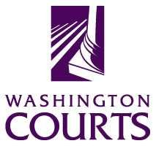
Judges in the Classroom

Claim Your Jurisdiction Game: One-Class Period

Source:
The concept for the game was originally created by New Mexico Law-Related Education, a program of the New Mexico Bar Foundation, and is used with their permission. It was updated in 2019 by staff at the Washington State Administrative Office of the Courts (AOC). For more information, contact AOC, Temple of Justice, 415 12th Ave SW, PO Box 41174, Olympia, WA 98504-1174. For an electronic copy of this lesson, or to view other lesson plans, visit Judges in the Classroom on the Washington Courts Web site at: www.courts.wa.gov/education/.

Objectives:
- Students will identify the levels within the judicial system.
- Students will identify the courts in the federal and state systems; students will then identify which court would handle a particular type of case.
- Students will list the differences between federal and state court jurisdiction.

Grade Level:
Grades 8-12

Time:
One class period (approximately 50 minutes)

Materials:
- Docu-Camera Slide 1 - Diagram of Federal and State Courts.
- One copy of Handout 1 (Federal and State Courts - Overview for Washington) for each student
- One copy of Handout 2 (Federal and State Courts - Vocabulary List) for each student
- A Guide to Washington’s Courts, 2011 edition.
- Eight signs saying "Claim" on one side and "Do Not Claim" on the other side
- Paper and markers for eight groups to make signs identifying their assigned court – Municipal Court; District Court with Small Claims Court; Superior Court; State Court of Appeals; Washington State Supreme Court; U.S. District Court; U.S. Circuit Court of Appeals for the 9th Circuit; and U.S. Supreme Court
- PowerPoint Slides—What do you know about courts?

Procedures:
- Begin the class by introducing yourself to the students, and telling a little bit about what you do, if this is your first class.
- Tell students they will play a game, after you review the structure of the court system with them. (Alternatively, the students can research an assigned court and make presentations about their court to the rest of the class, in advance of the judge’s visit.) Explain that the information you will give will be important in playing the game.
- Inform students that there are also tribal courts within the state. Ask how many tribes are recognized by the federal government within Washington? Within the boundaries of Washington State, there are 29 federally recognized Native American Indian tribes, several not federally recognized tribes, and several reservations. Once Native Americans were a people who possessed full sovereignty over their lands. After the conquest by the Europeans, Indians' status was drastically altered to one of semi-independence.

Today, Indian tribes are greatly controlled by the U.S. government, but they have remained "a separate people, with the power of regulating their internal and social relations." According to federal law, the tribes keep all aspects of independence that have not been terminated by Congress and that are not "inconsistent with their status as a dependent tribe." A tribe has the power to determine tribal membership, to regulate domestic relations among its members and to write rules for the inheritance of property. In addition, a tribe has the authority to enforce its criminal laws against its own members.

The Claim Your Jurisdiction Game does not include the tribal courts, but this would make an interesting extension activity for students to research. See www.tribal-institute.org/lists/jurisdiction.htm for information on tribal jurisdiction compared to federal and state jurisdiction.

- Put up docu-camera slide 1 or draw diagram on the board. Describe the structure of the federal and state courts to the class. The two court systems are composed of the federal and state court systems. The three levels of federal courts include the U.S. Supreme Court, the U.S. Courts of Appeals, and the U.S. District Courts.
Explain that the four levels of state courts include the Washington Supreme Court, the Washington State Courts of Appeals, superior courts, and the district courts and municipal courts.
- Begin by asking students:
What is the difference between a trial and an appellate court? Point out that trial courts hear testimony, consider the evidence, and decide the facts of the case. A trial court may sit with or without a jury. A trial in which just the judge hears the case without a jury is called a bench trial. Once a trial court has decided the case, the losing party may appeal the case to an appellate court.
- Write the word "jurisdiction" on the board. Ask the class what this word means.
Explain the derivation of the word "jurisdiction" is from Latin, "to say the law." When a court has jurisdiction of a case, that court has the power to hear that case. Original jurisdiction is the authority to consider and decide cases when the case is first brought to court, as distinguished from appellate jurisdiction, which is the authority to review a lower court’s decision.
Involve the students in the discussion as much as possible, by soliciting examples of cases they know or examples to which students can relate. Take about 15 minutes in total to describe the judicial system.

Federal Court System:
The federal courts are courts of limited jurisdiction. Article III, section 2 of the Constitution empowers the federal courts to hear only cases involving certain subject matters, certain persons, or occur in specific places such as military bases, Indian reservations, or federal property. This is called "subject matter jurisdiction" and "jurisdiction over the parties." Congress also has the authority to set limits on the jurisdiction of the federal courts.
Cases involving the following subjects may be heard by federal courts:
- cases arising under the United States Constitution;
- cases arising under the laws of the United States and treaties; and
- cases of maritime or admiralty jurisdiction (which means cases arising on the navigable waters of the U.S. or the high seas or directly related to maritime matters).

Cases involving the following parties may be heard by the federal courts:
- the United States and one of its officers;
- an ambassador or consul or official of a foreign government;
- one state suing another state, or a citizen of another state;
- citizens of a state, or a state itself, suing a foreign government or foreign citizen; and
- citizens of different states suing one another. This last type of jurisdiction is called diversity jurisdiction. Congress requires that more than $75,000 in potential damages be involved in the case before the federal court has this type of jurisdiction.

(There are a few other types of jurisdiction over parties, but these are the most common).
Cases occurring in certain locations are heard in federal court:
- Military bases
- Indian reservations, and
- Federal property, such as U.S. post offices, U.S. Courts.
Sometimes, state courts can hear cases that can also be heard in federal courts. This is called concurrent jurisdiction. State courts share jurisdiction of most of the above types of cases with the federal courts, except in certain areas where the federal courts have exclusive jurisdiction, such as a case involving an ambassador, patents and copyrights, or violations of certain federal laws.
So, for example, prisoners may sue state prison administrators for violation of their constitutional rights in either federal or state courts, because state as well as federal courts have the duty to apply the U.S. Constitution.
The federal court system consists of the United States Supreme Court at the top; the 13 U.S. Courts of Appeal; and the 94 U.S. District Courts. (There are also some specialized federal courts that are not included here.)
The U.S. district courts are the federal trial courts. Washington State has two federal district courts. One district court is for eastern Washington, with the main court office located in Spokane and court offices in Yakima and Richland. The second district court is for western Washington, with the main court office located in Seattle and another court office in Tacoma. The United States Court of Appeals for the 9th Circuit in San Francisco decides appeals from both United States District Courts in Washington, as well as from District Courts from many other western states and territories.
Generally, federal cases begin in the trial court, the U.S. District Court. Plaintiffs file their federal civil cases or diversity jurisdiction cases, and federal prosecutors file their federal criminal cases in U.S. District Court. Parties to cases that are dissatisfied with the outcome in U.S. District Court may appeal their cases to the U.S. Court of Appeals. The U.S. Supreme Court at the top of the court structure may be asked to review the decision of the U.S. Court of Appeals, through a petition for certiorari or in limited cases, by an appeal.
The United States Supreme Court receives about 8,000 petitions for certiorari each year. The loser in the case at a lower court petitions that the Supreme Court review the case, but the Court is not required to do so. The Supreme Court selects those cases that are very important to the country and where there may be differences of outcomes in the 13 United States Courts of Appeals. In recent years, the Supreme Court issues opinions in about 75-80 cases.
Article III of the Constitution allows the Supreme Court to hear some cases first (called original jurisdiction), such as with cases of ambassadors and consuls, between two or more states, between the United States and a state, or where a state sues the citizens of another state. However, the lower federal courts can also hear these cases since the Supreme Court’s jurisdiction is original but NOT exclusive. The one exception is cases in which states are suing other states. The only court that can hear state-against-state cases is the Supreme Court, but it can hear that case only if it passes a two-part test.

Washington State Court System:
The Washington Supreme Court, located in Olympia, is the state's highest court. The decisions of this court set the law for all the other state courts in Washington.
Generally, cases are appealed from superior court to the Washington State Court of Appeals in the appropriate division, and then to the Washington State Supreme Court. Sometimes though, a case has such broad public interest and requires a prompt and final decision by the Washington Supreme Court that it will go directly from Superior Court to the Washington State Supreme Court.
Appeals where the death penalty has been ordered go directly from the superior court to the Supreme Court. An appeal directly from superior court to the Washington Supreme Court is also permitted when the case involves a state official, when a trial court has ruled a statute or ordinance is unconstitutional, and when conflicting laws are involved.
The State Court of Appeals hears most cases appealed from Superior court. Each case is decided only after a transcript (written record of everything that was said in the trial proceedings in superior court – or a video recording) is reviewed and oral and written arguments, called briefs, have been considered. No witnesses testify in appeals cases.
The State Court of Appeals is divided into three divisions and each division serves a geographic area of the state.
Superior courts or courts of general jurisdiction are found in each of Washington's 39 counties. These trial courts have the authority to hear all types of civil and criminal cases and to act as appeals courts for cases from district and municipal courts. They are the only state courts that can hold trials for civil cases involving over $100,000; title or possession of land (real property); legality of a tax, assessment, or toll; probate and domestic relations matters; felonies; and appeals from district and municipal courts. Juvenile matters are heard by a division of the Superior courts. Because there is no limit on the civil and criminal cases they may handle, they are called general jurisdiction courts.
Courts of limited jurisdiction include district courts (small claims is a division of the district court) and municipal courts; these courts can only hear certain types of cases. However, courts of limited jurisdiction hear seven out of every eight legal cases (excluding parking infractions) filed in state court. This is mainly because traffic violations and misdemeanor cases are heard in these courts.
District courts hear misdemeanors, gross misdemeanors, and infractions from the county and municipal courts hear misdemeanors, gross misdemeanors, and infractions occurring in the cities. Examples are driving under the influence (DUI), hit-and-run, and driving with a suspended license. Persons convicted in limited jurisdiction courts may be sentenced up to $5,000 in fines, a year in jail, or both. Courts of limited jurisdiction may also hold preliminary hearings for felony cases.
District courts and municipal courts also have jurisdiction over civil traffic infractions, such as speeding, inattentive driving, texting/calling while driving. The maximum penalty for traffic infractions is a monetary fine; no jail penalty may be imposed. District and municipal courts may also issue domestic violence and anti-harassment protection orders. They may also hear change-of-name petitions and certain lien foreclosures.
District courts may hear civil matters such as personal injury or property damages and contract disputes in amounts up to $100,000. Municipal courts in communities of 400,000 or more may have jurisdiction over additional types of cases if authorized by a municipal ordinance.
The small claims division of the district courts is limited to money claims of $5,000. People represent themselves without attorneys and witnesses generally cannot be compelled to come to court.
Municipal courts hear anti-harassment protection orders if they adopt a court rule allowing them to do so.
- Announce to the class that you will now play a game. Divide the class into the following eight groups (or modify the groups for your area). Give each group a group number and ask each group to make a sign identifying its court by name and number.
- Municipal Court
- District Court with Small Claims Division
- Superior Court
- Washington State Court of Appeals
- Washington State Supreme Court
- U.S. District Court
- U.S. Ninth Court of Appeals
- U.S. Supreme Court

Pass out the "Claim" and "Do Not Claim" signs.
- Explain that you will describe a number of cases. Each group will caucus and decide whether their court has jurisdiction to hear that case. After one minute, ask the groups to hold up their signs either claiming or not claiming jurisdiction of the case. Teams get three points for correctly claiming jurisdiction, one point for correctly not claiming jurisdiction, and a minus three points for incorrectly claiming or not claiming jurisdiction.
- Have the teacher keep track of the score on the board, using a grid:
SCORE
Case | U.S. Supreme Ct | U.S. Ct of Appeals | U.S. District Ct | Etc.
a.
b.
c.
d.

Use most of the rest of the class period on this activity.
Conclude the class by asking students to find a court case in the newspaper or Internet and have them identify which court it is in.
**************************************

CASES AND ANSWERS
- Martha shoots and kills her husband in Washington State. The state prosecutor brings charges in which court?
Answer: Superior court. Since the state prosecutor is bringing the charges, the case is in a Washington court that hears felonies. Note that if the case had been brought by an Assistant U.S. Attorney, the federal prosecutor, it would be because the person killed was a federal officer or the killing took place on federal property, such as a military base.
- Larry's landlord refuses to return his damage deposit of $850 when Larry moves out of his apartment, even though the apartment is in excellent condition. Larry wants to sue his landlord, but doesn't want to hire a lawyer. In which court can Larry file suit?
Answer: District court (small claims division). Landlord-tenant issues are state issues and when the amount in question is less than $5,000, the case would go to district court’s division of small claims.
- Frank has been convicted of murder in superior court and his sentence is the death penalty. He appeals his case to which court?
Answer: Washington State Supreme Court. Generally, appeals from state superior courts go to the State Court of Appeals for the division that that specific superior court is in. However, because the most serious penalty, the death penalty, has been ordered, the case will skip the State Court of Appeals and go directly to the State Supreme Court. In Washington State in 2018, the State Supreme Court ruled that the death penalty as currently carried out is unconstitutional. The court stated that the death penalty was applied in an arbitrary and racially biased way. State v. Gregory, 192 Wash.2d 1.
- Some parents with their children file a lawsuit against the state for failing to make ample provision for the education of all children residing with its borders as required by the Washington State Constitution. Which court will they file in?
Answer: Superior Court. This is the trial court of general jurisdiction. The McCleary case, which dealt with this issue, was filed in the King County Superior Court in 2007.
- The Superior Court Judge ruled in favor of the parents along with their children that the state had failed in making ample provision for the education of all students, in violation of the Washington Constitution. Which court hears the State’s appeal?
Answer: The Washington State Supreme Court heard the appeal. Even though the normal route is to go to the State Court of Appeals (in this case it would have been Division I), this case was deemed to present a fundamental and urgent issue of broad public import which requires a prompt and ultimate determination by the State Supreme Court and so it went directly to the State Supreme Court.

- The State of Washington filed a lawsuit against President Donald Trump claiming that the President’s executive order to ban certain groups of individuals entering the United States violated the Constitution. What court would hear this case?

Answer: United States District Court. The federal court has jurisdiction over the Immigration and Naturalization Act and actions of the President.

- Sara, who is 25 years old, is arrested for a small amount of marijuana in her purse. Which court would her case be in?

Answer: Since marijuana possession is legal under state law, this must have been possession in a federal location, such as a national park or federal building. This case would be in U.S. District Court. There is speculation that certain local law enforcement may choose to ignore state law and arrest individuals for small amounts of marijuana possession, claiming their right under federal law. This interpretation by local law enforcement is not likely to be upheld by the courts.

- A non-profit corporation opposed to United States support for Israel submitted an ad to run on the outside of county buses. After initially agreeing to accept the ad, the bus system rejected the ad saying it would likely result in vandalism and violence. In what court should the non-profit corporation file its case to claim a violation of free speech?
Answer: This case could be filed in either the U.S. District Court or the Superior Court.

- After the non-profit lost its case to run the ads on the buses, to what court should it appeal?
Answer: If the case were filed in the U.S. District Court, it would go to the 9th Circuit Court of Appeals; if it was filed originally in the Superior court, it would go to the State Court of Appeals.

- Martha appeals her conviction in superior court for murder in the second degree to which court?
Answer: Washington State Court of Appeals. This is the normal appeals route in state court.
- Alice Singer sues a famous band for stealing her song and violating her copyright in which court?
Answer: United States District Court. The federal court has exclusive jurisdiction over copyright cases, so the case will be filed in the federal court.
- Kelly is cited for her disruptive behavior on a city bus. Which court will hear her case?
Answer: Municipal court. Her citation was issued within a city, so that the city court, the municipal court, will hear her case.
- Yolanda was in a car accident in which she injured her neck. She sues the driver of the other car for $90,000 in which court?
Answer: District court. Civil cases in which the amount is under $100,000 are brought in state district court. If the other driver were from a different state, the case could be brought in U.S. District Court. This would be federal diversity jurisdiction.
- Regina is charged with a misdemeanor of fourth degree assault in which court?
Answer: District court or municipal court. Both district and municipal courts have jurisdiction over misdemeanors. Depending upon where the assault occurred, it will be brought as a case in district or municipal court.
- Arnold was convicted of burglary in the first degree by a jury in superior court. He appeals his conviction to which court?
Answer: Washington State Court of Appeals. This is the normal appeals route for state convictions in superior court.
- The United States District Court rules that the state initiative to terminate mandatory busing violates the equal protection clause of the United States Constitution. The state of Washington appeals to which court?
Answer: United States Courts of Appeals for the Ninth Circuit. This is the normal appeals route for cases decided by the federal trial court.
- The United States Courts of Appeals upholds the United States District Court’s ruling that the state initiative to terminate mandatory busing is unconstitutional. The state asks which court to review the decision?
Answer: United States Supreme Court. The state may ask the highest court to review this decision. This is a discretionary on the part of the U.S. Supreme Court whether to take this case. The federal courts have jurisdiction in this case because it is an interpretation of the U.S. Constitution.
- A superior court judge rules that the state law against cross burning is unconstitutional. The prosecutor appeals this decision to which court?
Answer: Washington State Supreme Court or Washington State Court of Appeals.
The usual route of appeal from the superior court is to the state Court of Appeals. In certain cases where a speedy resolution is warranted, the state Supreme Court will hear the appeal directly. Note this case could have been brought in the federal court system, as both the state and federal courts have the duty to uphold the U.S. Constitution.
- Jesse is arrested for driving while intoxicated within the city limits of a large city. In which court is he charged?
Answer: Municipal court or district court. Generally, if arrested within the city limits, the case will go to municipal court.
- Elizabeth, who lives in Seattle, crashes her car into Juan’s sports utility vehicle, causing injuries and damages of $120,000. Juan, who is from Oregon, files a lawsuit in which court?
Answer: United States District Court or superior court. The federal trial court can hear this case because of diversity jurisdiction – the parties are from different states and more than $75,000 is being claimed in damages. Also, the superior court can hear cases where the amount of damages is $100,000 or more.
- Disabled individuals appeal a jury verdict that a movie theater did not violate their rights under the federal Americans with Disabilities Act. In which court is the appeal filed?
Answer: United States Courts of Appeals or the Washington State Court of Appeals. The federal courts have jurisdiction because the claim is being brought under a federal statute (law passed by Congress). However, state courts have concurrent jurisdiction with federal courts over ADA claims.
- Inmates ask this court to review their case from the state’s Supreme Court, claiming that the jail failed to provide them with basic human needs.
Answer: United States Supreme Court. The next level court from the state’s highest court is the U.S. Supreme Court.
- The state Court of Appeals overturns Austin’s conviction for selling drugs, based on an illegal search and seizure. The state asks which court to review the decision?
Answer: Washington State Supreme Court. The next level of review is with the Washington State Supreme Court. However it is a discretionary court of review and does not have to hear the case.
- Maya is cited for sitting on the sidewalk in violation of a local ordinance. In which court will her case be tried?
Answer: Municipal court. This is a violation of a local ordinance passed by a municipality, so her violation will be in Municipal Court.
- T’Andre, who is 14, is charged with theft of a smart phone in which court?
Answer: Superior court (juvenile division). Juveniles are generally tried in a division of the superior court, called the juvenile division. Some juvenile cases because of the age and seriousness of the offense may be tried as adults in the regular superior court.
***************************************
- Conclude the lesson by allowing time for questions. If time permits, explain to students how your court fits within the state court system.

Docu-Camera Slide 1

FEDERAL AND STATE COURTS – OVERVIEW FOR WASHINGTON

 |  | United States Supreme Court
United States Courts  of Appeals |  |  | Washington State  Supreme Court
Washington State Court
of Appeals
 |  |  | Superior Courts
United States District Courts
 |  |  | District Courts with Small Claims | Municipal Courts
Federal Cases |  |  | Local and State Cases

Handout 1

Federal and State Courts – Overview for Washington

Federal Court System
THE U.S. SUPREME COURT
- Appeals and discretionary review of cases involving
- the Constitution, federal laws and treaties, admiralty and maritime laws
- the United States as a party
- disputes between states
- controversies between citizens of different states when the amount involved is over $75,000
- controversies between citizens of the same state claiming lands under grants of different states
- controversies between a state or its citizens and foreign states or citizens
- Cases involving federal officers or that occur on military bases, Indian
reservations, or federal property
- Trials involving ambassadors and consul or involving civil lawsuits brought by or against a state.
UNITED STATES COURTS OF APPEALS
- Appeals from U.S. District Court
- Same as above, only no jurisdiction over cases by or against a state or involving ambassadors or consults
UNITED STATES DISTRICT COURTS
- Trial Court
- Same as above, only no jurisdiction over cases by or against a state or involving ambassadors or consults

Handout 1 (Page 2)
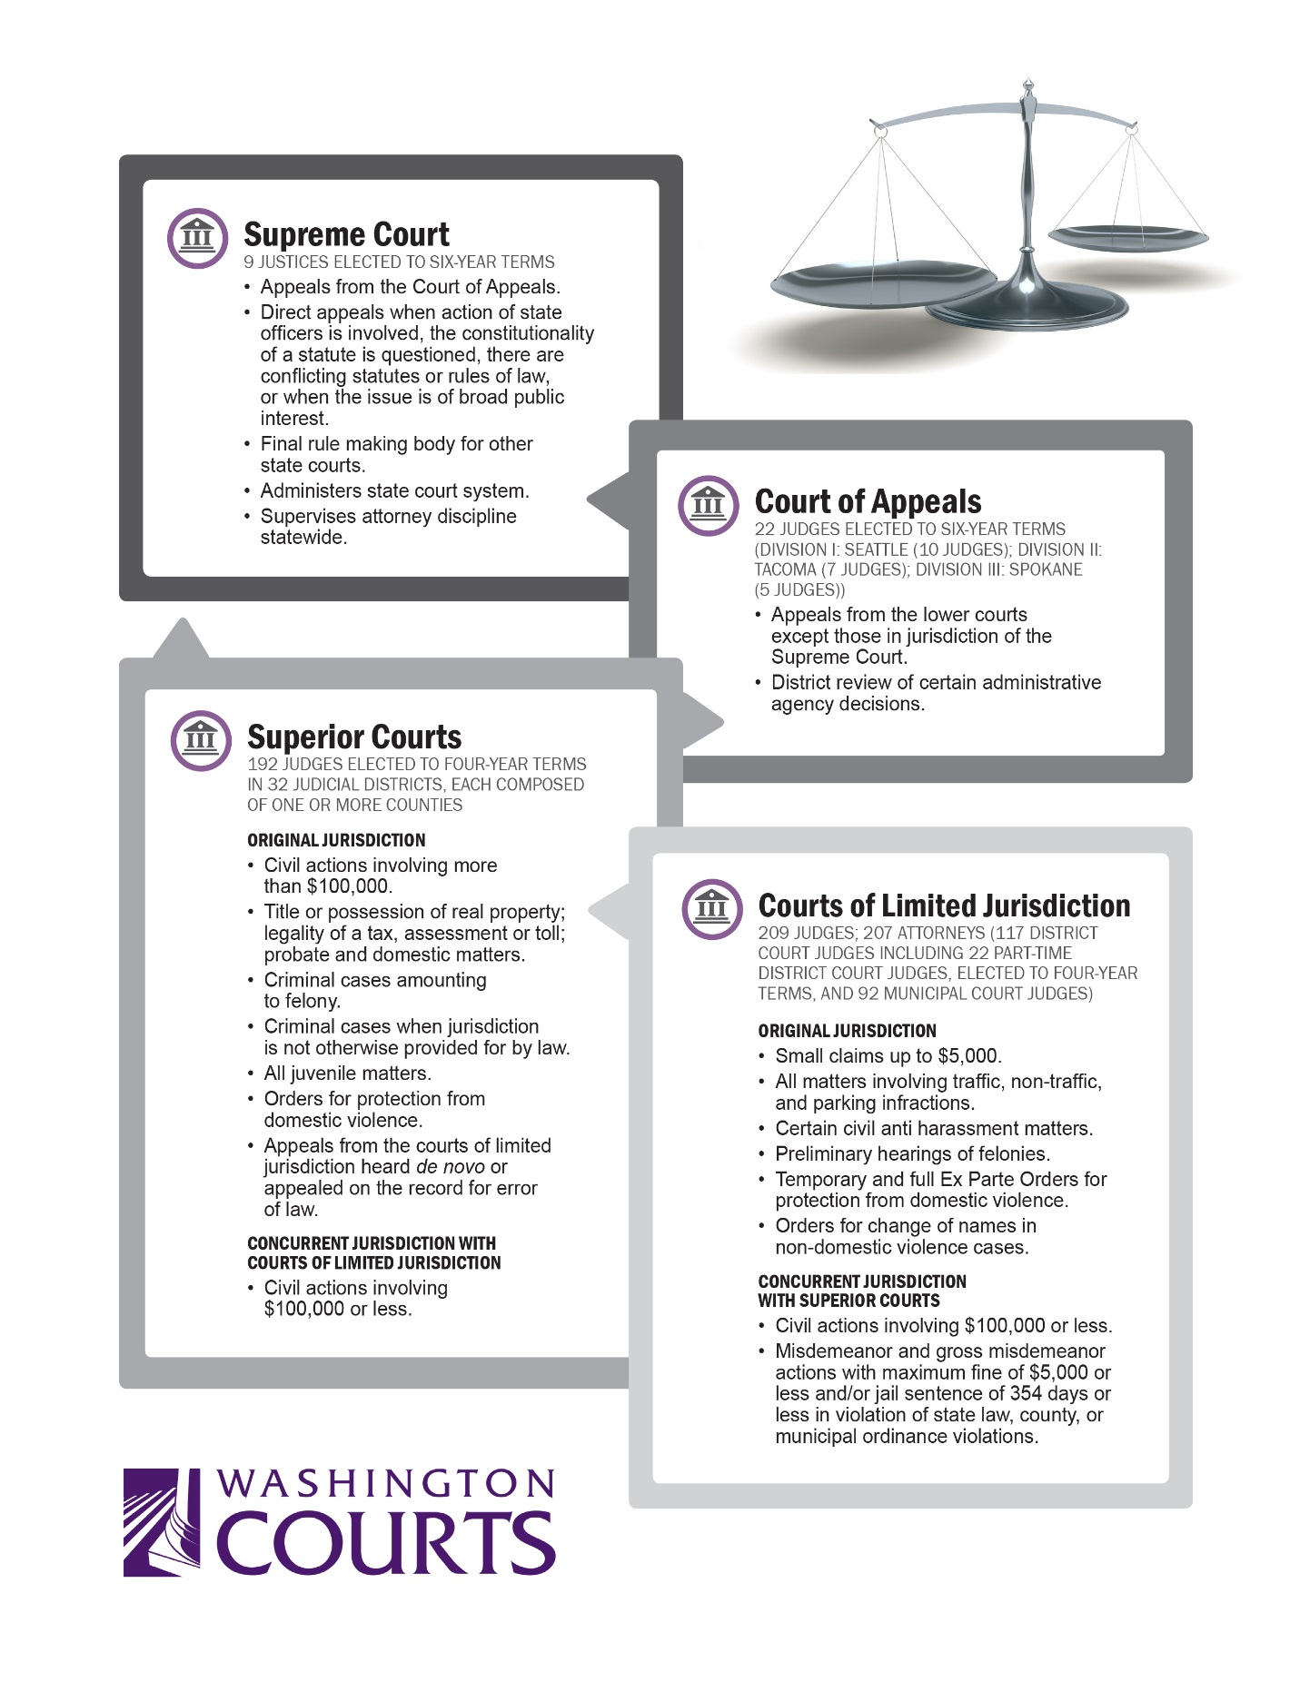

Handout 2

Federal and State Courts – Vocabulary List

Appellate court—A court that has jurisdiction or the power to hear cases that have been appealed from a lower court. An appellate court reviews whether the correct law was applied in a case.
Bench trial—A trial in which there is no jury; rather, the judge hears the evidence and decides the facts of the case.
Brief—A written statement submitted by an attorney to the court that presents the law and facts supporting his or her side of the case.
Civil cases—All areas of law that do not involve criminal matters. Examples of civil matters are suits regarding contracts between two parties, suits to recover money for personal injuries, and actions in domestic relations (issues relating to families like divorce and child custody).
Criminal cases—A legal action brought by the government (state, federal or local) charging a person with committing a crime.
Jurisdiction—The authority of a court to hear and decide a case. Some courts have "general" jurisdiction, which means they may hear all types of cases; other courts have "limited" jurisdiction, which means they may only hear certain types of cases.
Jury—A specific number of persons (usually 6 or 12) who hear the evidence at a trial and render a verdict.
Transcript—The official record of what was said during a trial or hearing. The transcript is prepared by a court reporter. Some trials are videotaped and the videotape serves as the transcript, unless it is very lengthy.
Trial court—The court that initially hears the evidence in a case, usually through the testimony of witnesses and introduction of documents and other tangible evidence. The trial court decides the facts in the case.
Verdict—From Latin "to speak the truth." The formal decision made by a jury or judge after hearing all the evidence in a trial.

Claim

Do Not Claim

