

The Courts – High School Level

Safe Employment

Source:
Staff at the Washington State Administrative Office of the Courts (AOC) authored the lesson. For more information, contact AOC, Temple of Justice, 415 12th Ave SW, PO Box 41174, Olympia, WA 98504-1174. For an electronic copy of this lesson, or to view other lesson plans, visit Judges in the Classroom on the Washington Courts Web site at: www.courts.wa.gov/education/.

Objectives:
- Students will analyze a fact pattern and make arguments regarding the interpretation of the law.
- Students will be able to present an appeals case and be able to describe at least four characteristics of an appeal.

Grade Level:
Grades 5-12

Time:
One to two class periods (approximately 50 to 100 minutes)

Materials:
Handout 1—Questions While Watching the Video (one per student).
Video: Supreme Justice, a 25-minute TVW production developed in part with a grant to
AOC from the State Justice Institute, and available on the Internet at
https://www.tvw.org/watch/?eventID=1998121025.
Handout 2—Instructions for Group 1 (Kevin - for one third of the class).
Handout 3—Instructions for Group 2 (Loomis - for one third of the class).
Handout 4—Instructions for Group 3 (Judges - for one third of the class).

Procedures:
- Tell students that today’s class will begin with a video about the Washington State Supreme Court. Prior to showing the video, pass out Handout 1 to students. Tell students that as they watch the video, they should look for answers to the questions. They will have time immediately after the video to write them down, or they may jot down answers as the video is playing.
- Show part of the video, stopping the video before the Court’s opinion is given. (A suggested stopping time is after the narrator says, “The process can take weeks or months.”) Give students time to write down their answers after that portion of the video is finished.
- Discuss the questions.
Answers to Handout 1:
- What happened to Kevin Gardner? Kevin Gardner lost his job as a guard and driver of an armored car after he violated a rule at work, which said that drivers could not leave their vehicles under any circumstances.
- Who was Loomis Armored Inc.? Kevin Gardner worked for Loomis Armored Inc., a company that transported large amounts of money in its armored trucks.
- What rule did Loomis have about drivers getting out of their armored vehicles? Loomis had a rule that drivers could not leave their vehicles unattended under any circumstances.
- Why did Loomis have this rule? Loomis had this rule in order to keep its drivers safe. The law requires that employers provide a safe and healthy place to work. Transporting large amounts of money is dangerous and criminals use ruses or tricks to lure drivers out of their trucks in order to steal money.
- Why did Kevin Gardner disobey this rule? Kevin could not stand by and watch a woman be stabbed.
- Select a quote from the video that you find compelling. Students’ answers will vary.
- Explain to students that they are going to have a chance to make arguments in a court, just as they did in the video. Explain that the students will be assigned to argue either for Kevin or Loomis, or they will be assigned to be judges. Each side will have four minutes to make its arguments, with a one-minute rebuttal by each side. Since Kevin filed the case, he is the plaintiff in this case and will make his four-minute argument first. Loomis is the defendant and will go second.
- Divide the class into three equal groups assigning group 1 to argue for Kevin Gardner, group 2 to argue for the Loomis, and group 3 will serve as judges.
- Further divide groups 1 and 2 into smaller groups of up to five students. Group 3, the judges, should remain as one large group. Pass out one copy of Handout 2 to each of the smaller groups in group 1 (Kevin), pass out one copy of Handout 3 to each of the smaller groups in group 2 (Loomis), and pass out Handout 4 to group 3 (judges).
- Ask each small group in groups 1 and 2 to pick someone to be the lead attorney to make arguments for their group. Give the class ten minutes for each group to write out all the arguments that support their side. Have them think about the other side’s arguments and how they will respond to those arguments.
At the same time, have group 3 pick a chief justice. Additionally, they should pick a justice to keep track of the time (four minutes per side with one minute of rebuttal per side). They should also write out as a group at least four questions for Kevin’s side and four questions for Loomis’ side.
After the ten minutes of preparation time, ask the lead attorneys from all the small groups in group 1 (Kevin) to meet together for five minutes and divide up the arguments that they came up with. Each lead attorney should make at least one argument to the court.
At the same time, have the lead attorneys from each of the small groups in group 2 meet together for that same five minutes and divide up the arguments that they came up with. Each lead attorney should make at least one argument to the court.
- While groups are preparing, bring seats to the front of the room for all the judges in group 3.
[Alternatively, after the preparation, students can be grouped into triads consisting of an attorney for Kevin Gardner, an attorney for Loomis, and a judge for each group. Under the triad strategy, several arguments take place throughout the classroom and the several judges each make a ruling and report back to the entire class. One helpful strategy for judges is to have them decide what argument was strongest for Gardner and what argument was strongest for Loomis.]
- Conduct the hearing. Judges should be instructed to ask their questions of each side.
Arguments are many and may include:
For Kevin (plaintiff): It goes against human nature to sit back in safety while another person is being killed in front of them. The moral thing for Kevin to do is to go to the aid of another who is about to be killed. While the rule has a good intent, there should be some discretion in applying the rule and Kevin should not be fired. Washington has a policy that encourages citizens to go to the assistance of someone in trouble. This policy should override the employer’s rule as applied to Kevin.
For Loomis: The purpose of the rule to remain in the truck is to keep employees safe. Due to the nature of this industry, it is a common practice of criminals to lure truck drivers out of the armored trucks in order to steal the large amounts of money in the trucks. Washington law requires that employers provide a safe working environment for its employees. Additionally, this rule was included in the agreement negotiated by the union. Kevin Gardner was a union representative who helped negotiate the agreement.
It would be a very bad policy to fire employees when the employee got out of the truck and was wrong, that is, that it was a trick of the robbers and not to fire the employee in cases where the employee was right and saved someone’s life from a real threat.
Kevin had other options: He could have called for help, used his two-way radio, called over the public address system, and turned on the sirens.
- After the students have made their arguments, have the judges decide the case. Depending upon how much time you would want to spend on this activity, you could have all students write out their decision, citing the arguments that they found persuasive.
- Conclude by showing students the end of the video, and ask students for their reactions. Identify with students what arguments seemed most and least persuasive to the justices.

Handout 1

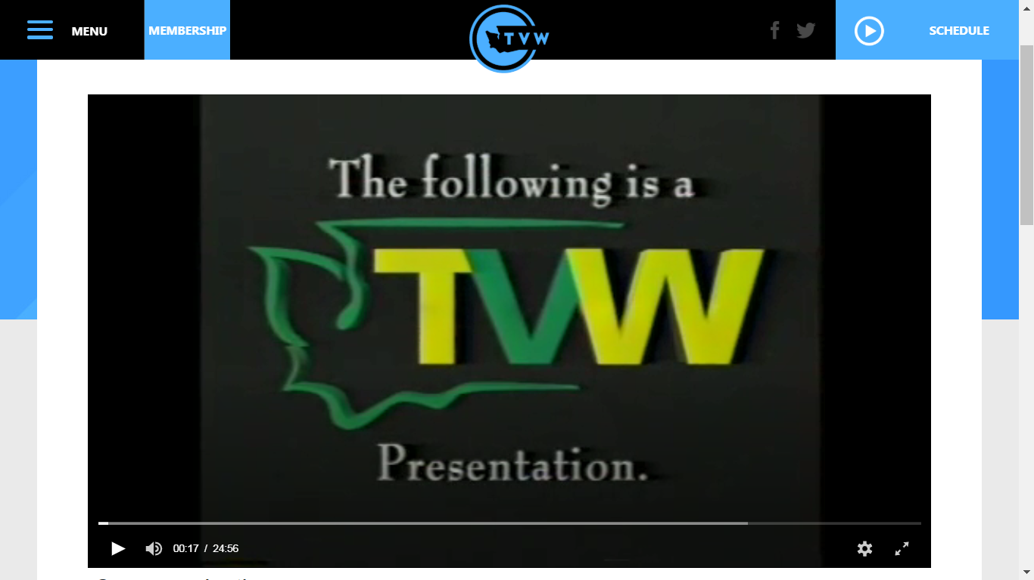

Questions While Watching the Video

Directions: Find answers to these questions while watching the video:
What happened to Mr. Kevin Gardner?

Who was Loomis Armored Inc.?

What rule did Loomis have about drivers getting out of their armored vehicles?

Why did Loomis have this rule?

Why did Kevin Gardner disobey the rule?

Select a quote from the video that you find compelling.

Handout 2

Instructions for Group 1 (Kevin)

Group Members: | ________________________________________
 | ________________________________________
 | ________________________________________
 | ________________________________________
 | ________________________________________

Your group needs to make a list of all the arguments that you can think of for Kevin Gardner. Think about what Loomis will argue and what response you can make. Select one of your group to be the lead attorney who will present arguments from your group.
List your arguments here:
____________________________________________________________________________
____________________________________________________________________________
____________________________________________________________________________
____________________________________________________________________________
____________________________________________________________________________
____________________________________________________________________________

Handout 3

Instructions for Group 2 (Loomis)

Group Members: | ________________________________________
 | ________________________________________
 | ________________________________________
 | ________________________________________
 | ________________________________________

Your group needs to make a list of all the arguments that you can think of for Loomis. Think about what Kevin will argue and what response you can make. Select one of your group to be the lead attorney who will present arguments from your group.
List your arguments here:
____________________________________________________________________________
____________________________________________________________________________
____________________________________________________________________________
____________________________________________________________________________
____________________________________________________________________________
____________________________________________________________________________

Handout 4

Instructions for Group 3 (Judges)

Group Members:
___________________________________ | ___________________________________
___________________________________ | ___________________________________
___________________________________ | ___________________________________
___________________________________ | ___________________________________
___________________________________ | ___________________________________

You are all justices on the Supreme Court. You need to elect a chief justice to run the hearing and select one justice to be the timekeeper: four minutes for each side, plus a one-minute rebuttal. You also need to write four questions that you will ask of each side.
Questions for Kevin:
1. __________________________________________________________________________
2. __________________________________________________________________________
3. __________________________________________________________________________
4. __________________________________________________________________________
Questions for Loomis:
1. __________________________________________________________________________
2. __________________________________________________________________________
3. __________________________________________________________________________
4. __________________________________________________________________________

