Frequently Asked Questions (FAQs)
  - CLJ-CMS Clean-up reports in the Business Intelligence Tool (BIT)

Contents
Error: Results Too Large for Report 2
Results Produce Results not Fitting my Court Business 3
Filtering Report to Manage the Data 4
Filter Bar (Simple Filter) Example: 4
Filter Column (Complex Filter) Example: 5
Query Context Options 6
Context Options Pre-checked 6
Context Box Unchecked 6

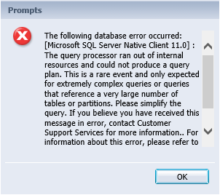
Error: Results Too Large for Report
Some reports may produce results too large for BIT to return in a single run. Instead of results, an error similar to this one will display:
Most of these instances can be solved by using the pre-defined filters included in the canned clean-up queries.
For Example:
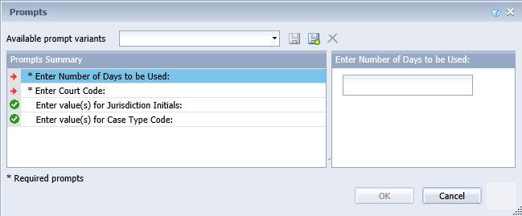
The Open Stagnant Cases report may produce large results. The following filters are present when running the canned report:
- The Red Arrow indicates a required prompt:
  - Enter Number of Days to be Used: this filter represents the number of days a case has been stagnant or not updated. Enter a negative number as that will indicate the number of days since last updated. Example: -30 for 30 days or greater since case updated.
  - Enter Court Code: This will be your court code. Example: CLD for Clark District
- The Green Checkmark indicates optional prompts that are not required to be completed to run the report, but may help relieve the issue a report too large to run.
  - Enter value(s) for Jurisdiction Initials: enter one or more jurisdictions within the court to limit the results. Example: VAN for City of Vancouver or CLR for County of Clark.
  - Enter value(s) for Case Type Code: enter one or more case type codes to limit results. Example: CN and CT to limit results to criminal cases only.
If the error still occurs, increase the filters by narrowing to one case type at a time orincreasing the date range to a larger number.

Results Produce Results not Fitting my Court Business
The canned reports for the CLJ-CMS cleanup process are built generically for all courts to use statewide. In this process, running a canned query may not produce desired results for all reports.
This may require the report to be modified to add in additional filters to match the report to the court business. Any report can be copied from the Cleanup Folder and pasted to your personal folder to modify.
For example:
Courts that use the COS to assign cases to an outside agency to handle payment plans makes this report produce overstated results. The query can be modified to remove an agency from the results.
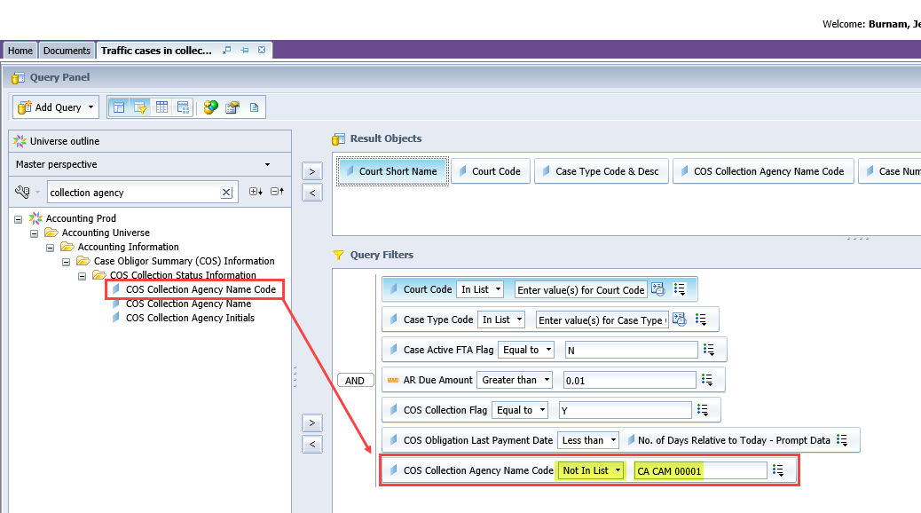
- Edit the query;
- Locate the COS Collection Agency Name Code and add it to the Query Filters;
- Update the operator to Not in List;
- Type in the applicable collection agency CA Name Code for the agency the cases are assigned to for pre-collection payment plans.
- Run query.
Result: This query will no longer display cases assigned to an agency for pre-collection payment plans.
This same process can be used on other clean-up reports by adding the applicable object to narrow down results for the court.

Filtering Report to Manage the Data
Even when you plan to work an entire report, sometimes cleanup reports can produce overwhelming results. Reports can easily be filtered to limit the results displayed.
This filtering can be done easily in BIT by filtering one column of data for one-time use or a filter bar which allows for ease of repetitively filtering the data. The following examples use the AR Due not in Collections report, which can be very large

Filter Bar (Simple Filter) Example:
To limit the results to only cases currently on a payment plan, quickly add the payment schedule flag to the Filter Bar:
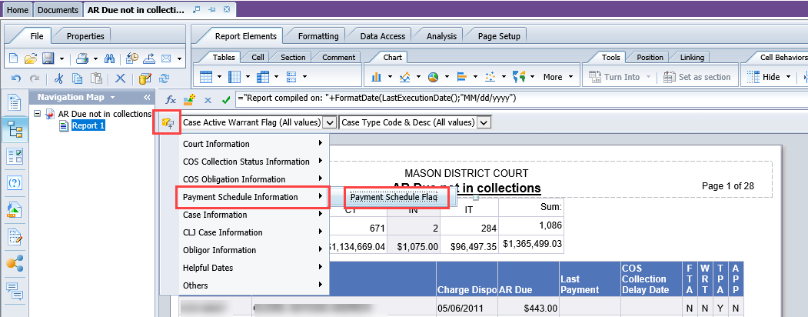
- Click on the Add Simple Filter icon;
- Click Payment Schedule Information;
- Select Payment Schedule Flag;
- The Payment Schedule Flag option will now appear on the Filter Bar;
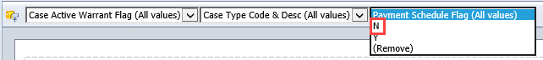
- Click the drop down from the Payment Schedule Flag;
- Select N (for no time pay on the case).
Result: This will remove all cases currently on a time pay in JIS.
Once you have worked the cases not on time pay, you can change the filter to Y and look at those on time pay. This can be done with other report objects as well.

Filter Column (Complex Filter) Example:
To filter the results to only cases without any payments can be done by filtering the Last Payment to only show the blank results.
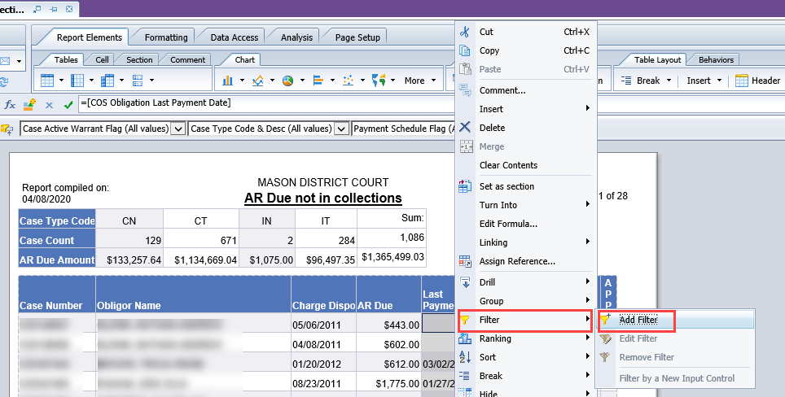
- Right click the Last Payment Column;
- Click the Filter option;
- Select the Add Filter;
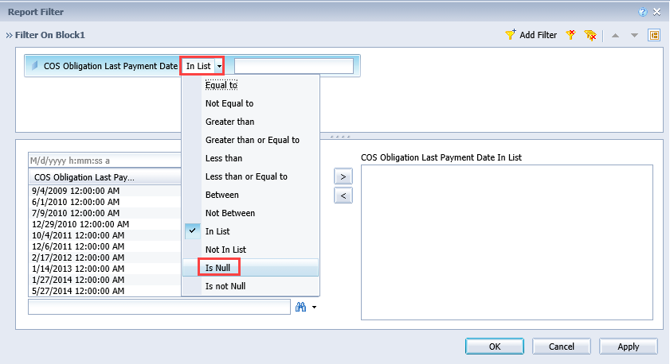
- From the Report Filter box, click the In List drop down;
- Select Is Null;
- Press OK.
Once the review of cases without a payment is done, remove the filter by right clicking the column, click Filter and then Remove Filter.

Query Context Options
Some reports require additional context details based on the query filters. This helps guide how the information will be obtained and displayed.

Context Options Pre-checked
When running the Open Stagnant report, a Query Context box appears for context on the accounting part of the query – keep Obligation Summary checked.
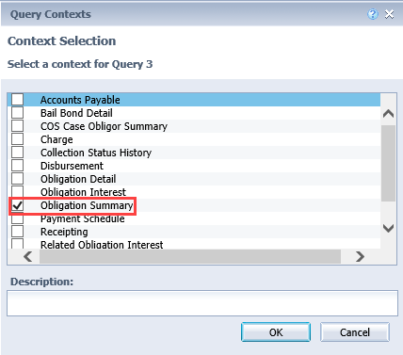

Context Box Unchecked
For the Cases with Disposed Charges in “Potential” Status report, the Query Context box appears without a pre-checked option for the accounting data. It’s recommended to use Obligation Summary.
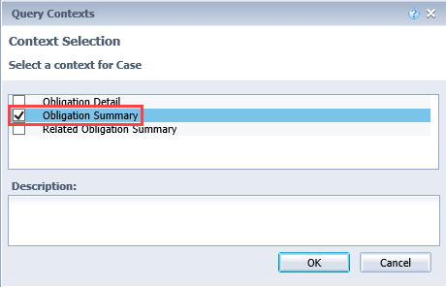
Reports that include accounting data need additional context to pull the correct results. Other context results may be for person information to determine if results should include relationship or AKA connections.

