

MOCK TRIAL PROGRAM

CASE 2003

State of Washington
vs.

Taylor Garrison

2002/2003 YMCA Youth & Government
High School Mock Trial

Frederick Mendoza
Curran Mendoza P.S.
(Case Author)

Mike Lang
Deputy Prosecuting Attorney for King County
(Co-Editor)

Hon. William Downing, Judge
King County Superior Court
(Co-Editor)

Maya Mendoza
Senior, University of Puget Sound
(Co-Editor)

Table of Contents

Introduction………………………………………………………..4
Case Summary……………………………………….5
Special Considerations……………………….………7
Definitions……………………………………………9
Soccer Field Layout…………………………………10

Information……………………………………………………….12

Pre-Trial Motion………………………………………………….14
Declaration of Quinn Carpenter (Pre-Trial Motion)…15
Journal of Taylor Garrison…………………………...18
Case Law Summary (Pre-Trial Motion)……………. 23

Prosecution Witnesses
Declaration of Alex Chavez……………………….…39
Declaration of Jordan James…………………………42
Declaration of Jessie St. Laurent…………………….44
Declaration of Sidney Lee……………………………48

Defense Witnesses
Declaration of Taylor Garrison……………………… 51
Declaration of Andy Jacobs…………………………..54
Declaration of Kelly Quoc……………………………57
Declaration of Kyle Dennis………………….………..60

Exhibit List……………………………………………………..…63
Exhibit 1. Field Diagram……………………………..64
Exhibit 2. FIFA Laws of the Game, Law 5……….….65
Exhibit 3. FIFA Laws of the Game, Law 12…………66
Exhibit 4. Journal of Taylor Garrison (5 pages)……...68

Jury Instructions………………………………………………….73

Bibliography………………………………………………………81

Introduction

Thank you for participating in the 2002-03 YMCA Youth & Government Mock Trial competition. We hope you find this case to be relevant, educational, entertaining and lots of fun.

The case combines two of my favorite activities: soccer and high school mock trial. While the characters in the case are completely fictitious, the fact pattern and legal issues are entirely realistic.

I wrote this case to explore two emerging sociolegal issues. The first one is whether too much violence is permitted in sports. The second one is whether the criminal court is an appropriate forum in which to “replay” an act of violence committed within the context of an organized and officiated athletic event.

I do not have answers to either of these questions. Let’s explore them together as the Maradona County Prosecuting Attorney takes on Taylor Garrison in State of Washington vs. Taylor Garrison.

I want to give special thanks to three people whose generous commitments of time, experience and expertise made this case possible. First, to my daughter, Maya Mendoza, who is a senior All American soccer player at the University of Puget Sound. Maya’s creative writing skills and wealth of experiences with coaches, referees and players made our characters come alive. Second, to King County Deputy Prosecuting Attorney Mike Lang who provided valuable editorial comments, researched the issues for the pre-trial motion and drafted the Information, jury instructions and case summaries. Finally, to King County Superior Court Judge William Downing, our mentor and taskmaster, for his editorial comments, encouragement, proofreading, advice and whip-cracking. He kept us on task and on track.

Good Luck.

Frederick Mendoza
Curran Mendoza P.S.
Case Author

Case Summary

Taylor Garrison and Alex Chavez are gifted soccer players who were both headed for bright careers in college soccer, and, perhaps, beyond. They have been competing against each other for years in the Washington youth soccer system. Chavez is a skilled, clever goal-scoring machine for his/her club team, FC Red Dog, and Garrison is the tough, masterful defender for FC Ignition. They both play together on the Washington Olympic Development team, but they are fierce competitors who do not care for one another.

In the U-18 state championship game between FC Red Dog and FC Ignition, Chavez and Garrison went at each other relentlessly. Everyone in attendance knew the game would be decided by one of these players. The experienced referee, Kyle Dennis, had a difficult time keeping the two under control. In the first half, both players are verbally warned repeatedly, and both are cautioned (shown the yellow card) for aggressive play. In the second half, Chavez and Garrison settled down a bit and the game is a nail-biter. Witnesses have said that Chavez was clearly the better of the two that day, beating Garrison repeatedly with quick, artistic dribbling moves. But the game remained scoreless in the 80th minute.

In the 81st minute, Chavez received a pass out on the left flank from teammate Jordan James and eluded Garrison’s slide tackle with yet another skillful move. Chavez had only the sweeper, Kelly Quoc, to beat. Chavez “megged” Quoc at the top of the penalty area and took a hard, low, right-footed shot toward the left corner of the goal. The last thing s/he remembers is seeing the ball roll wide of the left post. The next thing s/he remembers is being struck from behind on the outside of the left knee with such force that s/he felt his/her knee “explode.” The pain was excruciating.

Chavez suffered a very severe injury that will prevent him/her from ever playing soccer at a competitive level. The injury, known by orthopedic surgeons as the “terrible triad,” consists of a ruptured anterior cruciate ligament (the ACL), a ruptured medial collateral ligament (the MCL), and lacerated meniscus. In addition, s/he suffered a fracture of the tibial plateau. When healed, the fracture surface will be out of contour, which will cause Chavez’s left knee to function abnormally, causing a limp or hitch in his/her gait.

According to Garrison, the injury was just an unfortunate accident. S/he claims that when s/he recovered after missing the slide tackle and caught up with Chavez just outside the penalty area, s/he believed Chavez was going to take a shot toward the far post. So s/he launched his/her body, feet first, toward the spot where s/he thought s/he could intercept the ball after Chavez struck it. Unfortunately, according to Garrison, Chavez cut back to his/her left and took the shot toward the near post. This miscalculation by Garrison, s/he says, put them on a collision course that resulted in the injury.

Witnesses seem to differ on whether the foul was reckless and/or intentional. A visiting college coach (Sidney Lee) and a visiting referee (Jessie St. Laurent) both reluctantly concede that the foul was at least reckless, and, perhaps, intentional. But both witnesses are clearly uncomfortable with providing testimony that could cause Garrison to be convicted of a crime. On the other hand, Garrison’s coach (Andy Jacobs) and the match referee (Kyle Dennis) will firmly believe that, while the foul was very bad, it was not intentional and was, in any case, appropriately dealt with under the rules of the game. Chavez’s teammate, Jordan James, and Garrison’s teammate, Kelly Quoc, each supports his/her teammate.

After reviewing game films (which have been lost) and interviewing many witnesses, the Maradona County Prosecutor decided to file charges against Garrison for Second Degree Assault and the lesser included offense of Reckless Endangerment. The case is expected to go to trial in early 2003.

One piece of evidence that could break the case, if admissible, is Garrison’s personal journal. FC Ignition Coach Andy Jacobs required of every FC Ignition player to keep a journal for personal motivation and accountability. The journals were not for public consumption, and few players knew what each other wrote in their journals. But Quinn Carpenter, the newest member of FC Ignition, knew what Garrison had written in his/her journal during the week prior to the championship game, and it could be damaging to the defense case.

Quinn’s father, Jerry Carpenter, is a sergeant for the Maradona County Police Department. After the police started its investigation, Quinn mentioned the journal entries, which could be construed as threats against Chavez, to Sgt. Carpenter. At the persistent urging of his/her father, Quinn surreptitiously removed the journal from Garrison’s locked trunk and copied five pages, which s/he then gave to his/her father.

The journal pages were disclosed to the defense team during the discovery process, and Garrison’s attorneys have filed a motion to suppress the statements made in the journal on the basis that the journal was obtained as a result of an illegal search and seizure conducted by the Maradona County Police Department. According to the motion to suppress, Quinn Carpenter was acting under the direction of his/her father, Sgt. Carpenter, and the Police Department when s/he removed the journal from Garrison’s locked trunk and had it copied at a local 7 Eleven store.

The prosecutor believes the journal is admissible because the exclusionary rule does not apply to evidence obtained by private citizens acting on their own initiative. The motion will be heard on the day of trial.
Special Considerations

About Gender

This case creates a difficult gender issue, for which there is no easy solution. Mock trial cases are preferably written to be gender-neutral, so that males or females can assume the role of any character without affecting the integrity or realism of the case or the trial. But this case is a little different.

It would be extremely unusual for the incident portrayed in this case to have occurred in a co-ed soccer game. First, there are no co-ed leagues in existence anywhere in the world where aggressive, physical soccer is played. Second, the rules of co-ed soccer specifically prohibit most physical contact between players of opposite sex. That fact alone might weight this case too heavily in favor of the prosecution. That is, if the foul involved in this case were committed in a co-ed game, under co-ed rules, the foul would be so far outside the rules of the game that a criminal conviction would be more easily obtained. So, the game needs to be played by teams of the same gender (it does not matter which) or, at a bare minimum, the characters of Alex Chavez and Taylor Garrison need to be the same gender.
To bring this about in the mock trial courtroom, consideration was given to various complex arrangements. These involved expanded team rosters and last minute determinations as to which gender would be used in a given trial. Besides causing a certain amount of upheaval, this would have the undesirable effect of reducing the participation of some students.
Ultimately, it was decided that the simplest approach was best; that is, to simply ignore gender altogether. Each witness should testify as if the game were played by teams of the same gender and that the applicable rules are those provided with the case materials.
One more word about gender is in order. In drafting the Declarations we tried to catch all of the he, she, him, her pronouns and change them to “s/he” and “him/her” and “himself/herself.” If we missed any that refer specifically to a witness, we apologize. You should assume that it was overlooked and you should make the necessary correction. However, the reference may not be a mistake when we refer to a non-character, e.g. Quinn Carpenter’s father, Sgt. Jerry Carpenter. As stated, all witnesses may be portrayed as males or females.

About the Pretrial Declaration of Quinn Carpenter

We wish to make it clear that the declaration of Quinn Carpenter was introduced only for purposes of creating the pre-trial motion. Quinn is not a character in this case, and his/her declaration may not be used for any purpose during the actual trial. If the court denies the motion to suppress, thereby making the journal entries available for admission into evidence, Taylor Garrison’s declaration contains some addition material that can be used by his/her defense team to ameliorate the effect of the damage to him/her, if any, that is created by admitting the journal entries.

Definitions

The following definitions are provided for informational purposes only. They are not “text book” definitions, but they are accurate.

Slide Tackle: Describes the defensive maneuver when a player leaves his feet (like a baseball player would slide feet first into a base) to intercept a ball that is out of reach. The slide tackle is legal only when attempted from the front or from the side of the player with the ball. A player making a slide tackle may make contact with the body of an opponent only if s/he first makes contact with the ball. Contact with an opposing player before making contact with the ball is a foul. Slide tackles from behind are forbidden by Law 12 of the FIFA Laws of the Game.

“Megged”: “Meg” or “nutmeg” is a soccer term used to describe a situation where an attacking player dribbles the ball, or passes the ball, between the legs of a defending player.

“Professional Foul”: “Professional Foul” is a term used to describe a foul that appears to be too aggressive or intentionally committed. The term sometimes connotes a foul that borders the fine line between fair and unfair, and is often used to describe fouls that are so aggressive that they appear to have been committed more for the purpose of sending a psychological message to an opponent than to fairly challenge for the ball.

Caution/ Yellow Card: A caution is a form of disciplinary sanction imposed by the referee on a player who commits one of the 7 “cautionable offense” listed in Law 12 of the FIFA Laws of the Game. To notify the players, coaches and the public that a caution has been imposed, the referee will raise a yellow card in the air while standing in front of the offending player to signify an official notice that the caution has been issued. Upon receiving a second yellow card in the same game, a player is automatically disqualified and is sent off (ejected) the field.

Sending Off/ Red Card: If a player commits one of the 7 “sending-off offenses” described in Law 12 of the FIFA Laws of the Game, the player is disqualified from further play in the game and is “sent off” the field, i.e., he or she is ejected from the game. The team of a player who is sent off must play the remainder of the game with one less player. To signal a “sending off offense,” the referee will raise a red card in the air while standing in front of the offending player and then instruct the player to leave the field.

Warning/Verbal Warning: Referees will often issue verbal warnings for offenses that could be construed as cautionable offenses. There are no restrictions imposed on the referee regarding the use of verbal warnings. Some referees use them liberally before issuing yellow cards, and some do not. Most referees maintain an open dialogue with the players on the field as a means of communicating their expectations to the players.

ODP: “ODP” is the acronym for the Olympic Development Program, a national program designed to identify and train the top youth players in the country to form a pool from which the national team is developed and selected. Every state’s youth soccer association participates in the ODP program, which begins for players at the U-14 age group. ODP is a highly competitive environment as its sole purpose is to identify the top players in the country at each age group.

U-12, U-13, U-14, etc.: Youth soccer competition is conducted by age groups. Competitive soccer usually begins at the Under-12 (U-12) age. A player in the U-12 age group is a player who has not turned twelve years old before August 1 of the year in which the season begins.

The “D”: The markings on a soccer field create a “D” shaped area that is centrally located at the top of the penalty box. The “D” is actually the visible portion of a circle that is described by a 10-yard radius around the penalty spot, i.e., the spot from which penalty shots are taken. All players must be at least 10 yards away from a player taking a penalty shot at the instant when the shot is taken.

The Penalty Area: Also called the “penalty box” or the “eighteen yard box,” this rectangular area around each goal is eighteen yards from either goal post and eighteen yards from the goal line. The goalkeeper is permitted to catch and control the ball with his/her hands inside the penalty area. Fouls committed inside the penalty area by a defending team result in a penalty kick being awarded to the attacking team.

Touch Line: The lines that run the length of the field on either side of the field are called the “touch lines.” When the ball is out of bounds it is said to be “in touch.” A ball is not out of bounds until the entire circumference of the ball is outside of the touch line. In other words, a ball that is sitting on the line or still in contact with the line in any way is a ball that is in play.

Goal Line: The goal lines are the lines at either end of the field that run from corner to corner and mark the ends of the playing field. The goal line is also called the “end line.”

Corner Kick: A corner kick is awarded whenever a ball that is last touched by the defending team goes over the goal line/end line in the defending team’s defensive half of the field.

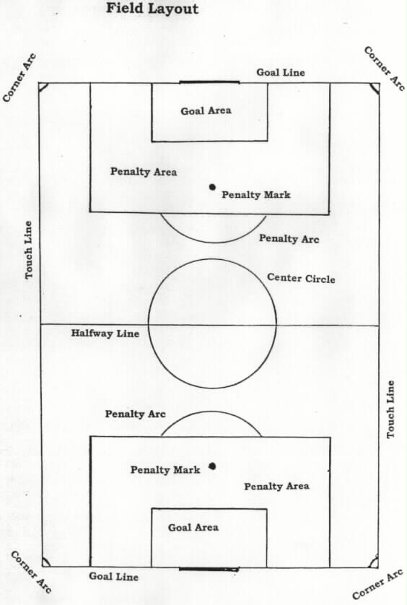

SUPERIOR COURT OF WASHINGTON FOR MARADONA COUNTY

STATE OF WASHINGTON,  Plaintiff,  vs.  TAYLOR GARRISON,  Defendant, |  | )  )  )  )  )  )  )  )  )  )  )  ) | No. 03-1-01334-5  INFORMATION

COUNT I

I, Charles P. Carroll, Prosecuting Attorney for Maradona County in the name and by the authority of the State of Washington, do accuse TAYLOR GARRISON of the crime of Assault in the second degree, committed as follows:

That the defendant, TAYLOR GARRISON, in Maradona County, Washington, on or about the 17th day of March, 2002, did intentionally assault another and thereby recklessly inflict substantial bodily harm upon Alex Chavez;

Contrary to RCW 9A.36.021(1)(a) and against the peace and dignity of the State of Washington.

COUNT II

And I, Charles P. Carroll, Prosecuting Attorney aforesaid, do further accuse TAYLOR GARRISON of the crime of Reckless Endangerment, based on the same conduct as another crime charged herein, committed as follows:

That the defendant, TAYLOR GARRISON, did recklessly engage in conduct which did create a substantial risk of death or serious physical injury to another person by kicking Alex Chavez in the leg;

Contrary to RCW 9A.36.050, and against the peace and dignity of the State of Washington.

CHARLES P. CARROLL

Prosecuting Attorney

By: /s/
Wayne Johnson, WSBA #52530

Deputy Prosecuting Attorney

IN THE SUPERIOR COURT OF THE STATE OF WASHINGTON
FOR MARADONA COUNTY

STATE OF WASHINGTON, )
)
Plaintiff, )
) No. 03-1-01334-5
Vs. )
) MOTION TO SUPPRESS
TAYLOR GARRISON, )
)
Defendant. )
______________________________)

COMES NOW the defendant, Taylor Garrison, by and through his attorneys, and moves the court for a pre-trial order suppressing written statements made by the defendant in his personal journal.

This motion is based upon the Declaration of Quinn Carpenter, attached hereto and incorporated herein by reference. Without waiving any of Defendant’s grounds for suppression or objections to admissibility, copies of the subject journal entries, comprising 5 pages, are also attached.

Dated this 6th day of January, 2003.

/s/ Lead Attorney
_________________________________
Of Attorneys for Defendant
Declaration of Quinn Carpenter

***TO BE USED ONLY FOR PURPOSES OF THE PRE-TRIAL MOTION***

***DECLARATION MAY NOT BE USED DURING THE ACTUAL TRIAL***

I, Quinn Carpenter, hereby declare as follows:

My true name is Quinn Carpenter. I am 18 years old. I was born on March 17, 1984. I graduated from Rock Haven High School in June 2002. I am going to the University of Washington in September.

I played with Taylor Garrison on FC Ignition this past season. It was my first and only season with the team, and I was the only new player selected from the try-outs. We won the state championship at U-18 by beating FC Red Dog, 1-0. I did not play much during the regular season but got to start in the semi-final and championship games of the State Cup (U-18 State Championship).

My father, Jerry Carpenter, is a sergeant with the Maradona County Police Department. Sergeant Carpenter suffered a ruptured disk in his lower back four years ago while leaping over a chain link fence during a foot chase with a fleeing burglary suspect. He never fully recovered from back surgery and has been re-assigned to administrative duties since returning to work. He is not always an easy father to live with. He is a militaristic disciplinarian. He suffered some depression during rehabilitation and has been mildly depressed about being relegated to the desk.

After the Police started the investigation against Taylor, Dad told me that one of his detectives was working on the case. I mentioned to my dad that Taylor’s player journal contained lots of references to Alex Chavez that were made during the week before the championship game. My dad questioned me about the journal every day for a week and suggested that I should get the journal and show it to him. Dad promised that no one would see it but him. Dad was always lecturing me about doing the right thing. I could not believe that he could not understand my position: Teammates should not rat on each other. He told me the journal was not that important because the prosecutor already had a strong case for assault against Taylor. But he still wanted to see it.

I did not want to do it. But dad kept hounding me about it all week. Every night at dinner Dad interrogated me about the journal. He accused me of being disrespectful to him and his badge for not wanting to assist law enforcement and lectured me making the right decision. He said some of the choices adults have to make are not going to be popular with our friends, but we need to make them anyway, just because they are the right decisions to make. He said I was an adult and this was one of those tough decisions I had to make.

By the day of our post-season team party, the pressure was getting intense. I kept pacifying my Dad, telling him I did not know where the journal was, even though I knew it was probably in Taylor’s backpack in the trunk of his/her car.

I think I was the only member of the team who saw Taylor’s journal, and that was only because s/he used it to teach me how to use a journal for self-motivation in big games. I watched him/her make some of the entries about Chavez and s/he showed me his work. Due to an injury to our outside midfielder during the quarterfinal game, I was told I would be starting the semi-final match. Emotionally, I was excited and horrified, and Taylor knew it. Taylor shared his/her journal entries with me to get me “stoked” for the game.

Every member of FC Ignition is required by Coach Jacobs to maintain a personal journal. The primary purpose is to promote psychological preparedness and track personal development. Coach likes to use an old Yogi Berra phrase to emphasize his/her belief that the difference between winning and loosing big games is psychological preparation: “The game of baseball is half psychological and 50% mental.” Coach liked that saying.

Every player is required to write in his/her journal at least two times each week, each time answering four questions: (1) What technical aspect of your game is most complete today? (2) What are you doing to maintain your competitive fitness? (3) How are you preparing yourself mentally to compete in premier level soccer? (4) What personal goal will you achieve this season? The questions are purposely designed to promote “positive self-talk.” Coach Jacobs does not want any of his/her players dwelling on their deficiencies.

As captain of FC Ignition, Garrison makes it his/her personal responsibility to ensure that every player takes journal writing seriously. Taylor spent a lot of time with me this season working on my journal. Sometimes, Taylor berated me for lack of competitive toughness. I complained to my Dad one time and he called Coach Jacobs and demanded that Taylor “lay off my kid.” I was mad that my Dad got involved in my business and Taylor said it showed how weak I was. Dad was mad at me for not sticking up for myself, but I was just trying not to make waves on the team. After all, Taylor was the captain.

The team party to celebrate the state championship was scheduled for Saturday, April 6, 2002 at the Holiday Inn. Taylor asked me to help him/her unload the coach’s gifts from his trunk and stash them in a coat closet near the banquet room. As captain of the team, it was Taylor’s responsibility to collect money from each of his teammates and buy gifts for the coaches. While we were stashing the gifts, Coach Jacobs showed up and Taylor started steering him/her away from the closet. He tossed me his/her car keys and told me to lock the car.

When I got to the parking lot I remembered seeing Taylor’s backpack in his/her trunk, and I also remembered my Dad accusing me of disrespect. I stood in front of the locked trunk for ten minutes, not knowing what to do. I was sweating. Finally, I decided that my Dad would never respect me if I did not get the journal and I trusted his promise that no one else but him would see the journal. So, I opened Taylor’s locked trunk and removed the journal. I then ran across the street to the 7 Eleven store and made a copy of the last five pages, returned the journal to the backpack, locked the trunk and went back to the banquet room.

Next morning, after the team party, I showed the copies to my father. He looked disgusted when he finished looking at them. Within a few minutes I heard him talking to a detective at the Police Department, and the following day I was called out of class to talk to the detective. I was furious when I found out that Dad had given the journal pages to the Police. The prosecutor questioned me about how I got journal and I told her what happened.

Copies of the pages I took from the journal are attached to this Declaration.

Dated this 20th day of June, 2002.

I HEREBY DECLARE UNDER PENALTIES OF PERJURY UNDER THE LAWS OF WASHINGTON THAT THE FOREGOING IS TRUE AND CORRECT.

/s/ Quinn Carpenter
_________________________________
Quinn Carpenter

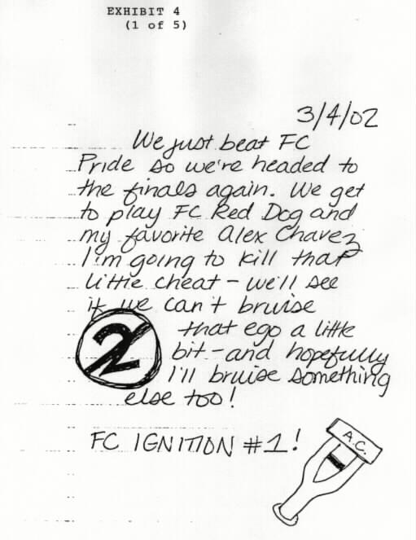

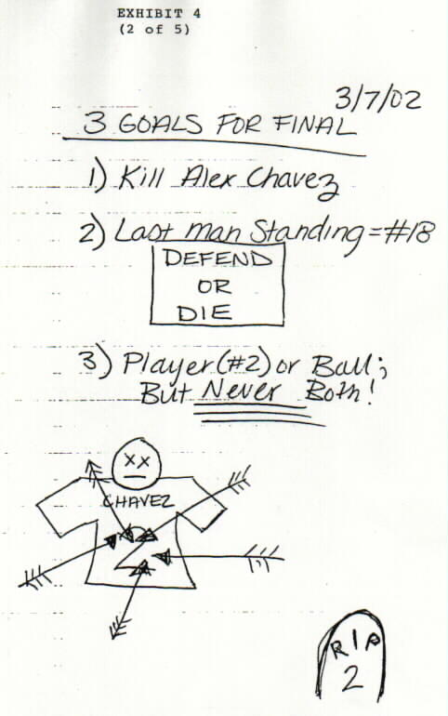

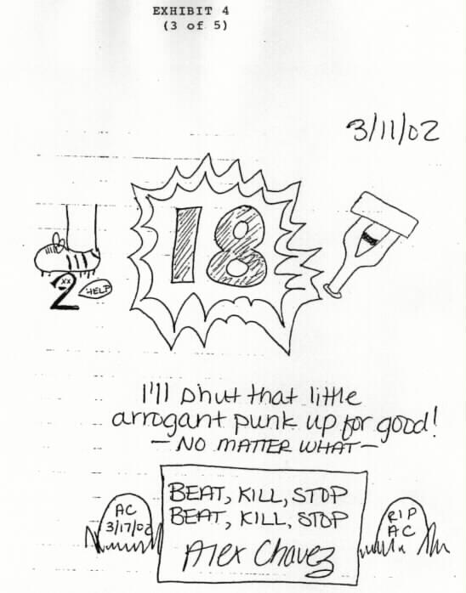

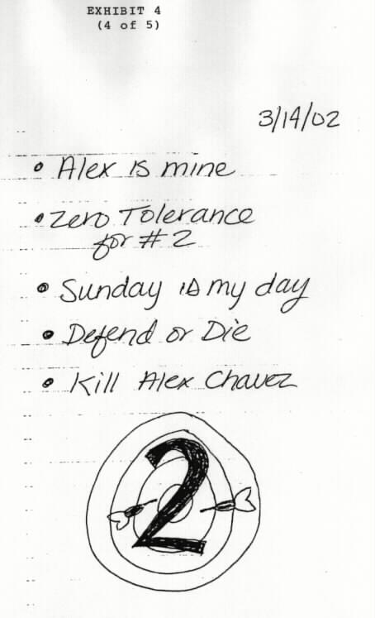

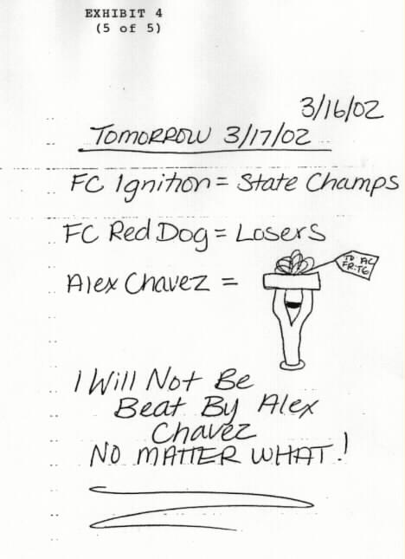

Case Law Summaries

The following Case Law Summaries are to be used to develop your oral argument for the Pre-Trial Motion to Suppress filed behalf of the Defendant, Taylor Garrison

NO OTHER CASES OR AUTHORITIES MAY BE CITED OR USED

Burdeau v. McDowell, 256 U.S. 465, 41 S.Ct. 574, 65 L.Ed. 1048 (1921)
(United States Supreme Court case)

Facts: J.C. McDowell was being investigated by a grand jury in the United States District Court for the Western District of Pennsylvania for the crime of fraudulent use of the mails. Joseph Burdeau was the Special Assistant to the Attorney General of the United States who was charged with prosecuting McDowell.

McDowell was employed by Doherty and Company as the head of the natural gas division of the Cities Services Company, a subsidiary of Doherty and Co. His office was in the Farmer’s Bank Building in Pittsburgh, Pennsylvania. In March 1920, an officer of Doherty and Co. was sent to Pittsburgh to take over McDowell’s offices. This officer and several private detectives drilled into and blew open two safes in McDowell’s office, then removed all the papers within, including McDowell’s private papers. The group also broke the locks on McDowell’s desk, and removed all of the papers from it. All of these items were then sent to Doherty and Company’s corporate offices in New York City.

In June, 1920, Doherty and Co. turned over a letter, found in McDowell’s desk, to the Department of Justice and Mr. Burdeau. Mr. Burdeau eventually took possession of more of McDowell’s private books, papers, memoranda, etc. Burdeau intended to present these documents to a grand jury investigating McDowell for a violation of section 215 of the United States criminal code, “fraudulent use of the mails.”

McDowell then filed a petition in the United States District Court, asking for an order for the return of the books, papers, memoranda, and correspondence stolen from his office.

United States District Court decision: The United States District Court ruled in McDowell’s favor. The court ordered that all of McDowell’s papers should be delivered to the clerk of the court, who would then seal and impound them for ten days. The papers would then be delivered to McDowell unless an appeal was taken. The court stated:

“It did not appear that Burdeau, or any official or agent of the United States, or any of the department, had anything to do with the search of petitioner’s safe, files, or desk, or the abstraction therefrom of any of the writings referred to in the petition, and added that ‘the order made in this case is not made because of any unlawful act on the part of anybody representing the United State or any of its departments but solely upon the ground that the government should not use stolen property for any purpose after demand made for its return.’

Expressing his views, at the close of the testimony the judge said that there had been a gross violation of the Fourth and Fifth Amendments to the federal Constitution; that the government had not been a party to any illegal seizure; that those amendments, in the understanding of the court, were passed for the benefit of the states against action by the United States—forbidden by those amendments, and that the court was satisfied that the papers were illegally and wrongfully taken from the possession of the petitioner, and were in the hands of the government.

United States Supreme Court decision: The U.S. Supreme Court reversed the District Court and held that Burdeau could use the stolen papers. The Court stated:

“In the present case the record clearly shows that no official of the federal government had anything to do with the wrongful seizure of the petitioner’s property, or any knowledge thereof until several months after the property had been taken from him and was in the possession of the Cities Services Company. It is manifest that there was no invasion of the security afforded by the Fourth Amendment against unreasonable search and seizure, as whatever wrong was done was the act of individuals in taking the property of another. A portion of the property so taken and held was turned over to the prosecuting officers of the federal government. We assume that petitioner has an unquestionable right of redress against those who illegally and wrongfully took his private property under the circumstances herein disclosed, but with such remedies we are not now concerned.

The exact question to be decided here is: May the government retain incriminating papers, coming to it in the manner described, with a view to their use in a subsequent investigation by a grand jury where such papers will be part of the evidence against the accused, and may be used against him upon trial should an indictment be returned?

We know of no constitutional principle that requires the government to surrender the papers under such circumstances. Had it learned that such incriminatory papers, tending to show a violation of federal law, were in the hands of a person other than the accused, it having had no part in wrongfully obtaining them, we know of no reason why a subpoena might not issue for the production of the papers as evidence. Such production would require no unreasonable search or seizure, nor would it amount to compelling the accused to testify against himself.

The papers having come into the possession of the government without a violation of petitioner’s rights by governmental authority, we see no reason why the fact that individuals, unconnected with the government, may have wrongfully taken them, should prevent them from being held for use in prosecuting an offense where the documents are of an incriminatory character.

It follows that the District Court erred in making the order appealed from, and the same is reversed.”

State v. Ludvik, 40 Wn.App. 257, 698 P.2d 1064 (1985)
(Washington Court of Appeals, Division Three)

Facts: In November 1982, Brooks Carmichael, a Washington State game agent, observed heavy pedestrian traffic in and out of the home of Douglas Ludvik, who lived across the street from Carmichael. Carmichael noticed that “the individuals involved stayed for only brief periods of time. As many as 15 vehicles would arrive in an hour. This traffic would continue until 10 or 11 o’clock at night.”

Several days after he began observing this traffic, Mr. Carmichael saw what he believed to be a drug transaction. Carmichael used binoculars to look into Ludvik’s home and see a plastic baggie exchanged for money.

On November 15, 1982, Carmichael reported his observations to the Spokane County Sheriff’s Department. The detectives asked the prosecutor’s office about obtaining a warrant, and it was decided that further investigation should be conducted. Mr. Carmichael agreed to the use of his residence for purposes of police surveillance. A sheriff’s deputy set up surveillance from Carmichael’s home, using binoculars and a spotting scope. The deputy observed the same traffic as Carmichael had observed, and also saw one person leaving the home with a baggie containing what appeared to be marijuana. The deputy also saw Ludvik retrieve a baggie of marijuana.

On November 16, 1982, deputies obtained a search warrant. The affidavit for the warrant contained the information originally supplied by Carmichael and also the observations made during the police surveillance. When the warrant was served, Ludvik led officers to a closet containing dried mushrooms, containing the controlled substance psilocyn.

Ludvik was charged with and convicted of unlawful possession of a controlled substance, psilocyn. The trial court ruled: “…the evidence gathered by Mr. Carmichael before contacting the sheriff’s office was lawful because the observations did not involve any governmental activity. In short, Carmichael had acted as a private citizen. However, the observations made by Deputy Quasnick and Mr. Carmichael through the window of the Ludvik residence during the police surveillance constituted an unreasonable intrusion into Ludvik’s legitimate expectation of privacy in his home. Nevertheless, the remaining information contained in the supporting affidavit established probable cause; therefore, the warrant was valid and the evidence seized during its execution was not subject to exclusion.”
Ludvik was then found guilty at trial.

Court of Appeals Decision: The court of appeals affirmed the judgment of the trial court. The court stated:

Mr. Ludvik initially contends Mr. Carmichael’s observations, prior to contacting the sheriff’s department, constituted a governmental search because Mr. Carmichael is employed as a state game agent and has authority under RCW 77.12.060 and .080 to execute search warrants and make arrests…

Constitutional guaranties against unreasonable searches and seizures protect only against governmental actions and do not require the application of the exclusionary rule to evidence obtained from private citizens acting on their own initiative…The history and origins of both the fourth amendment to the United States Constititution and article 1, section 7 of the Washington State Constitution clearly show they were intended as a restraint upon sovereign authority; in the absence of state action, they have no application regardless of the scope of protection which would otherwise be afforded under either provision.

In determining whether a search is subject to constitutional controls, official involvement is not measured by the primary occupation of the person conducting the search, but the capacity in which he acts at the time of the search…Further, a mere purpose to aid the government does not transform an otherwise private search into a governmental search.

Here, Mr. Carmichael was not acting in an official capacity at the time of his initial observations. His surveillance of the Ludvik residence was not related to his official duties. He exercised no greater authority under the circumstances than any other private citizen. He took no other action on his own, but instead contacted law enforcement authorities. His actions had not been coordinated or encouraged by the police. Therefore, the trial court did not err in determining Mr. Carmichael’s initial observations constituted a private search and were not subject to exclusion.

State v. Swenson, 104 Wn.App. 744, 9 P.3d 933 (2000)
(Washington Court of Appeal, Division One)

Facts: “On March 7, 1995, David Loucks left home for a 7 p.m. meeting at the Seattle recording studio that he owned and operated. The next morning, David Loucks’ father, Allan Loucks, Sr., discovered his son’s dead body on the floor of the studio with duct tape over his mouth and nose and around his hands and feet. David Loucks’ wedding band, keys to the studio, and some of his recording equipment were missing…

Allan Loucks, Sr., an attorney, took an immediate interest in helping the police find his son’s killer or killers. He suggested investigative strategies that the police should pursue and provided the police with information that a “Paul Waller” had an appointment with David Loucks on the evening of March 7, 1995. Detectives Alan Lima and Kevin O’Keefe followed up on many of these leads and kept Allan Loucks informed of their progress.

By June 1995, Allan Loucks decided that detectives were not competently investigating his son’s death. He took time away from his law practice to investigate on his own. Despite instructions from Detective Lima to let police handle the investigation, Allan Loucks continued to pursue various leads and provide information to the police. By August 1995, this information included driver’s license numbers, credit card numbers, birth dates, birth certificates, social security numbers, bank records, insurance information, court documents, and addresses of people that Allan Loucks thought the police should investigate. Through the end of 1995, Loucks continued to be a consistent source of information for the police.

In January 1996, Allan Loucks met with the police to provide them with some additional names of people to investigate, including Shawn Swenson. In turn, the police updated Allan Loucks on their investigation and exchanged information with him. Shortly thereafter, Allan Loucks provided police with an address and car that he connected to Swenson.

On February 6, 1996, Allan Loucks provided the police with a sketch, credit information for Swenson, and his social security number. On February 13, 1996, Allan Loucks tipped Detective Lima that Swenson had used a Washington Driver’s License with a Florida address at a music store in Spokane.

In March 1996, the police called Allan Loucks to ask for the cellular phone numbers that Allan Loucks thought they should investigate. Allan Loucks called back and said that he did not have any new cellular phone numbers to investigate. He did, however, indicate that he was able to connect Swenson to some stolen recording equipment.

In the spring of 1996, Allan Loucks received some anonymous information that Swenson had called David Loucks’ studio five times in the weeks and days leading up to his son’s death. The information included days, times, and lengths of the calls. Earlier, Allan Loucks had contacted several people in the telephone industry asking for this information. He advised them to provide the information anonymously because he knew that his contacts could not obtain the information legally.

Allan Loucks did not immediately provide the information to police because he was frustrated with how the police were conducting their investigation. On June 10, 1996, Allan Loucks told police that the key to solving the case was Swenson’s phone records and that he believed Swenson was “Paul Waller.” Allan Loucks also said that he had a lot of additional information but needed to consult a criminal attorney before releasing it.

On June 18, 1996, Allan Loucks met with police and again advised them that Swenson’s phone records were very important to solving the case. In addition, he provided police with information connecting Swenson to another theft of recording equipment. On July 3, 1996, the police received a “Crime Stoppers Tip” advising police that Swenson called David Loucks’ recording studio from Swenson’s home telephone on February 24, 1995, that Swenson called the studio several times around David Loucks’ death, and that Swenson was involved in two other thefts of recording equipment in the Seattle area. The tipster also provided Swenson’s home telephone number.

On July 6, 1996, after meeting with Allan Loucks, King County Deputy Prosecuting Attorney Patty Eakes told police that it might be important to obtain a subpoena for Swenson’s phone records. Shortly thereafter, a warrant was issued for Swenson’s arrest in connection with recording equipment stolen in Redmond, Washington. The police called Allan Loucks and informed him that the police would interview Swenson once he was arrested on the theft charges.

In September 1996, Allan Loucks met with Eakes. At that point, he was so angry that the police had not obtained Swenson’s phone records on their own that he provided her with the dates and times that David Loucks’s studio had been called from Swenson’s former Spokane phone number, and the lengths of the calls. On October 14, 1996, Allan Loucks followed Swenson’s girlfriend home from her place of work to an apartment building. After Allan Loucks spotted Swenson, he called the Spokane Police Department. The police arrived at the apartment and arrested Swenson on the outstanding warrant related to the theft charges.

The next day, Eakes and Detectives Lima and O’Keefe traveled to Spokane and confronted Swenson with the information provided by Allan Loucks and the fact that they now had his fingerprints. Swenson eventually admitted that he was at the studio the night David Loucks was killed. Swenson then gave a taped statement to the police, implicating someone named “Joe” in David Loucks’ death. Swenson later identified “Joe” as Joseph Gardner. The police interviewed Gardner, who was already in prison for another crime, and Gardner implicated himself and Swenson in the robbery at David Loucks’ studio.

Swenson moved to suppress the phone records and his subsequent statements to police, contending that Allan Loucks was acting as a government agent when Allan Loucks obtained initial information from Swenson’s phone records. At the CrR 3.6 hearing, Allan Loucks testified that the police never told him, directly or indirectly, that they wanted Swenson’s phone records. Detective Lima testified that he was concerned about how Allan Loucks was getting his information but did not want to know his sources. In addition, Detective Lima testified that he never asked Allan Loucks, directly or indirectly, to obtain any phone records and repeatedly discouraged Allan Loucks from continuing his investigative efforts. Detective Lima, however, also testified that he told Allan Loucks that the police could not obtain telephone records without probable cause, in response to a statement by Allan Loucks that the police needed to get phone records for certain individuals. The trial court denied Swenson’s motion to suppress, concluding that Allan Loucks was not acting as a government agent and even if he were, the police would have inevitably discovered Swenson’s phone records.

Court of Appeals Decision:

The defendant bears the burden of proving that a private citizen who provides evidence to the government was acting as an instrumentality or agent of the government…’Whether or not a person is acting as the State’s instrumentality depends on the particular circumstances of the case…Critical factors in determining whether a private person acts as a government agent include [1] whether the government knew of and acquiesced in the intrusive conduct and [2] whether the party performing the search intended to assist law enforcement efforts or to further his [or her] own ends…United States v. Miller, 688 F.2d 652 (9th Cir. 1982)…If the court answers both queries in the affirmative, then the private citizen was acting as a government agent when he or she conducted the search…

In this case, Allan Loucks clearly satisfies the second part of the so-called Miller test. Although Allan Loucks had a personal interest in identifying his son’s killer or killers, he obtained Swenson’s phone records to assist law enforcement officers in their investigation. Therefore, the only question is whether Swenson has met the first part of the Miller test—did the government know of and acquiesce in Allan Loucks’ obtaining Swenson’s phone records?

Swenson contends that Allan Loucks investigation was not independent of the police department’s investigation, and that the police acquiesced and encouraged Allan Loucks’ illegal seizure of Swenson’s phone records by accepting other information that the police suspected was obtained by Allan Loucks through illegal means. But even if this court accepts Swenson’s characterization of the testimony from the CrR 3.6 hearing, this does not establish that Allan Loucks was acting as a government agent when he obtained Swenson’s phone records.

Mere knowledge by the government that a private citizen might conduct an illegal search without the government taking any deterrent action [is] insufficient to turn the private search into a governmental one…It must be shown that the State in some way ‘instigated, encouraged, counseled, directed, or controlled the conduct of the private person…’

In this case, although one could conclude from the conflicting evidence that the police encouraged Allan Loucks to help them with their investigation, there is no evidence that the police instigated, encouraged, counseled, or directed Allan Loucks to obtain Swenson’s phone records. In fact, the evidence shows that Alan Loucks was continually frustrated at police failure to take advantage of the information he provided regarding the phone records, and that the police did not seize the records until they were able to obtain a search warrant based on their interviews with Swenson and Gardner. Moreover, Swenson does not even challenge the trial court’s finding that ‘[t]he police never articulated for Mr. Loucks any specific type of information that they were seeking in their own investigation.’…Without some evidence that the police indicated to Allan Loucks that they wanted Swenson’s phone records, it cannot be said that the police were using Allan Loucks to obtain evidence without a search warrant where a search warrant would otherwise be required. Therefore, the trial court’s finding that Allan Loucks was not acting as a government agent when he obtained Swenson’s phone records is supported by substantial evidence, and the trial court properly denied Swenson’s motion to suppress.

United States v. Souza, 223 F.3d 1197 (10th Cir. 2000)

Facts: On May 3, 1999, Larry Souza pled guilty to an indictment charging him with one count of possession with intent to distribute methamphetamine and aiding and abetting. Souza appeals the district court’s denial of his motion to suppress drug evidence discovered as the result of a search conducted at a United Parcel Service (UPS) facility in Sacramento, California, of a package addressed to him…

On June 9, 1997, agents of the Drug Enforcement Administration (DEA) were training officers assigned to a Sacramento task force on drug parcel interdiction. The training took place at the UPS office in West Sacramento. Detective Steve Sloan was one of the officers conducting the training at the UPS facility. At approximately 5:30 p.m., a white cardboard box caught Detective Sloan’s attention as he watched packages pass by on a conveyer belt. Detective Sloan believed that the package might contain contraband because it had been sent through third party shipping, the sender had only used a first name, all openings on the box were heavily taped with a clear tape, and the box was solid so that no side of it could be compressed. Detective Sloan testified that he suspected the box was filled with a type of foam that expands and hardens once it is put in the box, a characteristic that he believed, based on his experience as a narcotics detective, indicated that the box contained contraband.

The box was taken off the conveyer belt and placed next to a wall behind Detective Sloan. Special Agent Donald Rowden, also part of the interdiction operations, noticed the same suspicious characteristics of the package and decided to conduct a test to see if a narcotics dog would alert to the package. Special Agent Rowden took the package to a parking lot off UPS property and set the package on the ground with four other controlled packages that were placed about three feet apart and placed a plastic milk crate over each package. SA Rowden then directed a narcotics dog, Clause, to sniff the packages. Clause positively alerted to the package that had been targeted by Rowden and Sloan for the presence of narcotics…SA Rowden returned the package to Detective Sloan and advised him that he wanted to hold the package to write an application for a search warrant based on the probable cause of the narcotics dog alert…

Detective Sloan took the package and placed it behind him on the floor next to the wall. Subsequently, a UPS employee, April Denning, arrived on the scene. According to Denning’s testimony, a conversation was initiated by Detective Sloan who told her that a narcotics dog had alerted to the package and ‘stated that they couldn’t tell me to open the package, they were not authorized to do that, they would have to have a search warrant, but he pointed to where the package was.’ A couple of minutes later, another officer again told Denning, “I cannot tell you not to open the package, but there it is on the floor.” Denning estimated that approximately five minutes passed between the two conversations. She also testified that she was influenced by the statements of the interdiction officers.

After his conversation with Denning, Detective Sloan continued evaluating other packages that were on the conveyer belt. Approximately a minute or two after Detective Sloan continued with his evaluation, Denning picked the targeted package up, took it a few feet away to where her workstation was located, and began opening the package. Detective Sloan watched Denning open the package but did not tell her not to open it because he felt it was “not right to stop her.” He also believed she was acting within UPS policy in opening the package.

Due to hardened foam that completely encased everything, Denning had difficulty opening the package. She started tearing some of the foam away and, at that point, DEA agents intervened using a knife to cut through the foam and located the Tupperware container that was inside the package. The Tupperware container revealed a brownish substance that appeared to be methamphetamine. When Detective Sloan saw the methamphetamine, he took custody of the package. Detective Sloan then turned the package over to Special Agent Rowden, who was upset because he wanted to “get a couple of warrants behind Clause for reliability purposes” and “because he knew it would have been a good warrant.”…Special Agent Rowden then conducted a closer inspection of the package at his office, which revealed that the Tupperware container held plastic bags containing approximately 197 grams of a substance which tested positively for methamphetamine…The package was then delivered to the Souza residence and Souza was subsequently arrested.

Souza filed a motion to suppress the evidence…The district court agreed that the search was in violation of the Fourth Amendment….

Court of Appeals Decision: In determining whether a search by a private person becomes a government search, the following two-part inquiry is utilized: “1) whether the government knew of an acquiesced in the intrusive conduct, and 2) whether the party performing the search intended to assist law enforcement efforts of to further his own ends…Both prongs must be satisfied before the private search may be deemed a government search…The totality of the circumstances guides the court’s determination as to whether the two-part inquiry has been met.

If a government agent is involved “merely as a witness,” the requisite government action is absent and the search will be deemed private…The police must “instigate, orchestrate, encourage, or exceed the scope of the private search to trigger application of the Fourth Amendment”…The police are under no duty to discourage private citizens from conducting searches of their own volition…

In this case… the officers had substantially more involvement in the search of the box than merely being witnesses to the search. First, the officers specifically targeted the box and placed it to the side for safekeeping. Second, officers twice, within a span of five minutes, attempted to encourage Denning to open the package and Denning testified that she was influenced by the officers’ attempts…While companies such as UPS have legitimate reasons to search packages independent of any motivation to assist police…there is no evidence that in this instance Denning had a legitimate, independent motivation to open the package, despite her practice of randomly opening packages on other occasions…

Perhaps the most damning of all is that, as the district court found, the officers substantially assisted in the search initiated by Denning. “A search is a search by a federal official if he had a hand in it” and…[s]o long as he was in it before the object of the search was completely accomplished, he must be deemed to have participated in it…While private searches generally do not raise constitutional concerns, the Fourth Amendment would be seriously undermined if the search of the package in this case was described as anything other than orchestrated by the government.

United States v. Robinson, 504 F. Supp. 425 (1980)
(United States District Court, Northern District of Georgia)

Facts: Defendant Alphonso Robinson has been charged in a one-count indictment with possession of marijuana with intent to distribute…Defendant filed a motion to suppress evidence.

Defendant arrived at Ft. Lauderdale, Florida, airport before mid-morning on August 12, 1980, carrying a tote bag, a yellow suitcase, and blue suitcase…After defendant checked the two suitcases, he was approached by a Broward County, Florida, detective who asked to interview him. The detective identified himself as a narcotics detective. The defendant consented to speak with the detective. Having first acquired defendant’s two checked suitcases from Delta baggage personnel, the detective then asked defendant if he would consent to a search of his person, his carry-on tote bag, and the two checked suitcases. Defendant consented to a search of all of the above except the blue suitcase. He told the detective the blue suitcase belonged to a friend of his and he was transporting the suitcase to Los Angeles for the friend. As such, the defendant told the detective that he could not consent to a search of the blue suitcase, and in Ft. Lauderdale, it was never searched. The detective re-delivered the suitcases to Delta and defendant flew to Atlanta.

While defendant was en route to Atlanta, the detective phoned [Special Agent Gerald] Chapman [of the Drug Enforcement Administration (DEA)] at home in Atlanta and related to him the events in Ft. Lauderdale…When defendant’s plane landed in Atlanta, he went to the gatehouse from which his connecting flight would leave around 6:00 a.m. for Los Angeles. Agent Chapman approached him and asked if he could question him. Agent Chapman identified himself as a DEA agent. The pair walked into the corridor where defendant related to Chapman that he had been questioned and searched in Ft. Lauderdale…

Chapman asked defendant if he would consent to a search of his person and the tote bag in his immediate possession, and the defendant consented…The DEA agent found no contraband items on defendant or in his tote bag. When asked if he would consent to a search of the two suitcases which correlated to the claim checks in his pocket, he again consented to search of the yellow one, but refused to consent to a search of the blue bag, contending that he did not have authority to consent to a search of a bag that he carried for a friend.

The defendant then went downstairs with Agent Chapman who left the defendant with two Atlanta police officers in a police station. The defendant was not under arrest. Agent Chapman took the claim checks he had seized from defendant to Delta baggage personnel and requested them to remove defendant’s two suitcases from either the airplane bound for Los Angeles on which defendant was ticketed, or an area awaiting the arrival of the plane that was to leave for Los Angeles. Agent Chapman carried one of defendant’s suitcases to the police station where he had left defendant, while a Delta employee carried the other. Both suitcases were locked.

Each suitcase had an identification tag attached to it bearing defendant’s name…Agent Chapman, in the presence of the Delta employee, placed the keys he had seized from defendant on a desk in the Atlanta police station and told defendant that though the suitcase was for a friend of his, because he had custody and control of it he could consent to the opening of it. Agent Chapman told the defendant that the keys that had been found in his possession appeared to fit the lock on the blue suitcase. Defendant refused to consent to the search of the bag, again contending that although he was carrying it to Los Angeles, it belonged to a friend. The Delta employee asked defendant if the blue suitcase was his, to which defendant again made it clear that the bag was checked to him but that he could not consent to a search of it since it belonged to a friend.

The Delta agent who had carried one of defendant’s two suitcases to the Atlanta police station then took the keys which Agent Chapman had placed on the desk and opened the blue suitcase. According to Agent Chapman, the Delta agent and his supervisor decided either to open the blue suitcase to learn who in fact it belonged to or they believed they could open it “based on the tariff laws.” The blue suitcase contained marijuana, leading to the present charge against defendant…

District Court Decision: The Fourth Amendment’s warrant requirement, of course, is intended solely “as a restraint upon the activities of sovereign authority.” Burdeau v. McDowell…, and a search conducted by a private individual for purely private reasons does not fall within the protective ambit of the Fourth Amendment…However, if under the circumstances of the case the private party acted as an instrument or agent of the government, the ostensibly private search must meet the amendment’s standards…The decisive factor is the actuality of a share by a federal official in the total enterprise of securing and selecting evidence by other than sanctioned means…

…The contribution of Agent Chapman leading to the discovery of the marijuana was extensive. Had he not requested Delta employees to locate defendant’s two checked suitcases, they would have been transferred to the airplane bound for Los Angeles for which defendant held a ticket; had he not placed the keys to the blue suitcase on a desk in front of the Delta agent and told the defendant in the Delta agent’s presence that the keys appeared to fit the lock on the suitcase, the Delta agent would not have had access to the contents of the suitcase without damaging the suitcase which was checked to the paying customer; and had he not continued to request defendant to consent to a search of the suitcase in the Delta agent’s presence, the Delta agent may never have learned that a law enforcement officer wished to have the suitcase opened. In addition to these facts, the Delta agent who, according to Agent Chapman, opened the bag to learn who was the owner of it, knew that it was checked to defendant, that defendant’s name was on it, that the keys to it were in his possession, and that defendant claimed a possessory interest in the bag.

In the Court’s determination the Delta agent opened the bag at the unspoken, but real, encouragement of Agent Chapman, rendering the search of defendant’s friend’s blue suitcase a governmental search. Therefore, if no exception to the warrant requirement applies to this case, the search and seizure was illegal under the Fourth Amendment.

The government has failed to argue that any exception to the warrant requirement would justify this warrantless search…

State of Kansas v. Bohannon, 596 P.2d 190 (1979)
(Court of Appeals of Kansas)

Facts: The defendant, O.B. Bohannon, Jr., was charged with one count of burglary and one count of theft. The charges arose out of a burglary of the residence of Eddie Taylor in which a number of pieces of citizens band (CB) radio equipment were stolen. Taylor was of the opinion his equipment made a distinctive sound when transmitting, and a few days after the burglary he heard what sounded like his equipment on the air. Through conversation he learned the “handle” (Gambling Dog), and address of the person operating the equipment. Subsequent investigation disclosed that “Gambling Dog” was the handle of the defendant, O.B. Bohannon, Jr.

Taylor, a former reserve police officer with the Wichita Police Department, contacted a Lt. Bullins of the department and requested that Bullins meet him at 17th and Hillside. When Bullins arrived, Taylor told him of his suspicions regarding the defendant. Bullins and Taylor agreed that they had insufficient evidence to obtain a search warrant, and that if they merely went to the defendant’s home, the odds were that they would not be allowed to enter and the CB equipment would be disposed of. The two men then went to the home of Taylor’s son-in-law, Robert Emerson. Taylor asked Emerson, who was familiar with the equipment, to go to the defendant’s home and verify that it was Taylor’s equipment. Bullins instructed Emerson that he would need to be able to identify at least a portion of the equipment. Bullins and Taylor returned to 17th and Hillside in the police vehicle. Emerson, traveling in his own vehicle, proceeded directly to the defendant’s home. Emerson’s first attempt to view the equipment was unsuccessful and he returned to 17th and Hillside. The three men soon heard the distinctive transmitter noise, whereupon Emerson returned to defendant’s home and verified that Taylor’s CB equipment was in fact there.

Based on the information Emerson gave Bullins, a search warrant was obtained and the stolen CB equipment was seized. The defendant was charged with one count of theft and one count of burglary…The trial judge found that Emerson was acting as an agent for the Wichita Police Department when he went to the defendant’s home to view the CB equipment and accordingly suppressed the evidence. The State then brought this interlocutory appeal…

Court of Appeals Decision: In order to be admissible, evidence obtained through a search by a private individual must come to the State upon a “silver platter” and not as a result of any instigation by state officials or participation by them in illegal activities…The extent of official involvement in the total enterprise is the crucial element, for if it is too great the private individual’s role may be reduced to that of an agent…Once an agency relationship is established, the full panoply of constitutional provisions and curative measures applies, and any evidence which the police could not legally seize or observe is also off limits to the agent…

The facts in the case before this Court fall between the two extremes of when police had only an idea of what might occur and when they actually witnessed the illegal search and seizure taking place…Officer Bullins participated in obtaining a person to go to the defendant’s home, an entity enjoying special protection by our constitution, and there obtain evidence the officer did not think he could successfully obtain. We note that a police vehicle was used in the trip to recruit Emerson. Counsel for the State candidly admitted at oral argument that Bullins may have acted in a supervisory capacity, and he was clearly present during the entire planning stage. Bullins was also present when Emerson twice left to go to the defendant’s home. He further participated when he explained to Emerson what the latter must observe in the home, and was standing by the immediate neighborhood while the illegal search took place. While he did not instruct Emerson to take any illegal action, the record contained evidence from which the trial court could conclude that he must have been aware of the probability such activity would take place…Affirmed.

Declaration of Alex Chavez

I, Alex Chavez, hereby declare as follows:

My true name is [Alexandra][Alejandro] Chavez, but I go by “Alex.” I am 17 years old. I was born May 21, 1985. I will be a senior in September 2002 at Cherry Point High School.

I am in rehabilitation for a left knee injury I received in the U-18 State championship soccer game on March 17, 2002. I suffered an injury known as the “terrible triad,” which is a ruptured anterior cruciate ligament (ACL), ruptured medial collateral ligament (MCL), and torn meniscus. I also suffered a fractured tibial plateau. Because of the fracture, my knee will never function properly, and I will always walk with a slight limp or hitch in my gait. I will never be able to play competitive soccer again.

The injury happened in the 81st minute of the championship game between my team, FC Red Dog, and FC Ignition. I was blind-sided by Taylor Garrison, and my left knee was destroyed. All I remember is that I was dribbling up the left sideline with Garrison marking me tight. I knew s/he was going to slide tackle the ball out of bounds so I slowed down, showed him/her the ball and waited for his/her move. As soon as Garrison started the slide tackle, I toe-punched the ball beyond his/her reach, jumped over his/her legs and accelerated away. I cut sharply to my right with my next touch to seal him/her off and dribbled straight for the goal. I only had one more player to beat: the sweeper.

As I jumped over Garrison’s outstretched legs, I heard him/her cuss the “F word” and I remember laughing. I had been schooling Garrison all day with the same moves, and I could tell s/he was getting angrier as the game progressed.

Garrison and I had been going at it pretty good for most of the game. I was booked in the first half on a chippy call by the referee who said I was doing too much taunting. But, hey, at this level the game of soccer is as much psychological as it is physical, so you gotta dominate your opponent mentally. Garrison did his/her share of taunting as well. We were going at it pretty good from the opening whistle. Mostly, the referee was talking to me about shirt grabbing, talking to Garrison about late tackles, and warning both of us about mouthing off.

After I beat Garrison, the sweeper stepped in to defend me. At first, s/he back-peddled to slow me down. When s/he got to the top of the “D” s/he stopped, and I could tell that s/he was going to make his/her stand outside of the penalty area. I saw the goalkeeper move toward the near (left) post, so I decided to go for the far (right) post.

I dribbled right at the sweeper. When I was 6 feet from him/her I slowed and pushed the ball to the left, like I was going around him/her toward the near post. I knew s/he would move in that direction to block me. I waited for him/her to make his/her first step, and when s/he did, I “megged” him/her. As I got by his/her left shoulder, I glanced up and saw the keeper moving quickly back toward the far (right) post. Without thinking about it, I made one last preparation touch and hit a low, hard, right-footed shot toward the left corner of the goal. I remember seeing the ball going just wide of the left post when I felt something crash into my left knee, and I felt it explode. The pain was worse than anything I can describe, and that is all I remember.

I did not see who hit me. My mom told me in the hospital that Garrison did it. I do not remember seeing Garrison standing over me. I did not hear Garrison saying anything. The next thing I remember was being loaded into an aid car that was driven onto the field. The pain was real bad. Everyone says s/he kicked me at least once in the side and stood over me and kept shouting, “get up” until the referee pulled him/her away. I was out of it. I heard from Quinn Carpenter that Taylor planned for weeks before the game to take me out and even kept a daily journal describing what s/he planned to do.

Yes, I was carded in the first half. I guess it was for “persistent infringement,” they call it, but that is crap. There is always some holding, shirt-grabbing and pushing in soccer. All high-scoring strikers like me have to defend ourselves as best we can against the rough tactics used by defenders. They can be brutal and the referees know it. What I did was nothing and should not have been called. It was bogus. At our level, it is part of the game. Goes with the territory. I was not out of line challenging the ref’s calls. I was just protecting myself. Everyone does it. It’s part of the game and most refs just let it go. This was the championship game. The ref should have let it go and s/he should have paid more attention to what Garrison was doing to me for the entire game. If s/he had red carded Garrison earlier, I would still be playing soccer.

I have known Taylor for about 4 years. We first met at U-14 ODP (Olympic Development Program) camp in 1998. I was playing for Arsenal, and s/he was playing for F.C. Ignition. S/he is a year older than me, but I made the ODP team. We were both selected for the state ODP team and became competitors from the start. I was the only 13-year-old to make the team. All the other players were 14 years old and had played together on various teams for several years. One of Garrison’s best friends was cut from the ODP team to make room for me. I think that ticked Garrison off. Garrison was the captain of our U-14 and U-16 ODP state teams, but I was made captain of the U-18 last summer because Garrison missed some practices and a scrimmage without permission, using some lame excuse about needing to spend some time with his/her girl/boy friend before s/he left for Europe.

The intra-squad scrimmages at ODP camp became personal wars between Garrison and me. S/he never could stop me, unless s/he took me out. The coaches loved the battles.

I planned to play soccer in college at Duke or SMU. But that is all history now. The coach at Bogan State University told me a full ride scholarship was waiting for me, but that offer was withdrawn last week. It is not fair at all. Garrison gets to keep playing soccer but I can’t. Just because of s/he is a jerk who could not stand to be humiliated on the field by a better player.

This past season I broke the club U-18 scoring record with 27 goals and 12 assists. I have never scored less than 17 goals in a season of youth soccer.

I have examined the field diagram created by the prosecutor and agree with his/her positioning of Kelly Quoc and me at the time of the foul. I do not know where anyone else was located at the time, including Taylor Garrison. I never saw him/her coming.

I HEREBY DECLARE UNDER PENALTIES OF PERJURY UNDER THE LAWS OF WASHINGTON THAT THE FOREGOING IS TRUE AND CORRECT.

Dated this 20th day of June, 2002.

/s/ Alex Chavez
______________________________
Alex Chavez
Declaration of Jordan James

I, Jordan James, hereby declare as follows:

My true name is Jordan James, but I go by “JJ.” I am 18 years old. I was born on January 15, 1984. I graduated from Marchmount High School in June 2002 and will attend the University of South Carolina on a soccer scholarship in the fall.

I have played soccer since I was five years old. My parents had played recreationally as adults and got me started right away. I have played for a bunch of different teams but spent the last two seasons playing for F.C. Ignition before transferring to F.C. Red Dog for my final year. I was Taylor’s teammate on F.C. Ignition and first met Chavez on the U-16 state ODP team. Chavez and another teammate recruited me to play with Red Dog while at ODP that summer because they knew I was unhappy with the coaches at F.C. Ignition. Andy was just too intense for me as a coach and I never trusted him/her to look out for my best interests nor to help me get into the colleges that I wanted to go to.

Taylor Garrison has always been one of the toughest players I have ever played with, and definitely the most competitive. We could be doing the most mundane thing in practice, like picking up cones, and Taylor would always want to be holding the most to turn into the coach. S/he is definitely the kind of player you want on your team and not against you. I remember watching his/her high school team play my sophomore year, when we were still club teammates, and his/her team was killing the other team 8 to 0, and Taylor kept after them like they were the best team in the state. Usually when you are beating someone that bad, the high school coach pulls off all his/her starters and lets the reserves and some junior varsity players have a shot at varsity. Taylor flat out refused to leave the field when his/her coach was ready to substitute him/her. I couldn’t believe S/he would do that in front of everyone.

Taylor would also critique his/her own performance worse than anyone else I know. S/he was such a perfectionist and would punish him/herself by running extra lines after practice if s/he felt s/he had a bad day. S/he also used to wear this t-shirt that s/he made to practices before game days that read “Defend or Die” on the front with a big crutch drawn on the back. We all just kind of chuckled at him/her and dismissed it, especially because our coach, Andy Jacobs, seemed to love Taylor’s intensity.

I have also played against Taylor in high school for the past four years and have been the victim of many of his/her “professional fouls.” In our first high school league game this season, s/he sprained my left ankle on an illegal slide tackle from behind. I missed a whole week of high school games and could not travel with my club team to a tournament in Texas that weekend because of the injury s/he caused.

Garrison has hated Chavez for years. I guess their U-14 year of ODP, Chavez beat out one of Garrison’s teammates who was the right age, as Chavez is a year younger, and Garrison was furious. Then this last summer, Chavez was picked for state team captain when Garrison ditched his teammates to hang out with his/her girl/boyfriend before s/he left for Europe. Because of that, this whole season Taylor’s been out to settle the score with Alex. They were both cautioned in our two regular season meetings this year, but Taylor was also thrown out of the last game for a late tackle against one of my other teammates.

That tackle was not nearly as bad as the one in the state championship though. I saw the whole thing. I had the ball at midfield, and Alex made a great run out the wing. I passed the ball to him/her, and s/he totally left Garrison in his tracks. Garrison swore loudly then started right after Alex who was already headed towards Kelly Quoc, the last defender between Alex and the goal. I was making a run around the far side to support Alex, but when I saw him/her beat Kelly, I knew s/he was going to shoot and quickly headed straight towards goal to follow any rebounds in case s/he missed. Just as I crossed the top of the “D” I saw Garrison out of the corner of my eye and looked over to see him/her sliding, cleats up into Alex’s plant leg. The pop was so loud I knew Alex was hurt badly. S/he did not even see it coming. Then Taylor jumped up and kicked Alex in the side and stood over the top of him/her and kept telling him/her to “get up and play.” Kelly Quoc and the referee quickly pulled him/her off, but s/he wouldn’t leave the field, even after the referee ejected him/her. S/he was a maniac.

By the time the ambulance cleared the field, our heads were no longer in the game. Even though Ignition was down a player after Taylor was ejected we ended up losing on a corner kick in the 85th minute.

I know Taylor was frustrated that Alex was beating him/her all day, but s/he still did not have to end the game that way. It was the worst foul I have ever seen.

I have examined the field diagram created by the prosecutor and agree with his/her positioning of Alex, Taylor, Kelly, the referee and me. I do not know where Coach Jacobs was and I do not know the other two witnesses.

I HEREBY DECLARE UNDER PENALTIES OF PERJURY UNDER THE LAWS OF WASHINGTON THAT THE FOREGOING IS TRUE AND CORRECT.

Dated this 20th day of June, 2002.

/s/ Jordan James
______________________________
Jordan James
Declaration of Jessie St. Laurent

I, Jessie St. Laurent, hereby declare as follows:

My true name is Jessie St. Laurent. I am 50 years old. I am a stockbroker by profession. I work at Citibank Investors Group in Denver, Colorado.

I have been a licensed United States Soccer Federation (USSF) referee for 14 years. Currently I hold a Grade 4 license. I work both men’s and women’s games at the college, semi-professional, amateur and youth levels. With my next upgrade to Grade 3, I will be qualified to officiate professional games. I have been selected four times to officiate the final four of the Men’s NAIA College Soccer Cup (1998, 1999, 2000 and 2001), three times to officiate the Women’s NCAA Division I Southwest Regional, and two times to officiate the Men’s NCAA Division I Final Four. I have been the Director of Referee Licensing and Instruction for the Region IV Referee Association for the past six years. Region IV includes 12 western states, including Washington, Oregon and California. I have also been a member of the national referee discipline committee for the past five years. On this committee we hear and decide misconduct complaints against referees, appeals of referees who are denied promotion, and other matters involving referee licensing, referee fitness, and game-related referee conduct.

I was invited to be an observer at the Washington State Cup by the Washington State Referees Association and was asked to participate in a referee symposium on player safety, sportsmanship and proposed revisions to the Laws of the Game. During the symposium I met all the referees assigned to the senior age groups at the State Cup (U-16 through U-19).

The rules of soccer are unique in their simplicity. They have not changed much in 100 years. Seventeen “Laws of the Game” govern all aspects of the game from the size and dimensions of the field and air pressure of the ball to the rules of play and player discipline. Management of the game and interpretation of the rules are left largely to the sole discretion of the lead official, i.e., the “referee” of the match. The referee is assisted by two “assistant referees” (often called “linesmen” or “ARs”) who are stationed on either side of the field and who are primarily responsible for calling “off side” violations and ruling when the ball has gone out of bounds (i.e., when the ball is “in touch”). In college and professional games, there is a “fourth official” who manages conduct and behavior on the team benches and coordinates player substitutions.

I watched all four championship games that day (U-16, U-17, U-18 and U-19). In the U-18 game it was obvious from the start that Referee Kyle Dennis was going to have his hands full with the No. 18 player from FC Ignition and the No. 2 player from FC Red Dog. They started in on each other as soon as the game began. Garrison (#18) was marking Chavez (#2) very tight and took him/her down with a hard, late slide tackle in the opening minutes of the game. I say “hard” because Garrison made no attempt to avoid body-to-body contact as s/he slid through the ball. The tackle was late because Chavez had beaten Garrison, and the tackle came from a 45-degree angle from behind. Luckily for Garrison, s/he caught part of the ball before s/he upended Chavez or the referee might have shown him/her a yellow card right then. Referee Dennis did talk to Garrison as play continued and I saw Dennis make a hand gesture for Garrison to calm down.

Chavez was very vocal and challenged the referee for his failure to show the yellow card to Garrison. I thought the referee showed extraordinary restraint in not showing the yellow card to Chavez. Chavez was right in his face. But Dennis is an experienced referee. S/he talked to Chavez and kept a close eye on both of them. But Chavez would not let up. Chavez challenged every call Dennis made for the entire first half.

Chavez made a lot of blatant, ticky-tack fouls during the first half. It looked like s/he was daring Dennis to show him/her the yellow. S/he pulled opponents’ jerseys, pushed and shoved opponents, taunted them, and clipped their heels every chance s/he got. And Chavez and Garrison kept up this constant verbal war for the entire first half.

Garrison made a couple more hard tackles in the first half. Garrison was, obviously, not as fast as Chavez and it seemed like Chavez knew exactly how Garrison was going to defend his/her every move. Chavez is a gifted dribbler and adeptly sidestepped most of Garrison’s tackles. For most of the first half, Garrison was chasing Chavez. On several occasions Chavez made him/her look real bad, and Chavez let him/her know it. I heard Chavez use the word “schooled” many times. That term is a taunting comment used by player who uses his superior skill to beat another player. It means, “I just showed you up.” In that instance, the beaten player is said to have been “schooled” by the other player. On the third or fourth hard slide tackle, Garrison clipped Chavez’s heel before contacting the ball, and Dennis showed him/her the yellow card. Garrison did not seem to care.

Just before halftime it was starting to get out of control, and Dennis cautioned Chavez (showed him/her the yellow card) for his persistent infractions. S/he probably could have booked him/her for dissent also. The referee had his choice. Chavez should have been booked sooner, in my opinion. As the teams left the field at halftime, the referee talked to both players, but I could not make out what s/he said.

In the second half, Chavez and Garrison played with more restraint for the most part. Garrison continued to play hard, physical defense, but s/he stayed on his/her feet and only used the slide tackle on one occasion. It was a clean tackle. But Chavez was getting the best of him/her, and it was only a matter of time before Chavez scored a goal. S/he had three break-away chances in the middle of the second half and made three brilliant shots that just missed the mark. The second one hit the cross bar.

In the final minutes of the game, I think it was around the 80th minute, Chavez received a pass and beat Garrison down the left flank with a brilliant hesitation dribble move. Garrison was beaten and instinctively, it seemed, made a slide tackle to knock the ball out of bounds. But Chavez made him/her miss, and Garrison slid out of bounds then bounced up and started chasing Chavez. Chavez cut to his/her right and headed straight for the sweeper who was positioned between Chavez and the goal. Chavez slowed down to measure the movements of the sweeper then megged him/her (dribbled the ball between the sweepers spread-apart legs).

Before the sweeper could straighten up and recover, Chavez took a lightening quick shot on goal from just outside the penalty area in the “D” (the quarter circle that is in the shape of a “D” at the top of the penalty area). This area is sometimes called the penalty arc. While he/she was still in a follow-through position, Garrison came flying in from behind and on Chavez’s left side and made a wild, airborne slide tackle with his/her cleats up that was much too late. S/he contacted Chavez on the outside of the left knee and everyone in the stadium heard the multiple pops of the knee being shattered. It was sickening.

Garrison was way out of line with that tackle. It had no possible chance of success. The ball was all the way to the goal before Garrison made contact with Chavez. There was no possible excuse for that play.

I was astounded to see Garrison jump up and start yelling over Chavez’s crumpled body. I thought I saw Garrison kick Chavez while Chavez was writhing on the ground before his/her teammate and the referee stepped in to grab him/her. Chavez’s teammate also stepped in. Then the crowd of players gathered and it was a confusing scene. It all happened very fast. I was shocked.

Referee Dennis immediately stepped in and showed Garrison a red card. But Garrison refused to leave the field. S/he was out of control, yelling and gesturing at Chavez. Garrison’s teammate tried to restrain him/her but it took an assistant coach and a couple other team members to forcibly get him/her off the field. I have no clue what caused his/her eruption.

The game was delayed for about 15 minutes while the medics attended to Chavez, who was writhing in pain and screaming. Once s/he was loaded into the aid car the game continued but without much heart or enthusiasm. FC Red Dog missed the direct kick to restart play and both teams exchanged turnovers for the next few minutes. Finally, with only 1 or 2 minutes left, FC Ignition scored on a corner kick and the game ended 1-0.

The Laws of the Game make player safety the number one responsibility of the match referee. I suppose Dennis could have ejected Garrison earlier for one of his/her late tackles from behind, but that is sheer speculation. Law 12 prohibits the use of recklessness or excessive force, and several of Garrison’s earlier slide tackles could have been characterized as reckless. The last one was extremely reckless at the very least. It is absolutely unacceptable to slide tackle with your cleats up. It is also unacceptable to slide tackle from behind. Finally, the tackle was made so late it would be reasonable to conclude that it was intentional. But I do not know what Garrison was thinking at the time and I do not want to jeopardize his/her future by speculating on his/her intent.

Soccer is a very intense competition. There are no time-outs in soccer, and the clock never stops ticking. Unlike basketball and football players do not have time to cool down after every play. So, when tempers flare, things happen very quickly.

I do not fault Dennis for trying to allow these two good players to remain in the championship game. For his overall game management, I give Dennis a “B minus” grade or a high “C+.” That’s pretty good under the circumstances. This was a tough assignment.

I have examined the field diagram created by the prosecutor and agree with his/her positioning of the players, coaches, referees and spectators, including me.

I am available to discuss the Laws of the Game and their interpretation at any time. Just call my office.

I HEREBY DECLARE UNDER PENALTIES OF PERJURY UNDER THE LAWS OF WASHINGTON THAT THE FOREGOING IS TRUE AND CORRECT.

Dated this 20th day of June, 2002.

/s/ Jessie St. Laurent
______________________________
Jessie St. Laurent
Declaration of Sidney Lee

I, Sidney Lee, hereby declare as follows:

My true name is Sidney Lee. I am 48 years old. I was born on February 23, 1954. I am the head soccer coach at Dunlevy University in Carson, Indiana, where I have coached for the past 28 years.

I grew up in Scotland and played soccer in the club ranks from the age of seven, ending my playing career with eight seasons as the starting defensive midfielder for Aberdeen in the Scottish First Division. I left professional soccer when I tore ligaments in my ankle in my last season and could no longer play competitively.

In 1962 a friend was headed to a construction job in America. In those days growing up playing soccer in the club system meant that school was often sacrificed, and so I do not have a high school diploma. I decided to join my friend in traveling to America to look for work and just get a change of scenery. Soon after I got here, a Dunlevy player who had been working the same construction site that summer informed me of the coaching position at his school. I was hired there even before I could really apply. I think they assumed that because I was from Scotland and had so much playing experience that I would also make a good coach.

I have coached Dunlevy to 11 National Championships and 16 National Finals appearances. I am also active in youth soccer at both the local and national level. I served as the National Coaching Director for youth soccer for the past three years and have been President of our state youth association for the past five years. Because of my youth commitments and my love for the players at Dunlevy I have turned down countless job offers to coach professionally both in the U.S. and back home in Scotland. My college commitments are what brought me to this U-18 soccer game. I was actively recruiting Chavez, although I know s/he wanted to attend an NCAA Division I school, which Dunlevy is not. I hoped to hang on through his/her senior season so in case his/her top schools did not make him/her an offer, we could be there to snatch him/her up.

This particular U-18 final match was one of the tightest played state finals I have seen in recent years, and it was obvious that these two teams have some history between them. The battle between Chavez and Garrison was a particularly competitive match-up, but, knowing both players, I expected that. I had also recruited Garrison, but she had already orally committed to Barry University by the time the final was played. My first contact with both these players came at U-16 ODP Regional Camp where I was conducting a one versus one defending training session for their state team. It was in this session that I was first impressed with Garrison as a possible recruit. In that training session, they actively sought each other to compete in as many one versus one battles as time would allow. I have to admit that it was fun watching.

I was hoping for the same type of match-up at this state final game, but was in agreement with other college coaches watching with me that Chavez was getting the best of Garrison and his/her teammates for most of the game. Garrison was obviously frustrated right away, but seemed to calm down when the referee finally cautioned Chavez for dissent right before half time.

After halftime, the game between the pair was a lot cleaner for a while, but I expected the battle to heat up again. It had to; there was too much on the line and one of these two players was going to determine the outcome. Yet I did not expect it to end on that type of play. I saw the play, and it was obviously a late slide tackle on the part of Garrison. In my opinion, this type of tackle is well outside the laws of the game and was intentional, making it very dangerous. I have definitely seen tackles just as bad as this, but fortunately the victim has usually walked away from the encounter. I did not see Garrison kick Chavez but there was quite a bit of commotion right after the play. The sweeper, Chavez’s teammate, Garrison’s teammate and the referee all rushed in immediately. You could see that Garrison was yelling something and s/he was extremely agitated. It took several minutes and Garrison’s assistant coach to forcefully get him/her off the field. I have read Taylor Garrison’s declaration, and I do not believe his/her teammate could have impaired his/her view enough to justify this type of dangerous tackle.

As a coaching director on the state level, I have also unfortunately had to deal with Andy Jacobs, Garrison’s coach. S/he is known as a very hard-nosed coach who teaches a very physical and competitive-at-all-costs style of soccer. Two seasons ago I sat on a state disciplinary board which suspended Jacobs on three separate occasions for his/her misconduct and aggressive behavior towards opposing coaches, the referee and even one of his/her own players. We have sent state appointed monitors to almost all of the games s/he has coached in the last two seasons, and opposing coaches have sent countless complaints to the state office. S/he is known in coaching circles as notorious for teaching his/her players how to make “professional fouls,” the art of tactically fouling opponents, in order to prevent advantages for the other team. One of his/her former assistant coaches even told the state disciplinary board that the motto s/he preaches to his/her players is “player or ball; never both,” meaning that if a player cannot stop the ball they should at the least stop the player.

I am not here to comment on the place of “professional fouls” in youth soccer. Yet, even in this context, Taylor Garrison’s tackle was too aggressive and dangerous for this game.

I have examined the field diagram created by the prosecutor and agree with his/her positioning of the players, coaches, referees and spectators on the field and in the grandstand, including me.

I HEREBY DECLARE UNDER PENALTIES OF PERJURY UNDER THE LAWS OF WASHINGTON THAT THE FOREGOING IS TRUE AND CORRECT.

Dated this 20th day of June, 2002.

/s/ Sidney Lee
______________________________
Sidney Lee
Declaration of Taylor Garrison

I, Taylor Garrison, hereby declare as follows:

My true name is Taylor Garrison, but everyone calls me “Taylo.” I am 18 years old. I was born on June 23, 1984. I graduated from Rock Haven High School in June 2002. I have accepted a scholarship to play soccer at Barry University in Miami, Florida, but the scholarship may be withdrawn depending on what happens in this case.

I have played soccer since I was 6. My dad coached my first team. When I was 12, I was selected to play for FC Ignition and have played for them ever since. FC Ignition is the number one premier club in Washington. FC Ignition has won more state championships than any club in the history of Washington youth soccer. My coach for the past three years was Andy Jacobs.

I am a marking back (defender). I love defense. It suits my personality. I am very focused and demanding. My parents say I am “driven” to perfection in everything that I do. Unlike some players, like Alex Chavez, who are gifted athletes and who do not need to work hard to achieve, I believe that every player has a duty to push the limits of his/her potential. To players like Alex, everything comes too easily and they never push themselves to reach their potential.

I love the individual battles that go on in soccer between attackers and defenders. The reward for defense is self-satisfaction, not headlines. Defenders never get any ink. The sports writers always seek out the goal scorers when there is a soccer story to be written. But that doesn’t bother me. My satisfaction comes from not seeing my opponents’ quotations in the paper after I shut them down and prevent them from scoring.

I have known Alex Chavez since we both made the U-14 ODP team. S/he is an arrogant, self-centered prima donna. But that description fits all high-scoring strikers. They all think they are God’s gift.

Chavez and I have had our share of confrontations over the years. I think the ledger is balanced. S/he has received 3 or 4 yellow cards for dirty fouls on me and I have received 3 or 4 cards for fouling him/her. It’s all even now.

I did not intend to injure Chavez in the title game. I did not assault him/her. We had been going at it hard for the entire game. The referee warned Alex several times about hand checking and shirt grabbing, and I was warned about hard slide tackles. But it was Alex, not me, who was causing all the trouble. S/he complained about every call and verbally challenged the referee on many occasions. The ref warned him to stop talking at least 7 times, and I wondered if Chavez was ever going to get booked for dissent. S/he finally did right before half time. I guess the referee had had enough of his/her talking.

The referee warned me 2 or 3 times during the first half for late tackles, but I never touched Chavez. In the second half, I played it smart and did not leave my feet until the breakaway late in the game.

Jordan (“JJ”) James intercepted a pass at midfield and was dribbling at Kelly Quoc unmarked. I stepped up to defend JJ, who was to the left of the center circle, and Chavez was out on the left flank (to my right). Just as I stepped up to tackle the ball from JJ, s/he passed the ball to Chavez, who was near the sideline at midfield. I immediately sprinted out to intercept Chavez.

Chavez received the ball and started dribbling down the left sideline. I had a good angle on him/her and caught him/her about 35 yards from the end line. S/he started to accelerate and I had to make a quick decision to keep running with him/her or slide tackle the ball out of bounds. The ball was clearly exposed so I went for it, just as Chavez accelerated again. I missed the ball, and Chavez jumped over my outstretched legs. S/he was laughing. I admit I got mad.

I got up and started after him/her. I knew that Kelly Quoc would slow him/her down enough for me to catch up. Chavez megged Kelly and was preparing to shoot. I thought s/he was going to shoot far post, which is what s/he usually does. So I figured I might be able to block the shot by throwing my body into the path of a far post shot. I lost sight of the ball when Chavez went around Kelly. I did not see exactly where Chavez was. I did not expect him/her to take a near post shot. I guessed wrong.

Chavez reappeared in my view as I was flying through the air. S/he did not go for the far post (right corner) as I predicted, but, instead, attempted a low, hard shot at the near (left) corner. Because of my miscalculation, I did not get the ball and struck Chavez with the sole of my left foot right on the outside of his/her left knee. Yes, my cleats were up but that was only because I was fully stretched out trying to reach for the ball. I heard Chavez scream, but I thought s/he was faking, as usual. S/he always takes a dive in the box, and the referees know it. I quickly jumped up and shouted something like, “Get up.” I was hoping the referee would not card me, ‘cause I already had a yellow. I did not kick Chavez while s/he was down on the ground. Kelly Quoc and the referee immediately grabbed me and pushed me away.

I did not want to leave the field because I was concerned about Chavez.

I admit it was a hard, late tackle. Nothing more. I do not believe it was from behind. I have seen a lot worse. Coach Jacobs trained us to play hard and physical without worrying about the consequences. Coach always said that referees cannot help us play the game, so, we should not change our style just to please the referee. I guess I deserved the red card, but I just played hard. I did not commit a crime.

[This portion of the Declaration shall be used only for cross-examination purposes if the court denies Garrison’s motion to exclude his/her journal entries from evidence.]

Yes, I wrote the journal entries. But they were only intended to pump me up. Of course, Chavez was my sole focus. Everyone knew the game would be decided by Chavez or me, one way or another, and it was my personal goal to stop him/her, no matter what. Nothing in the journal was intended to be a plan of attack. The drawings were just my way of expressing my plan to dominate him/her on defense. I did not plan to injure Chavez. S/he is a jerk, but I would never intentionally hurt another player. I play hard, physical defense. But I always play within the rules as the referee interprets them. In soccer, you play as hard as the referee lets you play.

Crutches are a symbol I use to represent total domination over another player. It is kind of like the skull and cross bones that pirates use. It is just my symbol, my logo, my trademark, my calling card.

I have examined the field diagram created by the prosecutor and agree with his/her positioning of Alex, me, and Kelly. I did not see Jordan James or the referee. I heard Coach Jacobs yelling at me but I do not know where he/she was standing.

I HEREBY DECLARE UNDER PENALTIES OF PERJURY UNDER THE LAWS OF WASHINGTON THAT THE FOREGOING IS TRUE AND CORRECT.

Dated this 20th day of June, 2002.

/s/ Taylor Garrison
______________________________
Taylor Garrison
Declaration of Andy Jacobs

I, Andy Jacobs, hereby declare as follows:

My name is [Andrea][Andrew] Jacobs, but I go by “Andy.” I am 53 years old. I was born on March 25, 1949. I have been a machinist at Boeing for the past 25 years. I have coached for F.C. Ignition for the past seven years from
U-12 through U-18.

This was our third straight state championship. I am proud to have 10 of my players committed to play at top collegiate soccer programs this fall, including Taylor Garrison. I will be the first to admit that I demand a lot from my players. I coached my eldest child to a national youth semifinal appearance in his/her last season nine years ago, and I wanted this year’s F.C. Ignition team to go that far as well. I also want my players to be ready to play soccer at the next level in college and ultimately professionally.

I was never given the opportunity to play soccer growing up. Instead, I played football and basketball. In college I first encountered soccer in some intramural games and fell in love with the game. I started watching the English Premier League match of the week on Thursday afternoons. I joined a recreational league team with some fellow Boeing workers, and my spouse and I have been actively involved in coaching since my children were born. I have traveled all over the country to various coaching symposiums on all sorts of topics. I’ve attended the National Soccer Coaches Convention for the past five years in order to learn the things that I need to know to help my players play in college and beyond. I do not have any coaching licenses, but they are really just a piece of paper that show you can regurgitate information after going to class. They do not really say a whole lot about your ability to coach. I prefer to let my coaching record speak for itself. So instead, I have carefully watching college and professional coaches to figure out the finer aspects that make the biggest differences for players to help them get recruited and play in college.

When you get to the next level, it’s little things that make all the difference. I teach my players how to be more competitive than their opponents by using the game to their advantage. We talk about how to use time at the end of a game when we are ahead or behind. We talk about ways to psychologically take your opponent out of the game. We also talk about positive self-talk. I make each of my players keep a journal about their personal successes, their goals for the week, and anything else that helps them focus on their performance on the field. This is one of the things I picked up at last year’s youth coaches convention.

Controlling the tempo of the game and controlling opponents is an important part of the game at the highest levels of play. Psychological and physical dominance of an opponent are equally important factors in winning. Referees control the physical level of play. We teach our players to play as physical as the referee will allow. Every referee is different. On F.C. Ignition we talk about the role of the tactical foul. Some people call it the “professional foul.” We do not expect to get away with cheap shots and assume that if we commit the foul the referee will call it. We even expect yellow cards when necessary. It is all part of the game of soccer. In soccer we teach the players that the tactical foul is intended to deliver a message about dominance to our opponents. So, it is irrelevant what the referee does or doesn’t do. My high school basketball coach used to ride me unless I got at least three fouls every game. He said I was not playing hard enough if I did not make fouls.

I know I have gotten out of control at times. Everyone knows I hate to lose and I hate losers. But I never expect my players to be like me. The bottom line is that I expect them to play hard and competitively. Other coaches may complain about me, but we average about 4 goals per game, so it is not like close games are decided by questionable calls. The score usually speaks for itself, even when we lose.

I know Taylor was psyched up to mark Alex in this game. I talk to my captains about team attitude at every practice. We talked about Alex and how Taylor felt like s/he had something to prove because they had played so evenly against one another all season. Taylor knows s/he is the better player but defenders never get much recognition. I know s/he was still smarting from losing his/her captain’s armband at ODP over the summer. This seemed to focus Taylor even more. I told him/her to use his/her journal to talk through some of his/her feelings, focus his/her mind and, hopefully, enhance his/her performance in the final. S/he was not focused on injuring Alex, just on beating him/her on the field.

Taylor Garrison definitely fouled Alex Chavez, and I do not fault his/her efforts to prevent a goal from being scored. S/he was just doing his/her job as a competitive defender in a scoreless state final match. In my opinion, the foul itself wasn’t any worse than others in that same game on both sides of the ball. The fact that Alex got hurt is unfortunate, but it does not change the fact that hard tackles are part of the game. Taylor will be a good collegiate player because s/he knows how to tackle hard and even to take a yellow card for the team when necessary. It may be an intentional foul, but it’s never malicious or intended to hurt an opponent. Intentional “professional fouls” are part of the game at every level, and we might as well prepare our players now, otherwise they’ll have a rude awakening at the higher levels. The Laws of the Game allow the referee to decide whether a foul is bad enough to issue a yellow or red card. I have attended referee classes and was a licensed referee for one year many years ago. I am very familiar with the Laws of the Game. As a coach at this level, I have to know the Laws as well as the referees do.

I was standing on the near sideline about forty yards away when the foul occurred. I don’t think Taylor knew that Alex was going to shoot. I was in a direct line with his/her angle of approach, and it looked like s/he was sliding in to intercept Alex as if s/he were to going to continue dribbling towards the goal. Because Alex shot early, Taylor slid right into him/her instead. Sure, the tackle was late, but it was Taylor’s job to stop the shot and s/he did his/her best to get there.

The referee made the right decision in throwing Taylor out of the game. I do not teach players to taunt their opponents after a foul, but I can understand why Taylor did it. Everyone knows that Alex Chavez will take a dive if s/he’s anywhere near the edge of the penalty box to try to earn a penalty shot. His/her teammates know it, his/her opponents know it, coaches know it and the referees know it. Taylor thought Alex took a dive.

Taylor did not kick Chavez. I would have seen it. Yes, s/he was unusually agitated and was jumping around but s/he did not kick Chavez. It is not unusual for a player to be escorted from the field by an assistant coach after the player has been ejected. But I do not think Taylor’s conduct after the foul had anything to do with his/her decision to make the slide tackle. S/he was just doing his/her/her job the way s/he was taught.

When you play for championships you have to put everything on the line. Both Taylor and Alex did that during this year’s state final. They are both competitive and took every advantage they could find. In Taylor’s case that meant taking him/herself out of the game to help his/her team. It’s unfortunate that Alex got hurt, but the same thing could have happened to anyone else on the field during that game.

I have examined the field diagram created by the prosecutor and agree with his/her positioning of players, referees and me at the time of the foul. I do not know where Sidney Lee and Jessie St. Laurent were sitting during the game.

I HEREBY DECLARE UNDER PENALTIES OF PERJURY UNDER THE LAWS OF WASHINGTON THAT THE FOREGOING IS TRUE AND CORRECT.

Dated this/her 20th day of June, 2002.

/s/ Andy Jacobs
______________________________
Andy Jacobs
Declaration of Kelly Quoc

I, Kelly Quoc, hereby declare as follows:

My true name is Kelly Quoc. I am 18 years old. I was born on July 3, 1984. I graduated from Marchmount High School in June 2002. I will be attending Sonoma State University on a soccer scholarship in the fall.

I have been a teammate of Taylor Garrison for the last four years as I joined F.C. Ignition my U-15 season. I have also played against Taylor for the last four years as we attended rival high schools. Taylor is one of the best marking defenders I have ever played with. S/he is the hardest worker I know and the consummate perfectionist. S/he is always striving to be the best and always setting high goals for her/himself. S/he makes my job easy as a sweeper because I rarely have to cover for her/his mistakes, and s/he doesn’t make that many to begin with. Her/his tackling ability has earned her/him notoriety and respect from coaches and players alike and is what made her/him such a valuable asset for college recruiters and ODP coaches.

Not only that, but Garrison is a true team leader. S/he’s definitely our spiritual center on F.C. Ignition. When Coach Jacobs says to run after practice, and we are all moaning, Taylor’s the first on the line ready to go and leading by example. S/he always looks out for us making sure we are doing okay with everything. I remember last year one of our teammates was struggling in school, but no one knew it, and it was contributing to poor performances on the soccer field. Taylor never judged her/him, got coach Jacobs to lay off of her/him in practice and gave up her/his Friday nights for six weeks to help tutor our teammate in U.S. History. Of course s/he was no nonsense on the field, but s/he just demanded a lot of everyone without putting her/himself first, the way a captain should be.

That’s why I was shocked last ODP season when the captain’s band was taken away from her/him. The whole thing was just a misunderstanding between the coaches and Taylor. Our assistant coach had made the following week’s practices and scrimmage optional because of injuries and illnesses. Our head coach wasn’t there that week and was not aware of the change our assistant coach had made. When Taylor did not show up to practice, s/he was rightfully upset, but immediately announced Alex as captain in front of the whole team without even talking to the assistant coach first. By the time the whole thing got sorted out, Alex had already turned over half the team against Taylor, saying s/he was always self-centered and not a true captain. The coaching staff arranged a team vote, and because of Alex’s campaigning with some of the newer players, s/he won by like two votes. Taylor would never turn her/his back on the team like Alex was accusing her/him of, and Alex knows that. But Chavez would do it in a heartbeat.

I roomed with captain Alex this last summer at ODP regional camp, and s/he’s the one who doesn’t have the team in mind when s/he makes decisions. There is always this boy’s basketball camp the same week of our regional camp, and the boys stay in dorms right next to ours. Alex snuck out four times that week after curfew to hang out with the basketball players. S/he even ditched out on some mandatory nutrition and college recruiting meetings that our coaches are not supposed to go to. Plus every night behind closed doors s/he had someone new to bad-mouth on our team that s/he felt was a worse player than her/himself and would never get selected into the regional pool. It was obvious s/he hated Taylor too and would always try to provoke me, talking about high school and how Taylor had taken out my teammate Jordan James. S/he never said anything outright mean about Taylor, but I knew s/he was thinking it. Alex is really the one that started all the bad blood between Taylor and her/himself.

At half time of the championship game, Coach was all over Taylor for getting beat by Chavez so often during the first half. As we were walking out of the locker room going back to the field to start the second half, Coach challenged Taylor to take care of Chavez. I heard him say, “No more chances. You better take care of him/her, now.” But I did not take that to mean that Coach wanted Taylor to deliberately hurt Chavez.

I had a clear view of the tackle in the state game. Alex had been going at it with everyone all game, and I think we all wanted to stuff her/him any chance we got. Unfortunately s/he made a really good move against Taylor on the sideline and then did the same thing to me when I came over to cover. When I turned, I saw Taylor making a great recovery run and saw her/him slide in front of me at Alex. It was definitely a late tackle, but I don’t think Taylor expected Alex to shoot from there. I certainly did not. We were still outside the penalty box and, having beaten me, I expected her/him to take another touch at goal to sucker the keeper into coming off of her/his line. I think that’s what Taylor thought and was anticipating that touch and not a shot. Regardless, the tackle was pretty bad, but the referee responded appropriately and ejected her/him.

It was definitely not an intentional or malicious attempt to hurt Alex. Taylor plays hard and does not like to get scored on, like the rest of us. Bad tackles happen because no one is perfect all the time. Besides, that is what referees are for. They determine when fouls are too dangerous for the game. The referee did that in this case. I’ve seen so many teammates and opponents walk away from equally bad tackles. It is not fair to penalize Taylor just because Alex got hurt so badly.

Taylor did not kick Chavez when Chavez was down. S/he was jumping around and yelled at Chavez but that was it. I got in there real quick to protect Taylor from the card, but it was too late. Taylor was very upset about what happened to Chavez. That is why s/he did not want to leave the field.

I have examined the field diagram created by the prosecutor and agree with his/her positioning of me, Taylor, Alex and the referee at the time of the foul. I do not know where Jordan James was and I do not know Coach Lee or the other guy, St. Laurent.

I HEREBY DECLARE UNDER PENALTIES OF PERJURY UNDER THE LAWS OF WASHINGTON THAT THE FOREGOING IS TRUE AND CORRECT.

Dated this 20th day of June, 2002.

/s/ Kelly Quoc
______________________________
Kelly Quoc
Declaration of Kyle Dennis

I, Kyle Dennis, hereby declare as follows:

My true name is Kyle Dennis. I am 42 years old. I was born July 21, 1960. I am a stock broker. I am also a licensed referee and was assigned to this year’s U-18 youth state final. I started playing soccer recreationally in college and have been a referee for the past ten years. This match was my seventh U-18 State championship game as head referee.

My job as a referee is to manage the game effectively using the Laws of the Game in order to prevent either team from being disadvantaged by infringement of those rules. I know the Laws of the Game. My role is not to interfere with the speed, style or manner of play as I am there primarily for the protection of the players’ safety. As long as issues of safety do not arise, I try not to use my whistle too often to settle disputes. We are taught that referees should be invisible and should never influence the outcome of the game by blowing the whistle. It is the players’ game, not ours.

In my experience, most confrontations between players are settled through good competition on the field when the referee just lets the players play. I only make the calls they force me to make, and I think most teams respect me for that. I know that I get asked to referee at this level because of my ability to manage aggressive, intense play. I have just been asked by the U.S. Referee Association to start refereeing professional games for the A-League next season. That invitation came out of my successful experiences in refereeing at the top youth levels, like this game.

I watched the battle between Chavez and Garrison all game. I had been warned about the pair by the state association prior to the match and knew that the importance of this particular contest might send tempers flaring from the first whistle. I was right, as Garrison immediately came out and hammered Chavez from behind. I called the foul but did not caution Garrison and warned them both that I was watching them. I was hoping they would play their frustrations out. For the most part, they both did that until about the 30th minute. That’s when Garrison finally crossed the line. Chavez was checking back to receive a ball and Garrison kicked his legs out from under him just as the ball arrived. It was a cheap shot so I gave him a yellow card and warned both players again.

Chavez complained about every call, and s/he kept making ticky-tack fouls (shirt-pulling, holding and grabbing) that I could no longer ignore. I gave him/her about six warnings in the first 40 minutes of the game. Just before halftime s/he pulled a player’s jersey right in front of me, so I yellow-carded him/her in the 43rd minute for persistent infringement of the rules. I could have as easily carded him for dissent for his/her constant complaining. The yellow card seemed to pacify Garrison who was obviously frustrated about his/her own performance against Chavez. As the players walked off the field at halftime, I warned both of them that they were walking a very tight line with me and that I wouldn’t tolerate any further misconduct in the second half.

After halftime Garrison came out and tackled Chavez on a pretty hard play. S/he did manage to get the ball too, so I did not show him a card, but the tackle was aggressive. I looked at him/her sternly to show him/her I was watching closely. But I did not say anything. Other than that, the rest of the half was played pretty cleanly. There were hard tackles on both sides of the ball, but nothing you would not expect from that level of competition. Chavez was still talking to me on every play, but I chose to ignore him/her and let them play the game.

I could not ignore Garrison’s foul against Chavez in the 81st minute. I was running even with the play in midfield where Jordan James passed the ball to Chavez. After Chavez beat Garrison and was headed to goal, I assumed my position trailing the play to the left side of the field not more than 15 yards from the action. I was standing directly behind Kelly Quoc when the foul occurred. I did not have a clear view of the whole foul, but was in the appropriate position to make the call and issue a card. I, too, heard the pop in Chavez’s knee and immediately whistled the play dead. I did not see Garrison kick Chavez. The other players (Quoc and James) momentarily obscured my line of sight. It could have happened in the short period of time my line of sight was obscured, but I did not.

I moved in very quickly and grabbed Garrison, who was standing over Chavez. Quoc was also holding Garrison, who was out of control, yelling and jumping around.

I showed Garrison the red card and sent him/her off the field but s/he would not leave. S/he continued to yell at Chavez to get up and play. Finally, Garrison’s assistant coach and Quoc managed to get him/her to the sideline.

It took a good 15 minutes for the medics to load Chavez in the aid car and leave the field. I awarded a free kick to FC Red Dog and play resumed. Both teams seemed to lose their focus and energy after the foul. But I remember secretly hoping that someone would score so we would not have to go into overtime or a shootout. FC Ignition did score on a corner kick just before regulation time expired and the game was over. Despite that one foul, the game was a good game, and both teams deserved to win.

I have been criticized by the state association for not red carding Garrison earlier in the match, but feel that I made the right decisions in the overall management of the game. I wanted to let both teams decide this game without unnecessary interference from me. I knew it would be a hard, physical match. Other referees think that issuing a yellow card early in a game tends to force physical players to settle down and creates a “tone” for the match. I believe the players, and not the referees, should set the tone for the match. I do not feel that Garrison was out of control at any other point in the game, aside from his illegal tackle against Chavez in the 81st minute and his antics after the foul. I made the correct decisions in game management. I do not believe that any action that I might have taken in carding Garrison earlier in the game would have prevented this type of foul from occurring. A slide tackle cannot be committed without intent. Garrison chose to intentionally slide tackle late and from behind. That is beyond question. But, I cannot say Garrison intended to attack Chavez or that the tackle was planned before the game started. Clearly, it was wrong and the consequences for Chavez were disastrous. As referees we are trying very hard to clean up the game. But it is difficult when young players watch professionals make “professional fouls” on TV, their coaches teach dirty little tricks, and TV commentators make light of hard fouls during their broadcasts.

I have examined the field diagram created by the prosecutor and I agree with his/her positioning of players and referees, including me. I do not know where Andy Jacobs, Sidney Lee and Jessie St. Laurent were sitting or standing.

I HEREBY DECLARE UNDER PENALTIES OF PERJURY UNDER THE LAWS OF WASHINGTON THAT THE FOREGOING IS TRUE AND CORRECT.

Dated this 20th day of June, 2002.

/s/ Kyle Dennis
______________________________
Kyle Dennis
Exhibits

- Field Diagram, created by the prosecutor and stipulated for admissibility.

- FIFA Laws of the Game, 1999/2000 Edition, Law 5 “The Referee,” stipulated for admissibility.

- FIFA Laws of the Game, 1999/2000 Edition, Law 12 “Fouls and Misconduct,” stipulated for admissibility.

- Journal of Taylor Garrison, consisting of five pages identified with the following dates in the upper right hand corner 3/2/02, 3/7/02, 3/11/02, 3/14/02 and 3/16/02. This exhibit consisting of 5 pages will be admissible ONLY if the court denies the defendant’s motion to suppress. If the motion is granted, then this exhibit shall not be used in the trial. In the event the motion to suppress is denied and the exhibit is ruled to be admissible, then either party may move to admit one or more of the pages of the journal, subject to the opposing party’s demand that all pages must be admitted together as one exhibit. Such demand shall be ruled upon by the court in its sole discretion.
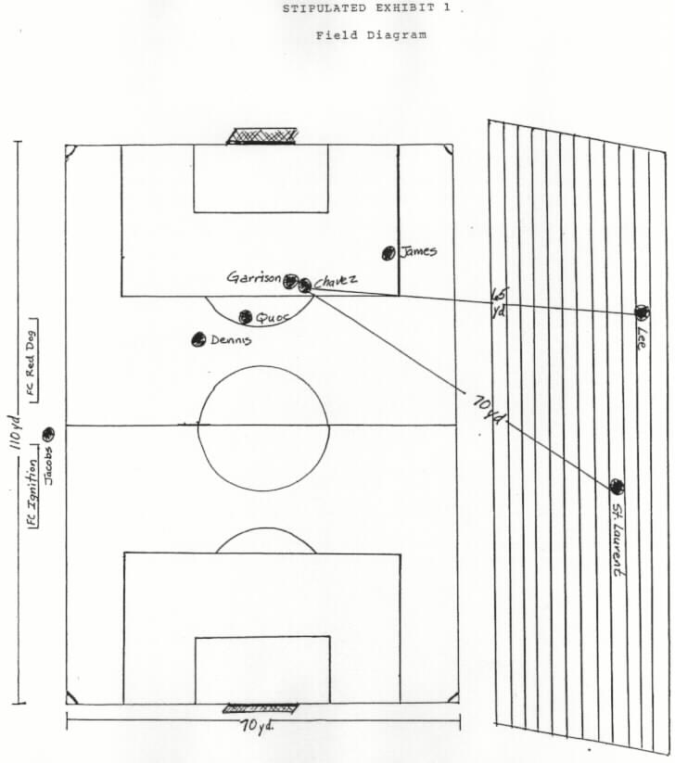
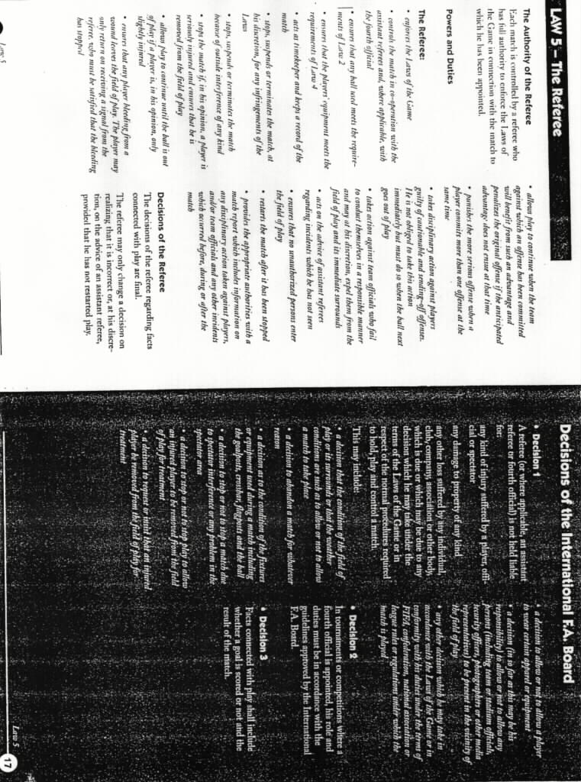
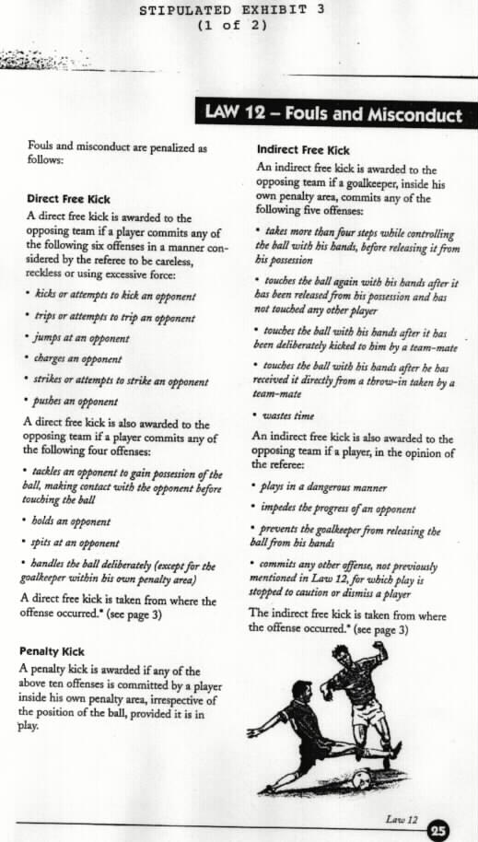
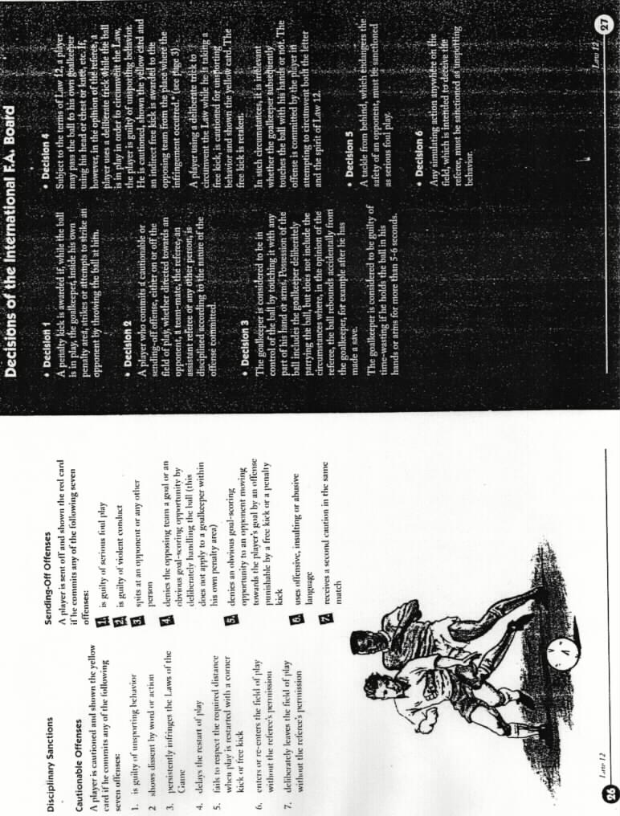

No. ___
A person commits the crime of assault in the second degree when he or she intentionally assaults another and thereby recklessly inflicts substantial bodily harm.

WPIC 35.10
No. ___
To convict the defendant of the crime of assault in the second degree, as charged in count one, each of the following elements of the crime must be proved beyond a reasonable doubt:
(1) That on or about the 17 March 2002, the defendant intentionally assaulted Alex Chavez;
(2) That the defendant thereby recklessly inflicted substantial bodily harm on Alex Chavez; and
(3) That the acts occurred in the State of Washington.
If you find from the evidence that each of these elements has been proved beyond a reasonable doubt, then it will be your duty to return a verdict of guilty as to count one.
On the other hand, if, after weighing all of the evidence, you have a reasonable doubt as to any one of these elements, then it will be your duty to return a verdict of not guilty as to count one.

WPIC 35.13
No. ___
An assault is an intentional touching or striking of another person, with unlawful force, that is harmful or offensive regardless of whether any physical injury is done to the person.

An assault is an act done with the intent to create in another apprehension and fear of bodily injury, and which in fact creates in another a reasonable apprehension and imminent fear of bodily injury even though the actor did not actually intend to inflict bodily injury.
An act is not an assault, if it is done with the consent of the person alleged to be assaulted.

WPIC 35.50
No. ___
A person acts with intent or intentionally when acting with the objective or purpose to accomplish a result which constitutes a crime.

WPIC 10.01
No. ___
A person knows or acts knowingly or with knowledge when he or she is aware of a fact, circumstance or result which is described by law as being a crime, whether or not the person is aware that the fact, circumstance or result is a crime.
If a person has information which would lead a reasonable person in the same situation to believe that facts exist which are described by law as being a crime, the jury is permitted but not required to find that he or she acted with knowledge.
Acting knowingly or with knowledge also is established if a person acts intentionally.

WPIC 10.02
No. ___
A person commits the crime of reckless endangerment when he or she recklessly engages in conduct which creates a substantial risk of death or serious physical injury to another person.

WPIC 35.32
No. ___
To convict the defendant of the crime of reckless endangerment, each of the following elements of the crime must be proved beyond a reasonable doubt:
(1) That on or about 17th day of March, 2002, the defendant acted recklessly by kicking Alex Chavez in the leg;
(2) That such conduct created a substantial risk of death or serious physical injury to another person; and
(3) That the acts occurred in the State of Washington.
If you find from the evidence that each of these elements has been proved beyond a reasonable doubt, then it will be your duty to return a verdict of guilty.
On the other hand, if, after weighing all of the evidence, you have a reasonable doubt as to any one of these elements, then it will be your duty to return a verdict of not guilty.

WPIC 35.33
No. ___
A person is reckless or acts recklessly when he or she knows of and disregards a substantial risk that a wrongful act may occur and the disregard of such substantial risk is a gross deviation from conduct that a reasonable person would exercise in the same situation.
Recklessness also is established if a person acts intentionally or knowingly.

WPIC 10.03

Bibliography

THIS SECTION UNDER COSNTRUCTION

