**Instructions for Invoice Form Submission**

**Q. How do I complete an invoice for reimbursement?**

1. Open the spreadsheet and select the Pro Tem Event tab.
2. Write in your Court Name and Signing Authority in the spaces provided at the top of the spreadsheet. The total for reimbursement will automatically populate from your entries in the pro tem assignment fields explained below.

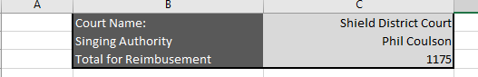

1. Begin entering information, including date(s) pro tems served and pro tem information.

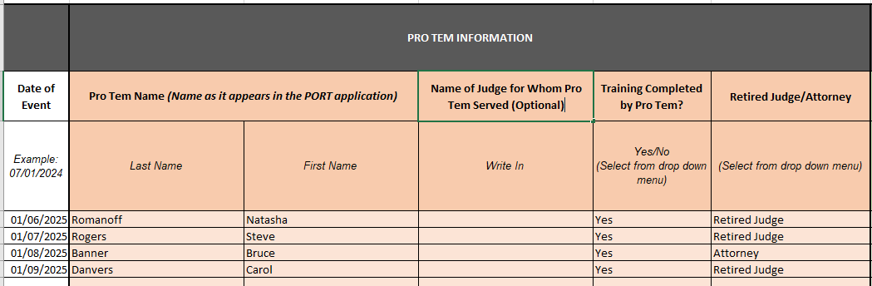

**Required Information**

* 1. Date: date of hearing(s)
  2. Pro Tem Name
  3. Training Completed: this is your certification that the pro tem has completed the required eLearning modules. You will not be reimbursed for time prior to when the pro tem has completed all training.
  4. Retired Judge/Attorney

**Optional Information**

* 1. Name of Judge for Whom Pro Tem Served, if applicable

1. Pro tem case and assignment information: enter the case information, pro tem hourly rate, length of docket and type of service. The total cost will be auto filled. This information will populate the Total for Reimbursement at the top of the spreadsheet.

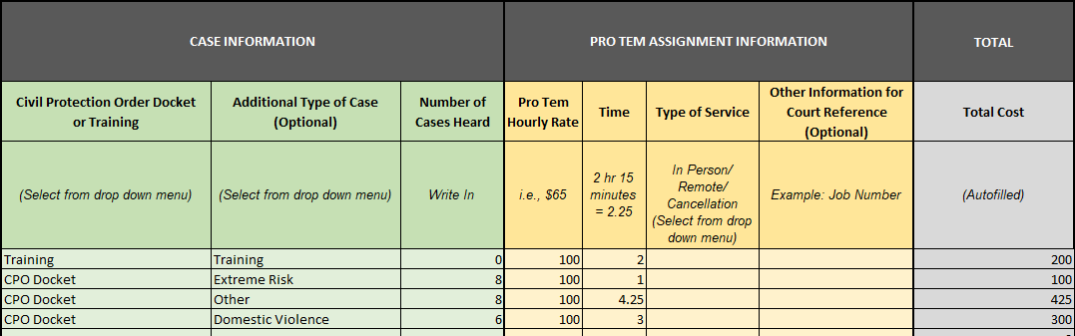

**Required Information**

* 1. Civil Protection Order Docket or Training: Is the reimbursement for time spent training, or coverage of a civil protection order docket?
  2. Number of Cases Heard
  3. Pro Tem Hourly Rate: the amount actually paid by your court (after any other reimbursements or deductions)
  4. Time: amount of time spent training or covering CPO hearings

**Optional Information**

* 1. Additional Type of Case
  2. Type of Service
  3. Other Information for Court Reference

**Q. How do I complete the A-19 form?**

The A-19 form is auto-populated with the information from the Pro Tem Event tab. After completing the Pro Tem Event information, select the A-19 tab and ensure that the Vendor, Signing Authority, and Reimbursement Amount are accurate. Electronic signatures are acceptable.

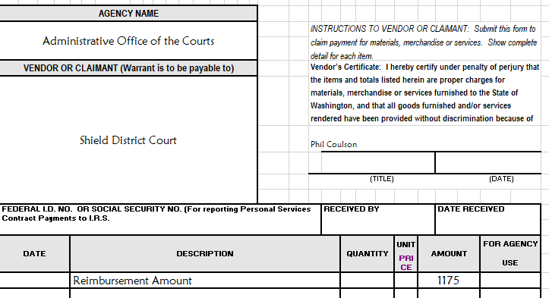

**Q. How do I submit a completed invoice?**

Once you have completed the reporting and invoice form, you must email the completed invoice for reimbursement to [Jessica.Janet@courts.wa.gov](mailto:Jessica.Janet@courts.wa.gov) for review.

**Q. What happens after I submit a completed invoice?**

Once you email the invoice to [Jessica.Janet@courts.wa.gov](mailto:Jessica.Janet@courts.wa.gov), the invoice will be reviewed and forwarded to the AOC fiscal team for payment. The process should not take more than thirty days. The final amount that is reimbursed may differ from the amount listed on the invoice that you submit based on the review of the information in the reporting form by the AOC.